
ATSB Transport Safety Report
Aviation Short Investigations
AB-2017-007
Final – 9 February 2017

Aviation Short Investigations Bulletin
Issue 57

Released in accordance with section 25 of the Transport Safety Investigation Act 2003

Publishing information

Published by: Australian Transport Safety Bureau
Postal address: PO Box 967, Civic Square ACT 2608
Office: 62 Northbourne Avenue Canberra, Australian Capital Territory 2601
Telephone: 1800 020 616, from overseas +61 2 6257 4150 (24 hours)
Accident and incident notification: 1800 011 034 (24 hours)
Facsimile: 02 6247 3117, from overseas +61 2 6247 3117
Email: atsbinfo@atsb.gov.au
Internet: www.atsb.gov.au

© Commonwealth of Australia 2017



Ownership of intellectual property rights in this publication
Unless otherwise noted, copyright (and any other intellectual property rights, if any) in this publication is owned by the Commonwealth of Australia.

Creative Commons licence
With the exception of the Coat of Arms, ATSB logo, and photos and graphics in which a third party holds copyright, this publication is licensed under a Creative Commons Attribution 3.0 Australia licence.

Creative Commons Attribution 3.0 Australia Licence is a standard form license agreement that allows you to copy, distribute, transmit and adapt this publication provided that you attribute the work.

The ATSB’s preference is that you attribute this publication (and any material sourced from it) using the following wording: Source: Australian Transport Safety Bureau

Copyright in material obtained from other agencies, private individuals or organisations, belongs to those agencies, individuals or organisations. Where you want to use their material you will need to contact them directly.

Contents
Jet aircraft
Taxiing incident involving Airbus A330, 9M-XXK 2
Emergency evacuation involving Fokker F28, VH-NHY 6
Turboprop aircraft
Engine failure involving Fairchild SA227, VH-VEU 13
Misaligned take-off involving Beechcraft B200, VH-XGV 17
Engine failure and forced landing involving Cessna 208, VH-TYV 21
Piston aircraft
Forced landing involving Cessna 188, VH-BCT 27
Helicopters
Collision with terrain involving Robinson R44, VH-YMJ 33
Ground strike involving Robinson R44, VH-HHZ 37
Separation Issues
Near collision involving Pilatus BN2, VH-IOA, and Bombardier DHC-8, VH-ZZJ 40
Remotely Piloted Aircraft
Collision with terrain involving Lockheed Martin Stalker XE UAS 46

Jet aircraft

Taxiing incident involving Airbus A330, 9M-XXK

What happened
On 9 September 2016, at about 0005 Eastern Standard Time (EST), an AirAsia X Airbus A330-343X, registered 9M-XXK (XXK) pushed back from gate D12 to disconnect point S7 (Figure 1) at Melbourne Airport, Victoria, to operate scheduled passenger flight D7213 to Kuala Lumpur, Malaysia. Although it was night-time, the apron was well lit by flood lights.
The aircraft maintenance engineer (AME) conducting the pushback was provided by a contracted company, the tug and tug driver were provided by a third company. Prior to commencing the pushback, the AME installed the nose gear steering bypass pin, connected the tow bar to both the aircraft nose landing gear and the tug. During the pushback, as the tug moved the aircraft, the AME was seated in the tug. The AME was in continuous communication with the flight crew using a headset connected directly through a headset jack to the cockpit. During the pushback, the flight crew started one engine. After reaching disconnect point S7, the flight crew applied the park brake and started the second engine.
Figure 1: Melbourne Airport apron section overview
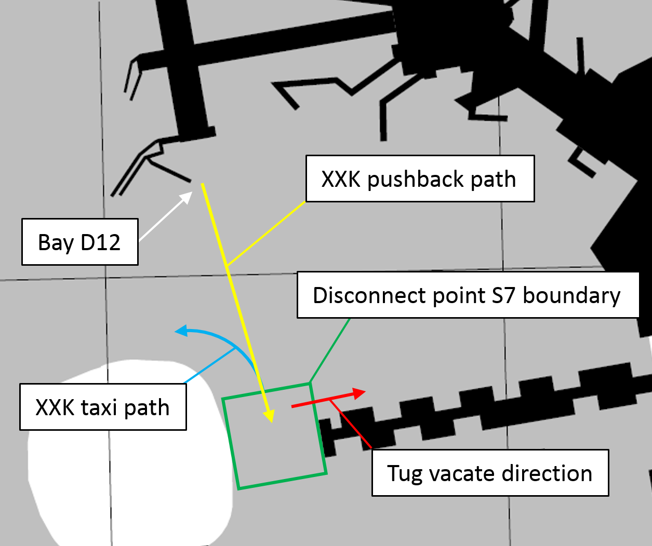
Source: Airservices Australia, modified by ATSB
At 0008, after both engines were started, the AME disconnected the headset and tow bar from both the aircraft and the tug, the AME also removed the bypass pin. The tug driver turned the tug around to allow the AME to attach the tow bar to the rear of the tug. The tug driver then moved the tug and tow bar to a position forward of the aircraft’s right engine and visible to the first officer (Figure 2). The AME then walked to a position in front of the tug, and displayed the bypass pin to the first officer. The AME received a hand signal from the first officer confirming the first officer had sighted the bypass pin. Sighting the bypass pin was the final item on the flight crew’s after start checklist. The flight crew then contacted ATC and obtained a taxi clearance.
At 0009, the first officer confirmed to the captain that the AME and tug were clear, the captain then began to taxi. At this time, the AME was walking towards the left side of the tug, which remained parked forward of the aircraft’s right engine and wing. As the AME walked, they detected the aircraft’s taxi light illuminate and the aircraft begin to move. The AME then ran toward the tug door and alerted the tug driver to the aircraft movement.
Video footage of the incident shows the tug driver taking action to avoid a collision with the taxiing aircraft.
The flight departed without further incident.
Figure 2: Positions at commencement of aircraft taxi
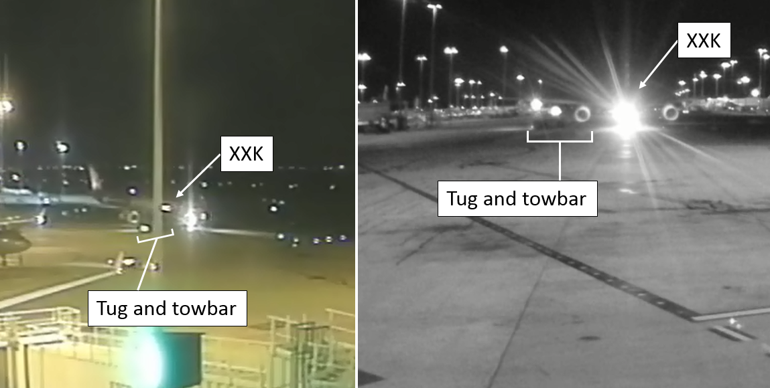
Source: Melbourne Airport, modified by ATSB

Flight crew procedures
The flight crew procedures included the following steps:
- After the pushback and engine start sequence is complete, the bypass pin must be sighted.
- Once taxi clearance is obtained, the flight crew shall ensure both sides of the aircraft are clear prior to taxi.

Flight crew comments
The flight crew of XXK provided the following comments:
- Both flight crew interpreted the AME displaying the bypass pin as meaning the tug and AME were clear, and it was safe to commence taxi.
- The flight crew assumed that ATC providing the taxi clearance meant that ATC had confirmed the tug was clear of the aircraft.
- The first officer observed the tug and AME to the right of the aircraft and assessed that they were clear of the right engine.

Aircraft maintenance provider procedures
The ground handling procedures include the following steps:
- Once the tow bar is connected to the tow vehicle (after being disconnected from the aircraft), the tow vehicle must move away to an area that is visible to the flight crew.
- At a suitable and safe distance from the aircraft, (the AME must) hold up the bypass pin to provide visual confirmation that it has been removed to the flight crew and give a ‘thumbs up’ signal indicating ‘clearance to proceed’. Once acknowledged by the flight crew, move away from the aircraft to a safe distance for the aircraft to taxi.

AME and tug driver comments
- The tug driver and AME both commented that they expected the aircraft to remain stationary until they had moved clear of the S7 disconnect point boundary.

Airservices Australia safety bulletin
The AME and captain commented that they expected air traffic control (ATC) to confirm that the tug was clear of the aircraft and disconnect point S7 prior to providing a taxi clearance.
In 2015, ATC provider, Airservices Australia, identified some misinterpretation among pilots, airside drivers and ground crew regarding the responsibilities for collision avoidance on aerodrome movement areas and the services ATC provide to aircraft and/or vehicles operating on these areas. In response, on 12 November 2015, Airservices Australia released an Aeronautical Information Circular AIC (H32/15) and subsequently in 15 March 2016, this information was released as a safety bulletin, Safety of ground movement on a controlled aerodrome. The bulletin had been provided to the operators involved in this incident.
The bulletin contains the following information regarding operations on the apron and push-back approvals:
The pilot in command (with any assisting ground personnel) is responsible for avoiding collision on the apron. ATC push-back approvals and taxi clearances are only to regulate entrance to, and movement on, the taxiways and do not relate to movement on the apron areas.
When ATC issue approval for push-back or taxi clearance, they will only provide information about relevant known aircraft moving on the same apron. This information may be incomplete as ATC has limited knowledge (or visibility) of movements on the apron. Pilots must also obtain traffic information from assisting ground personnel and, where available, the apron service which may be established as a discrete service at some locations.

Safety analysis
The flight crew interpreted the AME showing the bypass pin at the end of the pushback sequence as notification that all vehicles and equipment were clear of the aircraft and it was safe to commence taxi. The ground crew expected that the flight crew would commence taxi only after all personnel and equipment had crossed the line demarcating the boundary of the S7 disconnect point. Both the flight crew and AME expected that the aircraft would not receive a clearance to taxi until ATC had confirmed that the tug and AME were clear. The misunderstandings by the parties involved during this sequence likely led to incorrect expectations of when the aircraft would begin taxi and the aircraft beginning to taxi prior to the tug moving clear.
The flight crew procedures required the flight crew to visually confirm that all ground equipment was clear of the aircraft prior to taxi. The first officer assessed that the tug and tow bar were clear of the right engine when they were not, although their perception may have been influenced by an expectation of them being clear given the communications with the AME and ATC providing taxi clearance.

Findings
This finding should not be read as apportioning blame or liability to any particular organisation or individual.
- The flight crew and ground crew had differing understandings of procedures. These differing understandings led to different expectations of when the aircraft would commence taxi which resulted in the near collision.
- The first officer incorrectly assessed the distance of the tug from the aircraft.

Safety message
Ground handling of large aircraft presents many safety risks and requires many separate operators to work closely together. Effective teamwork ensures safe and efficient ground operations.
This incident highlights the importance of separate operators working closely together and having procedures which are well harmonised. It is also important that these procedures are well understood and practiced by all individuals involved from the different operators to ensure all parties understand their role but also how their role interacts with other parties.
Also highlighted, is the importance of understanding the services provided by ATC. ATC provide separation between aircraft, personnel and equipment operating on manoeuvring areas. ATC do not separate aircraft from tugs and other ground personnel on apron areas such as disconnect point S7.

General details

Occurrence details
Date and time: | 9 September 2016 – 0009 EST
Occurrence category: | Incident
Primary occurrence type: | Taxiing near collision
Location: | Melbourne Airport, Vic.
 | Latitude: 37° 40.400’ S | Longitude: 144° 50.600’ E

Aircraft details
Manufacturer and model: | Airbus A330-343X
Registration: | 9M-XXK
Operator: | AirAsia X
Serial number: | 1433
Type of operation: | Air Transport High Capacity - Passenger
Persons on board: | Crew – 10 | Passengers – 237
Injuries: | Crew – 0 | Passengers – 0
Aircraft damage: | Nil

Emergency evacuation involving Fokker F28, VH-NHY

What happened
On 23 September 2016, a Network Aviation Fokker F28 MK 100 aircraft, registered VH-NHY, departed Newman Airport, Western Australia (WA), on flight 1623 to Perth Airport, WA. On board were two flight crew, three cabin crew and 97 passengers.
About 550 km north of Perth, at 1048 Western Standard Time (WST), the flight crew were alerted to a caution for low quantity in hydraulic system 1. The flight crew completed the checklist actions, which included selecting the hydraulic system 1 pumps off. The loss of hydraulic system 1 results in the loss of the following systems:
- normal landing gear extension (alternate gravity landing gear extension required)
- normal flap extension (electric power used to extend flaps)
- nose-wheel steering, speed brakes and thrust reversers.
The flight crew notified air traffic control (ATC) of the fault and discussed the implications of the failure. Without nose-wheel steering, they planned to land the aircraft on runway 21 at Perth Airport and roll through to the end of the runway, where a pre-positioned tug would connect to the aircraft and tow it to the allocated gate for passenger disembarkation. Rather than use the engines for electrical power and air-conditioning during the aircraft tow, the captain elected to start the auxiliary power unit (APU) during the approach. The APU would then supply air for the air-conditioning system after landing and electrical power after the engines were shut down.
The flight crew discussed the issue with the cabin crew manager (CCM), advised them of the implications of the fault and their plan for when the aircraft landed. The flight crew subsequently advised the company of their plan and made a PAN call to ATC with their landing intentions. They started the APU and then configured the aircraft early for the approach and landing. The aircraft landed without further incident and rolled through to the end of runway 21.
Figure 1: Emergency evacuation of VH-NHY
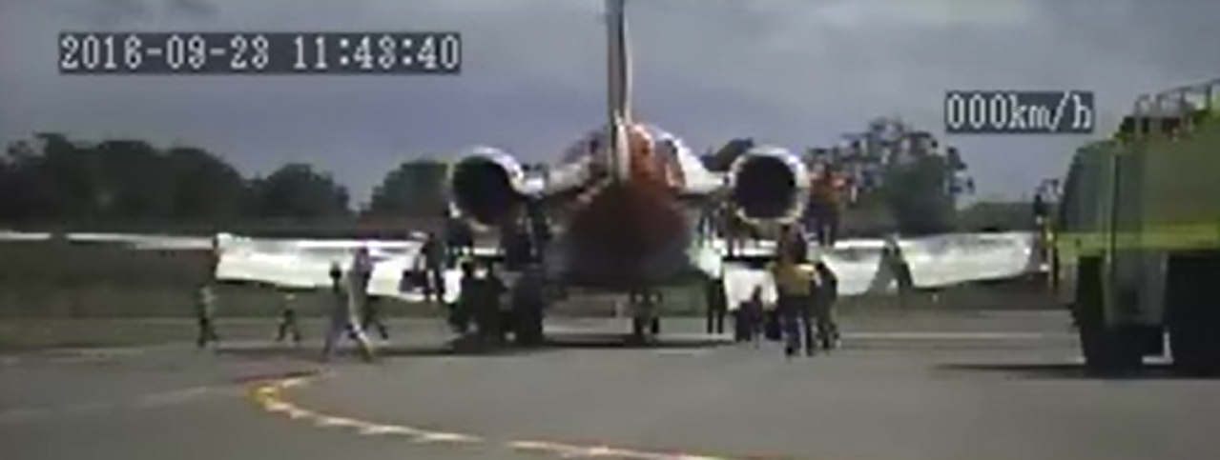
Source: Airport operator
At the end of runway 21, the flight crew could not see a tug waiting for the aircraft, so they used differential braking to turn the aircraft off the runway and onto the taxiway before stopping. The first officer completed the after landing checks, while the captain called the CCM to explain the situation and discuss the public address requirements. While on the interphone to the captain, the CCM reported that there were fumes present in the cabin. The captain turned the APU bleed off, to prevent the APU supplying air to the cabin. However, the CCM then reported that the fumes in the cabin were getting worse. Consequently, the captain suspected the fumes could be from the engines and in consultation with the CCM they elected to conduct an emergency evacuation (Figure 1).
The flight crew started the emergency evacuation checklist and the captain called for the evacuation over the public address system. The cabin crew opened the two front doors and the four over-wing emergency exits were removed by the passengers (Figure 2). The forward left door (L1) slide did not automatically inflate when the slide deployed, so the CCM manually inflated the slide. When the CCM checked on the forward right door (R1) slide they observed that it was not deployed and the cabin crewmember was blocking the exit. The passengers evacuated through the forward left door and the over-wing exits.
The flight crew completed the emergency evacuation checklist and the captain directed the first officer to take the fire extinguisher from the flight deck and join the passengers. The captain then left the flight deck about one minute after the evacuation started with the passenger manifest. They noted there were only a couple of passengers left in the cabin, and the CCM was directing one of them to leave their baggage behind and evacuate. The captain waited for all personnel to leave the aircraft, completed an inspection of the cabin and then exited the aircraft to join the passengers, provide them with support and liaise with the authorities. During the emergency evacuation, three passengers received minor injuries.
Figure 2: Aircraft emergency evacuation routes
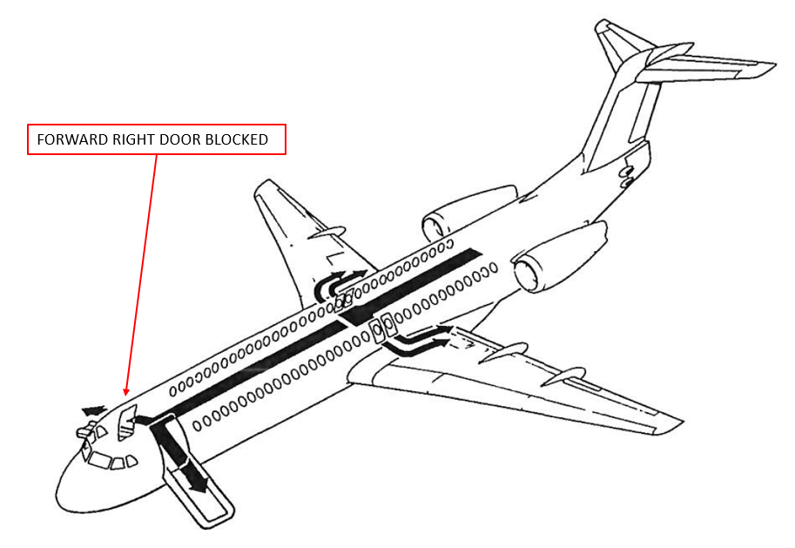
Source: Operator, annotated by ATSB

Maintenance findings
The maintenance organisation found the number 1 engine thrust reverser selector valve (see Thrust reverser selector valves), located in the left outboard APU (see Auxiliary power unit) compartment (zone 313), leaked hydraulic fluid from a damaged O-ring (Figure 3). Further inspection found the APU and air-conditioning system were contaminated with hydraulic fluid.
A gap between the APU intake door actuator rod cut-outs was identified as the path for contaminated air to enter the APU inlet. When the APU inlet door is open inflight, air is scooped into the inlet creating an area of high pressure. However, when the aircraft is on the ground with the APU running, the APU inlet becomes an area of lower pressure as the APU is now ‘sucking’ air into the inlet.
Figure 3: Location of APU and thrust reverser selector valves
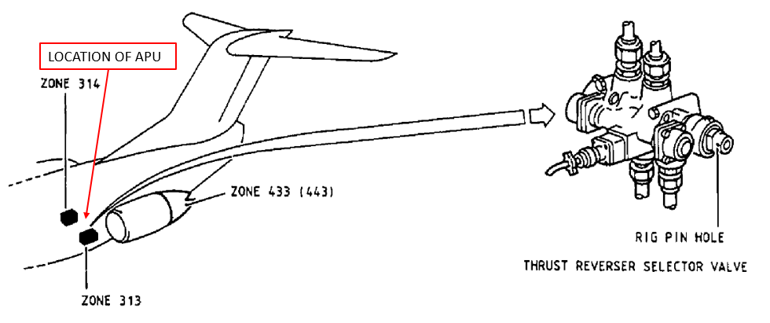
Source: Operator, annotated by ATSB
The R1 door was found by the maintenance organisation to be in the ‘DISARM’ position (‘MANUAL’ mode; see Cabin emergency exits) and an inspection was conducted on the slide and associated mechanism. No defects were found. Inspections of the L1 door slide could not identify a reason for this slide to not inflate automatically.

Auxiliary power unit
The APU is located in the aft fuselage, behind the rear pressure bulkhead. It supplies pneumatic power for starting of the main engines and air-conditioning on the ground, and electrical power if the number 1 and 2 engine driven generators are not supplying power. If the APU is started while airborne, it will not supply air to the air-conditioning system until the ground-flight logic switch detects the aircraft is on the ground.

Thrust reverser selector valves
The thrust reverser selector valves supply hydraulic fluid under pressure to the thrust reverser actuators. Hydraulic fluid for the thrust reverser selector valves is supplied by hydraulic system 1. The number 1 selector valve (left side) is installed in the rear aircraft fuselage behind the pressure bulkhead in zone 313 adjacent to the APU compartment.

Cabin emergency exits
The aircraft is fitted with one forward left side passenger door with an inflatable slide, one forward right side door with an inflatable slide, and four over-wing escape hatches. The inflatable slides will deploy automatically when the door is opened from the inside with the door selector set to ‘AUTOMATIC’. If the slides do not inflate in the automatic mode, then the red inflation handle on the right side of the slide pack must be pulled for inflation. When disarmed (‘MANUAL’ mode), the slide is not attached to the aircraft doorway and remains inside the door assembly when the door is opened. Once the door is opened in the MANUAL mode, there is no way to deploy the slide.

Previous incidents
A search of the ATSB database revealed two previous incidents of fumes entering the cabin on Fokker F28 aircraft from the same operator following a hydraulic leak when the APU was supplying air to the air-conditioning system:
- 21 November 2014: VH-NHM cabin fumes present on pre-departure. Source of hydraulic leak found to be from the horizontal stabiliser actuator.
- 21 January 2016: VH-NHP hydraulic system 1 low quantity inflight followed by cabin fumes during aircraft tow to the gate. Tail section was found wet internally with hydraulic fluid. Speed brake actuator found with damaged O-ring, which was identified as the source of the leak.
In response to the incident in 2014, the operator contacted the aircraft manufacturer to propose the design of a seal located at the entry point of the APU air intake. This would mitigate the potential for contamination of the air-conditioning system following a hydraulic leak. The manufacturer considered the proposal plausible and reasonable, but elected not to initiate action as this was their first reported occurrence.
Following the latest incident, and in light of the two previous incidents, the aircraft manufacturer considered if an amendment to emergency procedures was required to warn flight crew of the potential risk of a fumes incident from operation of the APU following a hydraulic leak. The manufacturer decided this was not supported based upon the following service experience:
The majority of the reported hydraulic leaks are not located in the tail section. Hydraulic fumes entered the cabin or flight deck in less than 1% of the non-tail origin events. The APU was not implicated in the non-tail origin events.
A change to the hydraulic quantity low emergency procedure was considered, but their review indicated that only a small percentage of tail origin hydraulic leak events that could potentially lead to fumes were associated with a hydraulic quantity alert.

Safety analysis
The hydraulic leak was the result of a failure of an O-ring in the number 1 thrust reverser selector valve. The checklist actions resulted in switching off the pumps supplying the number 1 hydraulic system with the loss of the associated systems, which included the nose wheel steering. The loss of nose wheel steering necessitated a tow to the gate by a tug after landing. The captain elected to start the APU inflight so that it would be available to supply air for the air-conditioning system after landing and electrical power after the engines were shutdown. However, unknown to the flight crew, the location of the hydraulic leak relative to the APU air intake, and a gap between the APU intake door actuator rod cut-outs, resulted in the contamination of the air-conditioning system. This occurred when the ground-flight logic switch detected the aircraft was on the ground and the APU started to act as a source of air supply for the air-conditioning system.
After the fumes were detected in the cabin, the first action by the captain was to switch off the air supply from the APU. Following this action, the air for the air-conditioning system was supplied by the engines. However, by this stage various parts of the air-conditioning system were contaminated with hydraulic fluid. Therefore, fumes continued to enter the cabin through the air-conditioning system.
During the emergency evacuation, the R1 door slide did not deploy. The maintenance inspection found the R1 door was disarmed and no fault was found with the door operating mechanism. Therefore, it is likely that during the emergency evacuation procedure the cabin crewmember at the R1 door reverted to previous experience and disarmed the door prior to opening it, which prevented the slide from automatically deploying.

Findings
These findings should not be read as apportioning blame or liability to any particular organisation or individual.
- A damaged O-ring in the left engine thrust reverser selector valve resulted in a hydraulic leak.
- Hydraulic fluid, or vapour, entered the APU air intake through a gap between the APU intake door actuator rod cut-outs.
- The cabin fumes were the result of the APU supplying air contaminated with hydraulic fluid to the air-conditioning system after the ground-flight logic switch detected the aircraft on the ground, which resulted in the contamination of the air-conditioning system.
- The R1 door slide did not deploy automatically because the door was disarmed when it was opened.

Safety action
Whether or not the ATSB identifies safety issues in the course of an investigation, relevant organisations may proactively initiate safety action in order to reduce their safety risk. The ATSB has been advised of the following proactive safety action in response to this occurrence.

Operator
As a result of this occurrence, the aircraft operator has advised the ATSB that they have taken the following safety actions:

Air quality checks
Following the replacement of parts contaminated with hydraulic fluid and cleaning of the APU area and air-conditioning system, the operator and their maintenance organisation conducted air quality checks on the aircraft before return to service.

Flying operations advisory bulletin
The operator’s flight operations department issued flying operations advisory bulletin (FOAB) 031/16: Fumes ingestion by the APU. The bulletin advises flight crew of the potential for ingesting fumes through the APU intake in the event that the APU is operating with a hydraulic leak in the tail section of the aircraft.

Human factors review
The human factors review of the incident was conducted for learning points and future training considerations.

Maintenance program
Changes to the aircraft maintenance program have been introduced to proactively identify potential issues, such as detailed visual inspections within areas which may lead to potential air quality issues.

Safety message
This incident highlights the importance of training and procedures, and the need for organisations to educate their workforce about safety incidents. The flight crew on board NHY were confronted with two consecutive emergencies. They responded to each situation in accordance with their training and procedures, which resulted in everyone safely evacuating the aircraft with only minor injuries reported.
Further information about the risk of fumes can be found in ATSB research report AR-2013-213: an analysis of fumes and smoke events in Australian aviation.

General details

Occurrence details
Date and time: | 23 September 2016 – 1048 WST
Occurrence category: | Incident
Primary occurrence type: | Systems - hydraulic
Location: | 550 km north Perth Aerodrome, Western Australia
 | Latitude: 27° 13.20’ S | Longitude: 117° 43.05’ E

Aircraft details
Manufacturer and model: | Fokker Aircraft B.V. F28
Registration: | VH-NHY
Operator: | Network Aviation
Serial number: | 11467
Type of operation: | Air transport high capacity - Passenger
Persons on board: | Crew – 5 | Passengers – 97
Injuries: | Crew – 0 | Passengers – 3 (minor)
Aircraft damage: | Minor

Turboprop aircraft

Engine failure involving Fairchild SA227, VH-VEU

What happened
On 12 October 2016, a Vee H Aviation Fairchild Industries Inc. SA227-DC, registered VH-VEU, conducted a regular public transport flight from Armidale, New South Wales, to Brisbane, Queensland. On board the flight were two flight crew and 13 passengers. The captain was the pilot flying (PF) and the first officer was the pilot monitoring (PM).
At 0755 Eastern Daylight-saving Time (EDT), the aircraft was about 170 km south of Brisbane, cruising at FL 170, when the aircraft suddenly yawed to the right. The PF re-stated they had command of the aircraft and directed the PM to identify the failure. The flight crew then employed their ‘identify and confirm’ crew resource management (CRM) procedures to confirm the right engine was not delivering power and then shut down the right engine and feathered the right propeller. During the diagnosis, the PM noted that all right engine indications were normal except for a low torque reading (10%) and low fuel flow (140 pounds per hour).
Air traffic control contacted the crew to confirm they were maintaining FL 170 and the PM responded with a PAN broadcast that they were descending due to a right engine failure. The crew reviewed their options and decided to continue to Brisbane Airport. They completed the remaining checklist actions and briefed the passengers. The crew then requested, and were given, a direct track to Brisbane Airport from air traffic control. They completed their normal and single engine landing checklist procedures and landed at Brisbane Airport runway 19 without further incident.

Maintenance findings
The engine installed in the aircraft was the Honeywell (previously Garrett) TPE331-12UHR-701G. The operator’s engine maintenance organisation found a retainer ring within the engine accessory gear assembly had failed, which allowed the main shaft (which drives the propeller) to de-couple from the engine driven reduction gearbox (Figure 1).
The retainer ring was shipped to the maintenance organisation from Honeywell in December 2008 as part of a batch of 10 with a certificate of conformance from the part manufacturer and Honeywell. It was fitted new to the incident engine in December 2009 at the last engine overhaul, about 2,429 hours prior to the failure. The maintenance organisation introduced this practice of replacing the retainer ring at each overhaul based upon their previous service experience of this part failing. December 2009 was the last overhaul of the accessory gear assembly prior to the failure.
In October 2015, Honeywell added temporary revision 72-241 to the maintenance manual procedure: removal and installation of accessory gear assembly, to direct the replacement of the retainer ring at each exposure. Figure 2 depicts the failed retainer ring.
Figure 1: Engine accessory gear assembly
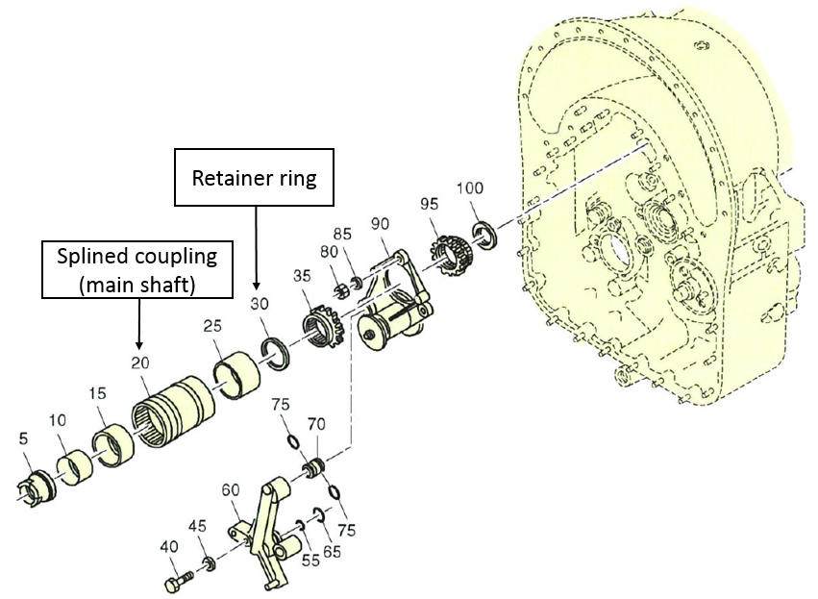
Source: Maintenance organisation, annotated by ATSB
Figure 2: Retainer ring
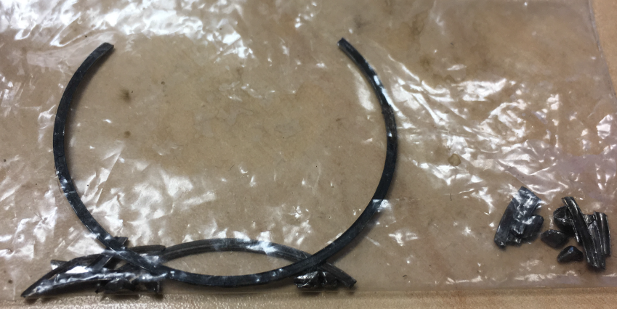
Source: Operator

Continuing airworthiness maintenance interval
The operator set their maintenance interval for the incident engine in accordance with the engine manufacturer’s service bulletin for periodic inspections, (Honeywell TPE 331-72-0476). From the service bulletin, the operator set the inspection of the engine at the 7,000 hour continuing airworthiness maintenance (CAM) interval with gearbox inspection, for commercial operations. This included the requirement for the accessory gear assembly inspection in accordance with the maintenance manual procedures at the 7,000 hour interval.
The operator’s spectrometric oil-analysis programme (SOAP analysis) was set at 150 hour intervals at the time of the incident. The previous SOAP analysis was conducted at about 26 hours prior to the failure and did not detect any anomalies. Further information on SOAP is available from Civil Aviation Safety Authority airworthiness bulletin (AWB 79-1): Spectrographic oil analysis program (SOAP).
The gearbox is fitted with a single magnetic drain plug (chip detector). If a metallic particle is detected by the chip detector inflight, it will activate a caution light to advise the flight crew. The inspection interval for the chip detector is set at 300 hours. The last inspection was about 144 hours prior to the incident and no anomalies were found. There were no activations of the chip detector between the last scheduled inspection and the incident flight, and the chip detector did not activate during the incident flight.
The operator also conducts propeller dynamic balance checks at 600 hour intervals. There have been no out-of-limit vibration indications since engine installation. The last check was performed 17 September 2016.

Safety analysis
The operator had several preventive maintenance inspections in place, which included an overhaul of the gearbox, SOAP analysis, magnetic drain plug inspection and propeller dynamic balance. The previous overhaul was about 2,429 hours prior to the failure at which time the retainer ring was fitted new to the gearbox. During the time interval to failure of the retainer ring, the SOAP analysis, magnetic drain plug inspections and propeller dynamic balance checks did not detect any anomalies. Therefore, the failure of the retainer ring was within the required gearbox inspection intervals and without prior warning of an impending failure.

Findings
These findings should not be read as apportioning blame or liability to any particular organisation or individual.
- The retainer ring failed within the prescribed maintenance interval.
- There was no prior warning of an impending failure of the retainer ring.

Safety action
Whether or not the ATSB identifies safety issues in the course of an investigation, relevant organisations may proactively initiate safety action in order to reduce their safety risk. The ATSB has been advised of the following proactive safety action in response to this occurrence.

Operator
As a result of this occurrence and subsequent to an update by the engine manufacturer to the engine manufacturer’s service bulletin, the aircraft operator has advised the ATSB that they are taking the following safety actions:

SOAP analysis
The operator reduced their SOAP analysis interval from 150 hours to 100 hours.

Damaged parts
The damaged parts from the gearbox were sent to the engine manufacturer for analysis.

Safety message
Following the aircraft yaw, the flight crew actively employed their crew resource management procedures to identify and confirm the engine fault and then shut down the right engine. The use of these procedures reduced the risk of an incorrect diagnosis of the fault or activation of the incorrect engine controls during shut down.

General details

Occurrence details
Date and time: | 12 October 2016 – 0755 EDT
Occurrence category: | Incident
Primary occurrence type: | Engine failure of malfunction
Location: | 170 km south of Brisbane Airport, Queensland
 | Latitude: 28° 53.37’ S | Longitude: 152° 47.10’ E

Aircraft details
Manufacturer and model: | Fairchild Industries Incorporated SA227-DC
Registration: | VH-VEU
Operator: | VEE H Aviation PTY LTD (Operating as Corporate Air)
Serial number: | DC-797B
Type of operation: | Air transport low capacity - Passenger
Persons on board: | Crew – 2 | Passengers – 13
Injuries: | Crew – 0 | Passengers – 0
Aircraft damage: | Nil

Misaligned take-off involving Beechcraft B200, VH-XGV

What happened
On 26 October 2016, a Beechcraft B200 aircraft, registered VH-XGV (XGV), taxied at Brisbane Airport for a private ferry flight to Archerfield Airport, Queensland. The pilot was the only occupant of the aircraft.
The pilot taxied the aircraft to holding point A7 (Figure 1).
According to recorded air traffic control communications, at about 2010 Eastern Standard Time (EST), the aerodrome controller (ADC) asked the pilot of XGV whether they were ‘ready to go’ and the pilot responded advising they were ready. The ADC issued an instruction to the pilot to conduct a right turn onto a heading of 090° after take-off, and cleared the pilot to line up on runway 01 and wait due to wake turbulence from an aircraft that had just taken off. The pilot read back the line-up instruction, but as they omitted to read back the assigned heading, the ADC repeated the turn and heading information and then also advised the pilot of an amended Departures frequency (from the one issued in their initial airways clearance).
After the pilot received the line-up instruction, they started to taxi the aircraft onto the runway, and commenced the line-up checks. The pilot read back the frequency initially, but subsequently asked the controller to repeat it. The pilot lined the aircraft up on what they thought was the centreline of runway 01, and the aircraft remained stationary on the runway for about 30 seconds before the controller cleared the pilot for take-off.
At about 2011, the aircraft commenced the take-off run. During the take-off, the pilot realised that the aircraft was not on the centreline, and steered the aircraft right towards the centreline prior to the aircraft becoming airborne. A subsequent runway inspection found damage to a runway edge light and the aircraft sustained minor damage to the nose landing gear.
Figure 1: VH-XGV commencing take-off on runway 01
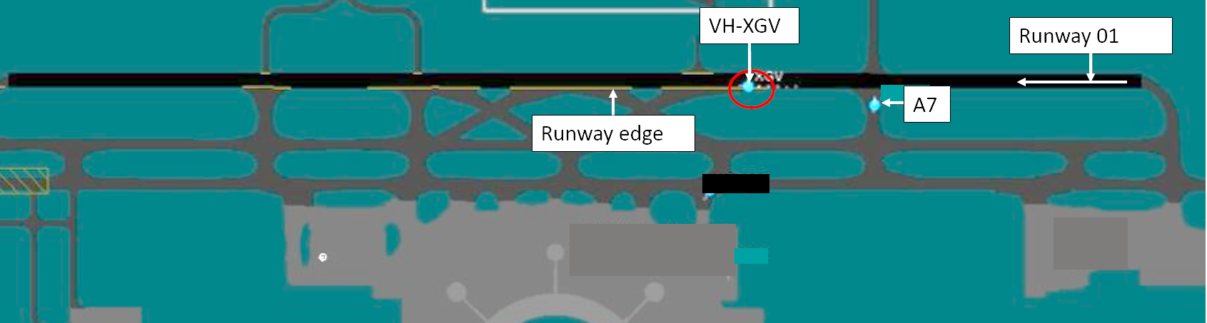
Source: Airservices Australia

Pilot comments
The pilot provided the following comments:
- It seemed very dark on the taxiway and runway 01. They had difficulty detecting the taxiway centreline markings.
- The aircraft had its LED taxi light on, but it did not seem effective, as it did not appear to illuminate the area.
- The pilot advised that the taxiway and runway lights were difficult to see, and was not sure if there were runway centreline lights and whether they were activated.
- Once they had changed to Tower frequency, they felt rushed by air traffic control to line up on the runway.
- The pilot was not expecting the change in Departures frequency, which was given to them with the departure instructions as they were in the process of entering the runway and completing their line-up checks. This distracted them from ensuring the aircraft was lined up correctly on the centreline.
- The pilot thought something was not right, but did not think the aircraft hit anything and realigned the aircraft on the runway centreline. Only after airport ground personnel found the parts of damaged lighting was it evident the aircraft took off on the runway edge.

Airport lighting
At Brisbane Airport, the taxiway has green centreline lights and lead-off lights from the runway, but no lead-on lights from any intersection departure points. The lead-off lights are one way lights and would not be visible to the pilot entering the runway. Runway 01 has white runway centreline lights, runway threshold lights, and both high and medium intensity runway lights along the runway edge.
Air traffic control selects the lights on with one switch, which turns on both edge and centreline lights on the runway. There were no reports of any technical problems with the lighting that night.

Aircraft lighting
The aircraft had two LED landing lights below a single LED taxi light, all of which are attached to the nose landing gear leg of the aircraft. The pilot confirmed that the taxi light was switched on during taxi and take-off. Switching on landing lights is part of the line-up checklist, but the pilot was uncertain whether it was switched on during take-off.

Previous incidents
A search of the ATSB database found similar misaligned take-off occurrences at night during the absence of a particular type of runway lighting and perceived pressure on the pilot to take-off:
- Operational event, Brisbane Airport, Queensland, 25 November 2007 (ATSB investigation AO-2007-064): The pilot of a Gulfstream Aerospace Corporation G-IV was operating a charter flight from Brisbane to Sydney, New South Wales (NSW). The pilot-in-command commenced take-off on taxiway A, which was adjacent to runway 01. The aerodrome controller instructed the pilot to cancel the take-off clearance. It was found that the electronic flight bag (EFB) was not functional, and the pilot-in-command relied on memory of the aerodrome from landing earlier that morning to take-off. On the entrance to runway 01 (at the A7 intersection), there were no runway threshold markings and lights to indicate the beginning of the runway.
- The crew of a SAAB 340B was preparing to take-off from Sydney Airport to Lismore, New South Wales. The aircraft was lined up for take-off on runway 25 on the left runway edge runway lights. During take-off run, the captain thought something was wrong and realised that the aircraft was incorrectly lined up on the runway edge lights and re-aligned with the centreline. The crew were completing the line-up checklist at the time. Furthermore, runway 25 does not have centreline lighting.
- Collision on ground, Townsville Aerodrome, Queensland, 11 February 2009 (ATSB investigation AO-2009-007). During take-off, the pilot-in-command realised that the Bombardier DHC-8 was aligned with the left runway edge of runway 01. The aircraft was manoeuvred to the centre of the runway, and the take-off was rejected. It was found that the aircraft’s left mainwheel had damaged a runway edge light. Factors that may have led to the misaligned take-off related to the adverse weather. These included the weather being a distraction to the flight crew to monitor the aircraft’s path onto the runway, pressure to depart, and reliance on aerodrome lighting. Furthermore, the centre taxiway lighting stopped prior to the runway threshold making it difficult for crew to identify the runway edge.

Safety analysis
Animation of the recorded radar data from Brisbane Airport showed the aircraft commencing take-off on the runway edge, then moving across to the centreline.
Brisbane Airport taxiway and runway lights were operational on the night of the incident. However, lead-in lights were not installed to assist pilots lining up on the runway centreline. In addition, the aircraft’s taxi light used during the taxi, and possibly the take-off, supplied only very limited visibility to the pilot.
The pilot stated they felt rushed when the ADC gave them clearance to line up, and they were still completing the line-up checks when the controller issued the change in frequency. This combination of time pressure and distraction affected the pilot’s ability to detect the aircraft was not on the runway centreline. Airservices commented that as there was a 30 second delay on the runway for wake turbulence and no other aircraft on final approach, there was no actual urgency for the pilot. Despite this, the pilot had a perception of time pressure.

Findings
These findings should not be read as apportioning blame or liability to any particular organisation or individual.
- The pilot lined the aircraft up and commenced take-off on the runway edge lighting from an intersection (A7) departure.
- The misalignment of the aircraft was influenced by the pilot rushing due to perceived pressure to commence the take-off when the line-up clearance was given, the issuing of a frequency change while the pilot was completing the line-up checks as well as lining up the aircraft on the runway, the lack of taxiway lead-on lights to the runway, and limited brightness of the aircraft taxi light.

Safety message
This incident highlights the effect time pressure and distraction can have on flight safety, particularly during critical stages such as while completing checklists. An ATSB research report Dangerous distraction: An examination of accidents and incidents involving pilot distraction in Australia between 1997 and 2004 provides an overview of occurrences resulting from pilot distraction. One strategy outlined is that if completion of checklists are disrupted, go back and start the checklist again (if possible) to reduce the potential for error.
In addition, ATSB research report Factors influencing misaligned take-off occurrences at night outlines conditions including intersection departure, air traffic control clearance/s issued during runway entry, and divided attention of flight crew. The ATSB has also developed a Pilot Information Card featured within the report to help flight crew identify factors that could increase the risk of a misaligned take-off.

General details

Occurrence details
Date and time: | 26 October 2016 – 1937 EST
Occurrence category: | Incident
Primary occurrence type: | Runway - Other
Location: | Brisbane Airport, Queensland
 | Latitude: S 27° 23.05' | Longitude: E 153° 07.05'

Aircraft details
Manufacturer and model: | Beech Aircraft Corp 200
Registration: | VH-XGV
Serial number: | BB-1230
Type of operation: | Private - Ferry
Persons on board: | Crew – 1 | Passengers – 0
Injuries: | Crew – 0 | Passengers – 0
Aircraft damage: | Minor

Engine failure and forced landing involving Cessna 208, VH-TYV

What happened
On 11 November 2016, at about 1546 Central Standard Time (CST), a Cessna 208B (C208B) aircraft, registered VH-TYV (TYV) entered runway 29, at the intersection of taxiway E2 (Figure 1) at Darwin Airport, Northern Territory for an aircraft type re-familiarisation training flight. On board were an instructor and trainee pilot.
Figure 1: Darwin Airport overview showing approximate flight path of TYV
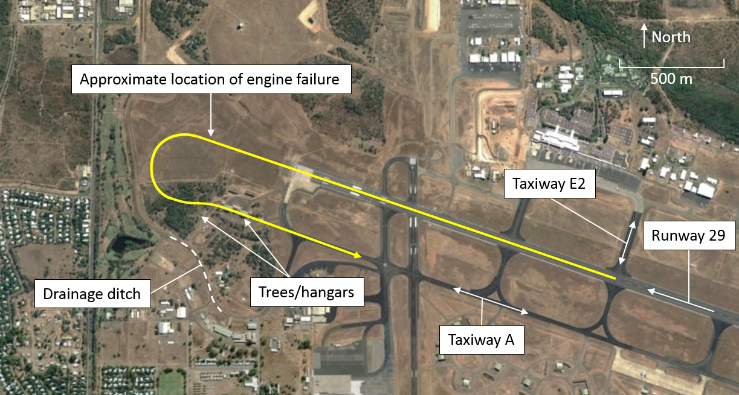
Source: Google Earth, annotated by ATSB
At the beginning of the take-off run, the trainee pilot set take-off power prior to releasing the brakes. After releasing the brakes, the aircraft accelerated to the take-off speed. The trainee pilot rotated the aircraft to 12 degrees nose up, to achieve a best angle of climb speed of 80 kt. The trainee pilot maintained 12 degrees nose up and 80 kt until the aircraft climbed to an altitude of about 500 ft above ground level (AGL).
At about 500 ft, the trainee pilot reduced the flap setting from the take-off setting of 20 degrees to 10 degrees. At this time, the instructor noted the climb speed reducing while the trainee continued to maintain the nose attitude for best angle of climb. At the same time, the instructor heard the engine lose power and a thin film of fuel partially obscured the windscreen. The instructor noted reducing engine torque, fuel flow, inter-turbine temperature and airspeed.
As the airspeed reduced to 60 kt, the instructor took control of TYV. They immediately felt a strong nose down force through the control column and the aircraft pitched significantly nose down. They recovered the aircraft to the glide attitude and could not see a suitable landing area ahead of the aircraft. They identified an area to the left of the aircraft as the most suitable for a forced landing and began a left turn towards that clear area at the target glide speed of 85 kt.
During the left turn, the instructor made a PAN broadcast on the Darwin Tower air traffic control (ATC) frequency advising that the engine had failed and that they intended to turn back to Darwin Airport. As the turn continued, they un-stowed the emergency power lever, in accordance with the engine failure procedures and attempted to recover engine power. The engine did not respond, so they feathered the propeller.
The instructor observed a drainage ditch within the clear area to the left of the aircraft, and initially selected the drainage ditch as the most suitable location for the forced landing. As the aircraft turned, they assessed that sufficient height remained to continue the turn back towards Darwin Airport. At the completion of the turn, they selected 30 degrees of flaps to provide a short climb, which allowed the aircraft to clear two hangars and an area of trees.
After clearing the hangars and trees, the instructor observed taxiway A in line with the aircraft and elected to land on taxiway A. The aircraft landed on taxiway A without further incident.
After landing, the instructor and trainee pilot exited the aircraft. They observed fuel on the canopy and underside of the aircraft along with a significant leak from the engine cowling which had created a large pool of fuel below the aircraft.
The instructor and trainee were not injured and the aircraft was not damaged in the incident.

Instructor comments
The instructor in TYV provided the following comments:
- A pre-flight inspection of the aircraft found no defects and no evidence of fluid leaks in the engine compartment.
- The instructor developed the C208B operating procedures for the operator. The instructor regularly practiced and trained pilots on the conduct of these procedures.
- The instructor had recently conducted significant multi-engine aircraft training, including engine failures where procedures direct a PAN broadcast. They probably reverted to this behaviour when contacting ATC to advise of the emergency rather than declaring MAYDAY. The ATC response indicated that the emergency situation was understood and further declaration of a MAYDAY was not required.
- The operator take-off safety briefing directs a pilot to only attempt a turn-back at altitudes in excess of 700 ft AGL.
- The aircraft departed with a 10-15 kt headwind, only two occupants on board and 900 kg of fuel. The light weight of the aircraft and the assisting headwind, which became a tailwind during the turn-back, led the instructor to continue the turn-back despite commencing the procedure at about 500 ft AGL.
- Departure from the E2 taxiway intersection on runway 29 provides in excess of 1,600 m of runway for take-off. This is ample for a C208B and more than is available at any other runway the C208B is operated to by the company. Departing from the end of runway 29 requires a significantly further taxi distance.
- The initial strong pitch down force, as the instructor took control after the engine failure, was probably due to the loss of thrust along with the drag produced as the propeller pitch initially reduced before the propeller was feathered.
- The turn back procedure is not suitable for all aircraft types, piston engine aircraft do not have the same ability to turn back after an engine failure.

Engineering examination
A post-incident examination of the engine found the number eight fuel nozzle locking plate missing (Figure 2). This allowed the fuel transfer tube to migrate out of the number eight fuel nozzle adaptor. There was no damage to the locking plate mounts.
The fuel nozzles had been replaced 86 flight hours prior to the incident, while the aircraft underwent maintenance in the United States, prior to importation into Australia. All other required hardware was found to be correctly installed, including the number eight fuel transfer tube locking plate fasteners.
Figure 2: TYV fuel transfer tubes
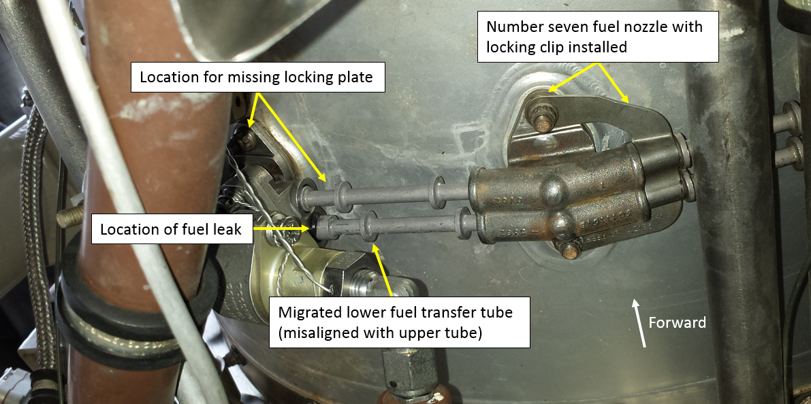
Source: Operator, annotated by ATSB

Safety analysis
The lack of damage to the locking plate mounts, along with the locking plate being entirely missing, and the fasteners being found installed indicates the locking plate probably did not fail. The locking plate was probably not reinstalled when the fuel transfer tubes and nozzles were installed after replacement. The missing locking plate allowed the fuel transfer tube to slowly migrate out of the nozzle adaptor over the subsequent 86 flight hours.
On the incident flight, the fuel transfer tube migrated far enough that fuel under pressure was able to escape from the nozzle adaptor (Figure 3).
Figure 3: Fuel under pressure escaping from migrated fuel transfer tube
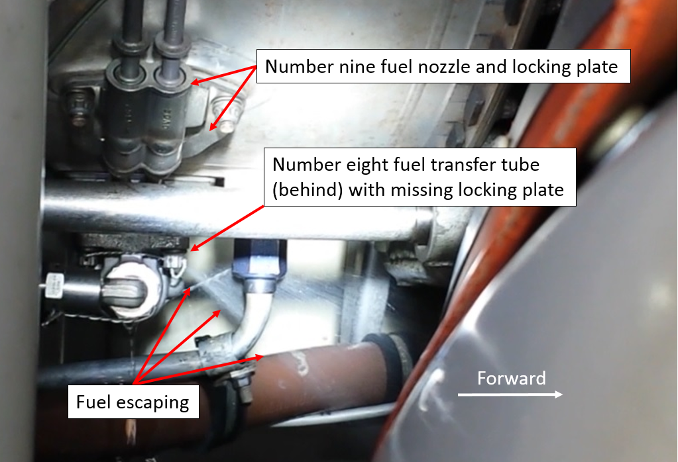
Source: Operator, annotated by ATSB

Findings
These findings should not be read as apportioning blame or liability to any particular organisation or individual.
- The number eight fuel transfer tube locking plate was likely not installed when the fuel transfer tubes and nozzles were installed after replacement.
- The missing locking plate allowed the fuel transfer tube to migrate out of the fuel nozzle adaptor and fuel to escape. This starved the engine of fuel and led to the engine power loss in flight.

Safety message
This incident serves to underline the importance of ensuring all maintenance is completed entirely and correctly. The locking plate was not installed during scheduled maintenance, however, the fuel leak did not develop for a further 86 flight hours. This demonstrates how the effects of incomplete maintenance can take a long period of time to manifest. The ATSB research report: An overview of human factors in aviation maintenance provides information on human factors errors made in the maintenance environment.
This incident also provides an excellent example of the value of regular training and the effective implementation of procedures following engine failure after take-off in a single engine aircraft.
Successful completion of a turn back manoeuvre to land on the departure runway, or other suitable airport area, requires well-developed procedures and good pilot proficiency to ensure procedures are effectively applied. Careful consideration of the characteristics and performance of each aircraft type is required when developing turn back procedures. The impact of wind and weather conditions must also accounted for when electing to conduct the turn back procedure. As demonstrated in this incident, during the turn back the pilot should constantly assess the ability of the aircraft to complete the procedure and be prepared at any time to cease the turn and land ahead.
The ATSB research report: Avoidable Accidents No. 3 - Managing partial power loss after take-off in single-engine aircraft provides information to assist pilots handling both partial and complete engine power loss after take-off.
Pilots can significantly reduce risk following a partial or complete engine power loss using the following strategies:
- pre-flight decision making and planning for emergencies and abnormal situations for the particular aerodrome
- taking positive action and maintaining aircraft control either when turning back to the aerodrome or conducting a forced landing.

General details

Occurrence details
Date and time: | 11 November 2016 – 1547 CST
Occurrence category: | Serious incident
Primary occurrence type: | Engine failure or malfunction
Location: | Darwin Airport, Northern Territory
 | Latitude: 12° 24.880’ S | Longitude: 130° 52.600’ E

Aircraft details
Manufacturer and model: | Cessna Aircraft Company 208B
Registration: | VH-TYV
Serial number: | 208B2137
Type of operation: | Flying training - Dual
Persons on board: | Crew – 2 | Passengers – 0
Injuries: | Crew – 0 | Passengers – 0
Aircraft damage: | Nil

Piston aircraft

Forced landing involving Cessna 188, VH-BCT

What happened
On 9 August 2016, at about 1310 Eastern Standard Time (EST), a Cessna A188B aircraft, registered VH-BCT (BCT), taxied to depart from a private strip near Hay Airport, New South Wales to complete a run to spread fertiliser on the property. The pilot was the only person on board the aerial agriculture operation.
The pilot had already completed two spreading runs, for the field being treated, and on each occasion, the pilot took-off and banked the aircraft to the right, and then banked to the left to align with the field. During the third take-off, the pilot noticed a vehicle traveling along a road at the beginning of the spreading run for that field. The pilot climbed the aircraft to about 200 ft and commenced an orbit to allow the vehicle to move out of the way (Figure 1).
Figure 1: Map showing the location of the landing area, field to be treated and the aircraft flight path
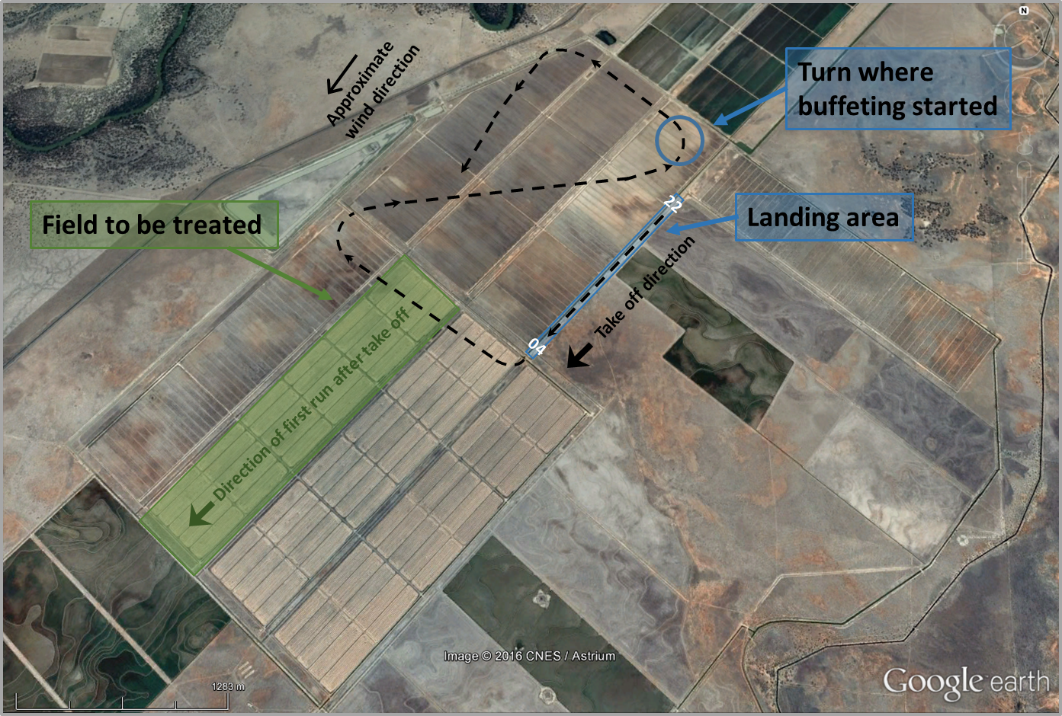
Source: Google earth, modified by the ATSB
During the 30-degree turn to the left, the aircraft started an aerodynamic buffet. The pilot moved the engine controls to full power but did not notice a difference in engine noise or a change in the aircraft performance. At the same time, the pilot levelled the aircraft wings, lowered the nose to increase speed and as there was no change in the performance, they began jettisoning the load. Due to the load type, the pilot had to jettison the load slowly so as not to block the spreader. The pilot elected to return to the airstrip to check the operation of the engine and commenced a gentle turn to the left. The aircraft continued to buffet and the altitude continued to decrease, despite having full engine power selected and the load being jettisoned. The pilot continued to lower the nose of the aircraft and when it became evident that the aircraft was not going to make the strip, the pilot elected to land straight ahead. As the aircraft flew over a channel, the tail wheel clipped that channel, and the aircraft collided with the ground on the flat area between two channels. The landing gear and propeller detached as the aircraft continued forward and came to rest on the top of the opposite channel. As there was a lot of fuel leaking from the fuel tanks, the pilot quickly turned off the engine magnetos and the electrical master switch and exited the aircraft through the cockpit door. The pilot was uninjured and the aircraft was substantially damaged (Figure 2).
Figure 2: BCT at the accident site
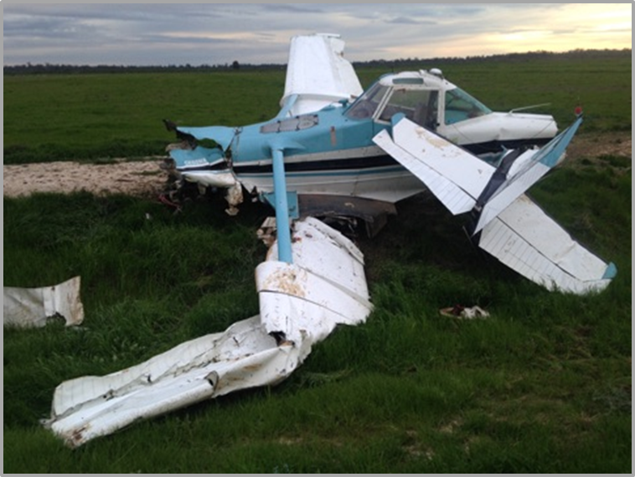
Source: Aircraft owner

Pilot comment
The pilot indicated that the wind was steady throughout the day, 12 to 15 knots gusting to 20 and from a northerly direction.
The pilot commented that the engine was not performing how it had been on the previous 17 flights that day. They also reported that at about 200 ft, there was little time from when the problem was first noticed to when the aircraft landed. The pilot reported expecting an instant response when full power was applied, a change in engine noise, and the aircraft should have gained airspeed and continued flying like had happened on previous turns.
The pilot indicated that the aerodynamic buffet occurs frequently during the spreading of fertiliser and occurs well above an aerodynamic stall. It indicates that the aircraft is getting slow and to ease off the pressure on the control column and increase engine power. The pilot reported that the aircraft maintained an aerodynamic buffet all the way to the ground.
The pilot indicated that the aircraft’s seat restraint was a 4-point harness and that they had locked the inertia reel system for the flight and it had worked well. The pilot was wearing a helmet at the time of the accident.
The aircraft was refuelled the night before the accident at Hay Airport and again from fuel drums about 20 minutes flight time prior to the accident. The pilot completed fuel drains on the aircraft and the drum pump and did not notice any issues. The pilot checked the fuel from the drums after the accident and found no contamination. Another aircraft completed the spreading job the day of the accident and also used the fuel from the drums and had no issues.

Operator comment
The aircraft operator conducted an investigation and identified the following:
The pilot had completed 17 similar flights that day, prior to the accident flight.
During the turn, the pilot allowed the aircraft speed to diminish and they did not have the height to recover.
The aircraft was loaded with about 600 kg fertiliser and about 130 litres of fuel. The aircraft engine and propeller had been modified from a Continental IO-520 engine to a Continental IO-550 engine with a three bladed constant speed propeller.
A licensed aircraft maintenance engineer inspected the engine and no reason was identified for an engine power loss. The engine magnetos and engine carburettor were tested separately and found to be operating normally. As such, the operator believed the engine was still producing full power at the time of the accident. The engine and propeller were extensively damaged by the accident sequence (Figure 3).
Figure 3: BCT damaged propeller
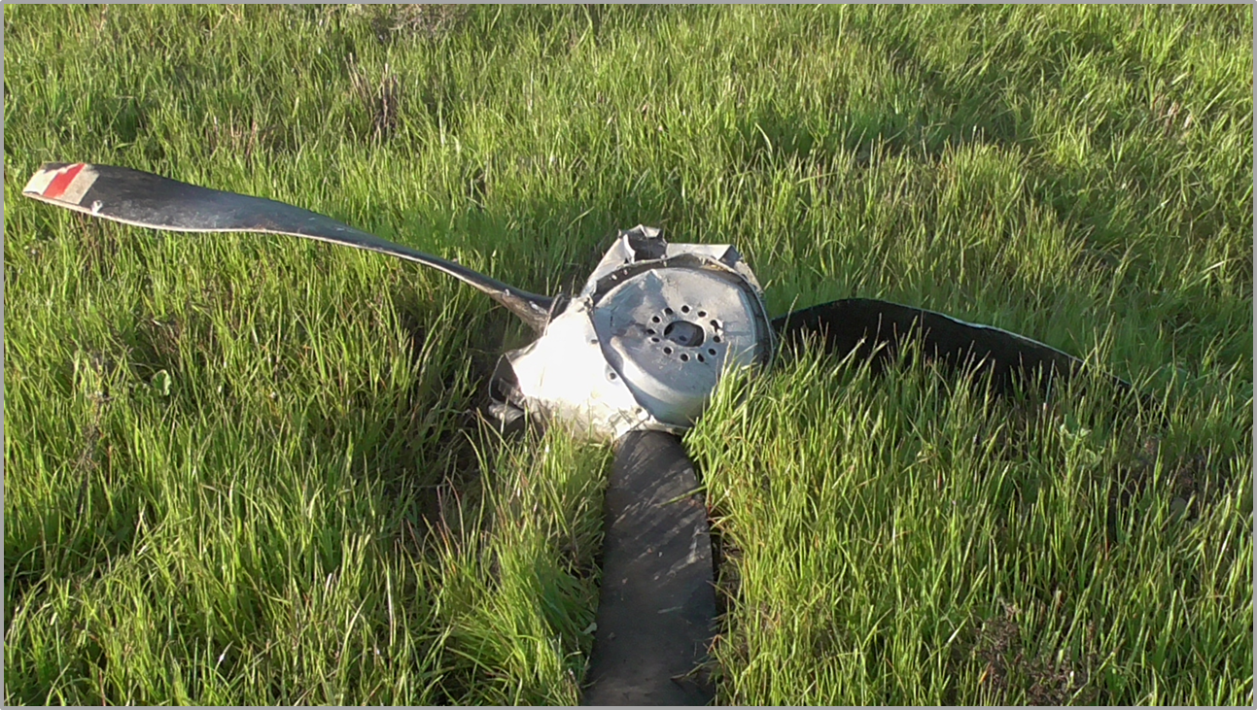
Source: Aircraft owner
The pilot had about 1,927 flight hours in the Cessna 188 conducting top dressing operations. In the last 12 months, the pilot had predominately flown an Air Tractor AT-502 turbo propeller aircraft and more recently had flown about 40 flight hours in the Cessna 188. Unlike the AT-502, there is very little difference between working power and full power in the Cessna 188. This may have resulted in the pilot having an over expectation of the aircraft performance especially when fitted with a spreader.
The aircraft was also fitted with vortex generators that allowed the aircraft to have a lower stall speed than the published stall speed. However, when the stall is reached there is considerable more speed required to resume normal flight and also more height loss to regain that speed at the working height of 150 to 250 ft. With the aircraft fully loaded, the pilot would not have enough height to regain enough speed to recover.
Another company pilot was also flying about 74 km south of the accident site, in a different aircraft type. They experienced down drafts, 20 knot winds, and a downgrade of performance in the downwind turns. With the increase of engine power, the effect of a downwind turn was negated.

Safety analysis
During a turn, the pilot allowed the speed to decrease and the aircraft started a buffet like an approaching aerodynamic stall. The pilot lowered the nose of the aircraft to increase the speed, levelled the wings, selected full engine power and started jettisoning the load. The pilot continued to lower the nose of the aircraft in in an attempted to regain control of the aircraft until it collided with the ground. With the vortex generators, the full load, and the minimal difference between working and full engine power, there was not enough height to recover the aircraft.
Although the pilot believed the aircraft engine was not performing as well as it had in previous flights there was no indications of this before the turn. No problems were identified with the engine after the accident, however, it had been extensively damaged during the accident sequence. The engine’s inability to counteract the effect of the buffeting during the turn (as the aircraft was fully loaded and minimal additional power was available above normal operating power), possibly also influenced by the pilot’s recent experience with a more powerful aircraft, may have influenced this belief.

Findings
These findings should not be read as apportioning blame or liability to any particular organisation or individual.
- During a turn, at a slow speed the aircraft started to buffet like approaching an aerodynamic stall. Due to the vortex generators, full load and insufficient engine power available, there was not enough height for the pilot to regain control of the aircraft before it collided with the ground.

Safety action
Whether or not the ATSB identifies safety issues in the course of an investigation, relevant organisations may proactively initiate safety action in order to reduce their safety risk. The ATSB has been advised of the following proactive safety action in response to this occurrence.

Aircraft operator
As a result of this occurrence, the aircraft operator has advised the ATSB that they are taking the following safety actions:
The pilot has undergone refresher training on the effects of the wind on a downwind turn and flight training in windy conditions with reference to the airspeed and lighter aircraft weights.

Safety message
In this accident, the time available to manage the degradation of the aircraft performance meant that there were little options in regards to a landing area. The accident highlights the importance of taking positive action and maintaining aircraft control in both turning back to the strip or conducting a forced landing, while being aware of flare energy and aircraft stall speeds.

General details

Occurrence details
Date and time: | 9 August 2016 – 1310 EST
Occurrence category: | Accident
Primary occurrence type: | Forced landing
Location: | near Hay Airport, New South Wales,
 | Latitude: 34° 33.88' S | Longitude: 144° 42.12' E

Aircraft details – VH-BCT
Manufacturer and model: | Cessna Aircraft Company A188B
Registration: | VH-BCT
Serial number: | 18803406T
Type of operation: | Aerial work – aerial agriculture
Persons on board: | Crew – 1 | Passengers – 0
Injuries: | Crew – 0 | Passengers – 0
Aircraft damage: | Substantial

Helicopters

Collision with terrain involving Robinson R44, VH-YMJ

What happened
On 12 November 2016, a Robinson R44 helicopter, registered VH-YMJ, departed from a landing site on the Riversleigh Station property for the return leg of a private sight-seeing flight to Adels Grove aircraft landing area (ALA), Queensland. On board the helicopter were the pilot and three passengers.
The pilot used the helicopter to ferry two groups of people from Adels Grove ALA, to a dirt road landing site near a river in the morning for swimming, and then ferried the first group back to Adels Grove after lunch. At about 1420 Eastern Standard Time (EST), the pilot attempted the last planned departure of the day from the landing site for the return flight. The take-off direction followed the road, which was a south-south-east direction. The pilot reported that there were no power performance issues in the hover, but then during the initial climb, at about 100–130 ft above ground level (AGL) and between 15–20 kt airspeed, the helicopter started to experience a loss of performance. The helicopter started to descend and the pilot advised there was insufficient engine power to prevent the descent.
As the helicopter approached the ground, the pilot raised the collective lever to cushion the landing. The right skid of the helicopter landed first, on the side of the road and the left skid landed off the side of the road below the right skid, which resulted in the helicopter rolling onto the left side before coming to rest (Figure 1). One passenger received minor injuries and the helicopter was substantially damaged.
Figure 1: VH-YMJ accident site
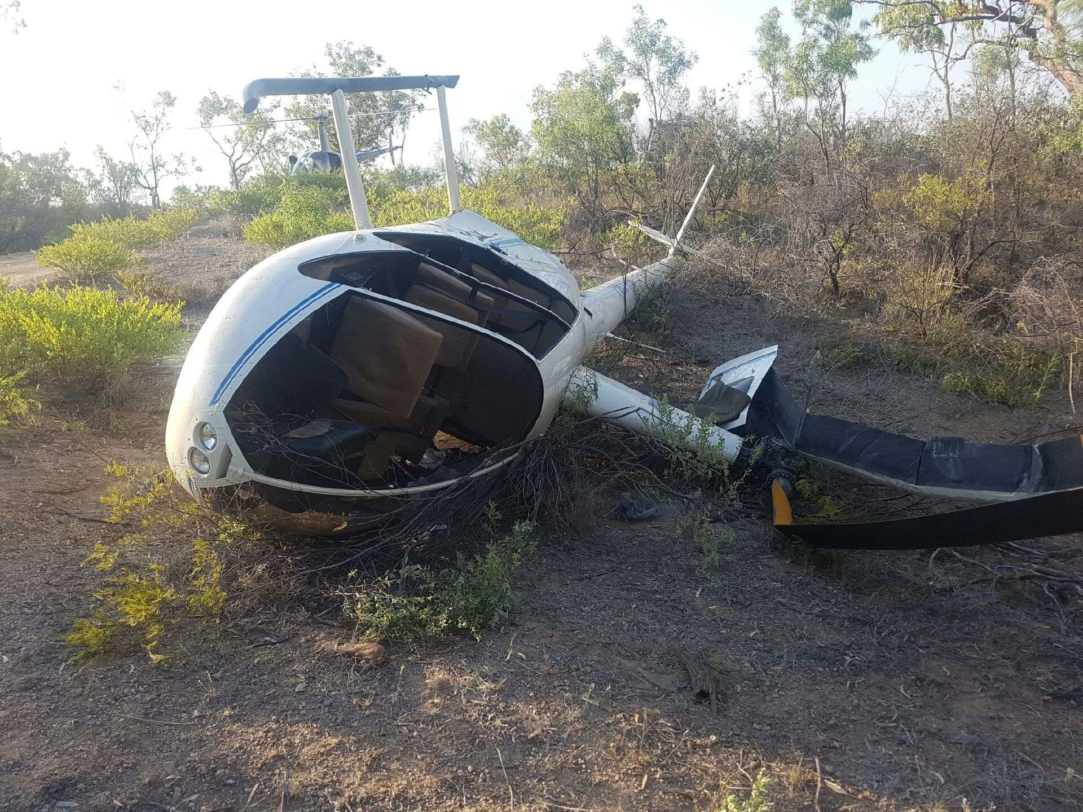
Source: Operator

Terrain and weather conditions
Riversleigh Station is located in the north-west quarter of Queensland, about 200 km south-west of the southern corner of the Gulf of Carpentaria. The countryside along the river in the vicinity of the accident site was described by the pilot as hilly with plateaus and escarpments and tall gumtrees.
The pilot reported that the weather conditions started fine in the morning, but changed late in the morning with a hot wind, which was gusting in strength and varying in direction. Wind strength varied from 0–20 kt, and wind direction varied between south and south-east. The temperature was about 38 °C, the elevation of the landing site was about 430 ft above mean sea level (AMSL), and the QNH was about 1010 hPa. There were also rain showers in the vicinity.

Aircraft performance
The maximum take-off weight (MTOW) published for the Robinson R44 in the rotorcraft flight manual is 1,088 kg. The weights of the occupants and estimated fuel on board at the time of the accident indicate the all-up weight (AUW) of the helicopter was about 1,041 kg. With an estimated elevation of 430 ft, QNH of 1010 hPa and maximum height on take-off of 130 ft, the pressure altitude was about 650 ft when the pilot noticed there was insufficient power to continue the climb. The pilot reported that they started the take-off with about 10 kt of head wind and the helicopter had just passed through translational lift and was at about 15–20 kt before the descent started.
If the wind speed dropped during the initial climb, then the helicopter could have been below translational lift at 100-130 AGL when the descent started. In this case the helicopter would have been in the hover out of ground effect (HOGE) flight regime (Figure 2). At the reported temperature and AUW, this would place the helicopter at the limit of the hover altitude for the power available (point B, Figure 2).
In comparison, the hover in ground effect (HIGE) performance chart indicated the helicopter could maintain a hover at about 4,500 ft pressure altitude at the AUW and 38 °C.

Air density
The power produced by the engine and the lift produced by the helicopter rotors are influenced by air density. Low atmospheric pressure and hot and humid conditions decrease air density. A decrease in air density decreases power available from the engine, but increases the power required for rotor thrust, because a larger angle of attack is required from the rotor blades to produce the same lift.

Tail rotor and demand for power
The helicopter tail rotor is an anti-torque device, which is controlled by the tail rotor pedals to increase or decrease the angle of attack of the tail rotor blades. The engine provides the power for the tail rotor drive. Therefore, an increase in demand for anti-torque ‘bleeds off’ engine power. When the relative wind is directly in front of the nose of the helicopter, the helicopter airframe behaves like a weathervane, holding the nose of the helicopter into the wind and reducing the requirement for anti-torque. However, if the wind strikes the helicopter from the right side, this will increase the demand for left tail rotor pedal to maintain heading, which will bleed off engine power.

Figure 2: R44 HOGE performance
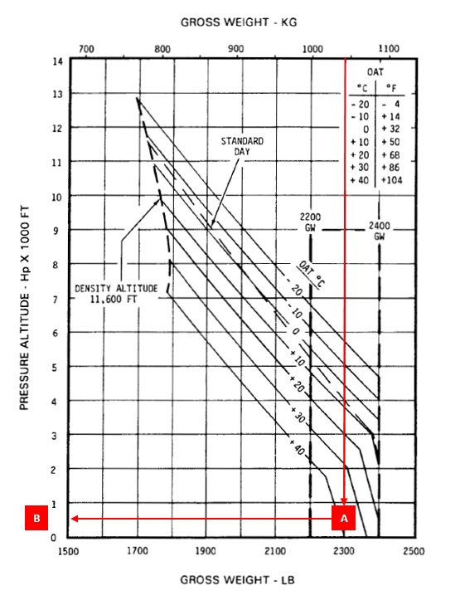
Source: Manufacturer, annotated by ATSB

Previous incidents
Previous ATSB reports of Robinson R44 helicopters descending with insufficient power in low airspeed and low air density (high density altitude) conditions include the following:
- Collision with terrain involving a Robinson R44, VH-HLB (AO-2014-154)
- Collision with terrain involving a Robinson R44, VH-UGC (AO-2013-203)
- Collision with terrain 10 km west of Gunpowder Mine, Qld, 21 February 2006, VH-HBS (200600979)

Safety analysis
The AUW of the aircraft was below the published MTOW and within the published limits for HIGE operations. At the time of take-off, there were no unusual noises or vibrations, the engine was delivering power to the rotors and the rotor speed did not decrease below limits. The pilot estimated they had a 10 kt headwind component, but that the wind was gusting in strength and variable in direction. Therefore, it is likely that the forced landing was the result of insufficient power for the prevailing environmental conditions at the helicopter’s AUW.
Two possible scenarios for insufficient power are a shift in wind direction to the right side of the helicopter or a decrease in head wind strength. In the first scenario, a shift in wind direction to the right would demand more left tail rotor pedal to maintain take-off heading and decrease the power available from the engine for main rotor thrust. In the second scenario, a decrease in wind strength just after translational lift would place the helicopter inside the HOGE flight regime and at the limit for the take-off AUW and temperature.

Findings
These findings should not be read as apportioning blame or liability to any particular organisation or individual.
- The forced landing was the result of power required to continue flight in excess of power available for the take-off AUW, temperature and wind conditions.
- The helicopter was within the published maximum take-off weight limit.

Safety message
This incident highlights the effect of high AUW, high air temperature and gusting wind conditions on the R44 helicopter’s performance. In particular, the combination of high AUW and high air temperature increase the power required and decrease the power available, which can lead to a significant difference between the HIGE and HOGE performance. In addition, the pilot reported that it is important to keep a close eye on changing wind conditions as they had never previously experienced a similar loss of performance.

General details

Occurrence details
Date and time: | 12 November 2016 – 1420 EST
Occurrence category: | Accident
Primary occurrence type: | Collison with terrain
Location: | Near Riversleigh ALA, Queensland
 | Latitude: 18° 58.88’ S | Longitude: 138° 45.32’ E

Aircraft details
Manufacturer and model: | Robinson Helicopter Company
Registration: | VH-YMJ
Serial number: | 2143
Type of operation: | Private – pleasure / travel
Persons on board: | Crew – 1 | Passengers – 3
Injuries: | Crew – 0 | Passengers – 1
Aircraft damage: | Substantial

Ground strike involving Robinson R44, VH-HHZ

What happened
On 18 November 2016, a Robinson R44 helicopter, registered VH-HHZ, was operating to support fire-fighting personnel near Sleisbeck, Northern Territory.
At about 1600 Central Standard Time (CST), the pilot conducted an approach to a landing site they had already landed at twice that day. The landing site was a flat rocky surface, but one side had a slight downwards slope. The pilot confirmed the wind direction from smoke nearby and approached the landing site into wind. As the pilot lowered the collective and the helicopter’s skids touched down, the helicopter started to slide to the right. The pilot attempted to correct the sideways movement, but the main rotor blade struck a rock, and the helicopter started vibrating. The pilot rolled off the throttle and applied right pedal, but the helicopter rotated to the left and the horizontal stabiliser struck a rock. The helicopter sustained substantial damage (Figure 1). The pilot and two passengers were not injured.
Figure 1: Accident site showing damage to VH-HHZ
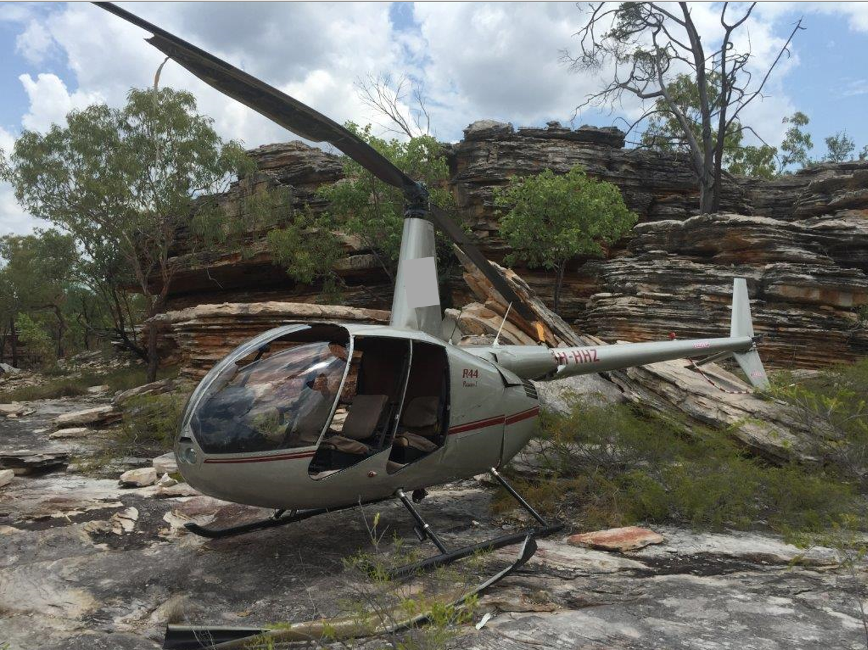
Source: Helicopter operator

Findings
These findings should not be read as apportioning blame or liability to any particular organisation or individual.
- The helicopter landed on a portion of rock, which had a slight downwards slope. The actions taken by the pilot, when the helicopter started to slide, did not prevent the main rotor blades and the horizontal stabiliser from striking a rock.

Safety action
Whether or not the ATSB identifies safety issues in the course of an investigation, relevant organisations may proactively initiate safety action in order to reduce their safety risk. The ATSB has been advised of the following safety action in response to this occurrence.

Helicopter operator
As a result of this occurrence, the helicopter operator has advised the ATSB that they are taking the following safety actions:
The company issued a notice to flight crew emphasising the importance of conducting a thorough aerial assessment before committing to landing at any remote location including confined areas.
The company also reminded pilots that in hot humid conditions, fatigue can occur a lot sooner that during the cooler months. They should make every effort to remain hydrated and inform the chief pilot immediately if they feel adversely affected.

Safety message
Civil Aviation Advisory Publication 92-2(2), Guidelines for the establishment and operation of onshore Helicopter Landing Sites, sets out factors that may be used to assess the suitability of a site for helicopters to land and take off. The guidelines include the recommendation that helicopter operators conduct thorough risk and hazard assessments for a basic helicopter landing site and implement controls to manage identified hazards.

General details

Occurrence details
Date and time: | 18 November 2016 – 1600 CST
Occurrence category: | Accident
Primary occurrence type: | Ground strike
Location: | 74 km NE of Sleisbeck, Northern Territory
 | Latitude: 13° 37.90' S | Longitude: 133° 03.13' E

Helicopter details
Manufacturer and model: | Robinson Helicopter Company R44
Registration: | VH-HHZ
Serial number: | 2087
Type of operation: | Charter – Passenger
Persons on board: | Crew – 1 | Passengers – 2
Injuries: | Crew – 0 | Passengers – 0
Aircraft damage: | Substantial

Separation Issues

Near collision involving Pilatus BN2, VH-IOA, and Bombardier DHC-8, VH-ZZJ

What happened
On 12 October 2016, at about 1330 Eastern Standard Time (EST), a Pilatus BN2A-20, registered VH-IOA (IOA), departed from Kubin on a charter flight to Horn Island, Queensland (Figure 1). On board IOA were one pilot and two passengers. At about the same time, a Bombardier DHC-8-202, registered VH-ZZJ (ZZJ), conducting surveillance operations, was preparing for departure from Horn Island. On board ZZJ were two pilots and three crewmembers.
Figure 1: IOA track from Kubin to Horn Island
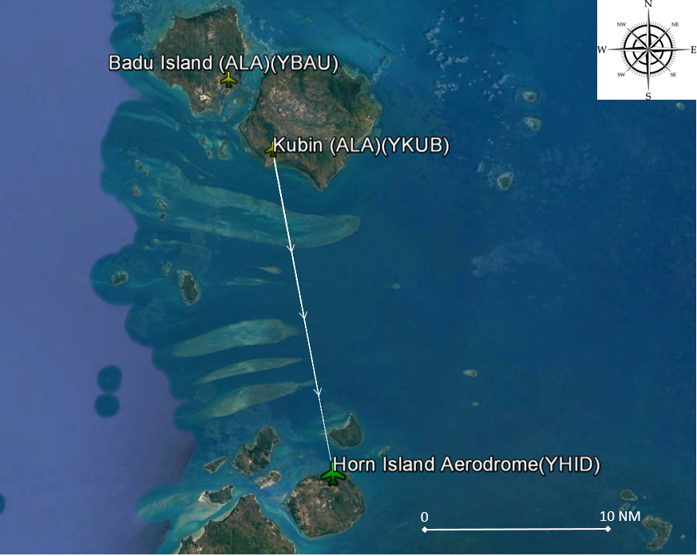
Source: Google earth, annotated by ATSB
The Kubin authorised landing area (ALA) is within the Horn Island broadcast zone, and the pilot of IOA reported that they made their departure call on the Horn Island common traffic advisory frequency (CTAF). At the time IOA departed from Kubin, a faster company aircraft, registered VH-WOT (WOT), departed from Badu Island (Figure 1) on track to Horn Island. In addition to WOT, there was a training aircraft conducting circuits on runway 08 at Horn Island. While tracking to Horn Island, the pilot flying IOA heard a radio broadcast from WOT, which indicated they would join the runway 08 circuit as number 2 to the training aircraft. The area controller then passed IOA traffic information about a DHC-8 (ZZJ) aircraft taxiing at Horn Island for departure from runway 08. The pilot flying IOA planned to join a straight-in approach to runway 14 from their track from Kubin. The pilot reported that they made all the required radio broadcasts for an arrival to Horn Island including broadcasts at 10 NM, 5 NM and 3 NM before they joined the final approach for runway 14.
The first officer on board ZZJ made a broadcast they were entering and backtracking runway 14 at Horn Island for a departure from runway 08 (position 1 on Figure 2). Just prior to the intersection of the two runways, ZZJ held short of runway 08 to allow the training aircraft to complete a touch-and-go landing on runway 08. The first officer then broadcast ZZJ was entering and backtracking runway 08. While backtracking runway 08 (position 2 on Figure 2), ZZJ’s flight crew heard a broadcast that WOT was joining the circuit as number 2 to the training aircraft and then observed a third aircraft appear on their traffic collision avoidance system (TCAS) display. The captain of ZZJ asked the first officer to contact the third unknown aircraft.
When the pilot flying IOA heard a broadcast from ZZJ, which indicated it was directed at them, they responded that they were approaching a 3 NM final for runway 14 and ZZJ would have time to depart from runway 08 if they were quick. At about this time, ZZJ was approaching the threshold of runway 08. The captain lined ZZJ up for departure and the crew completed their pre-take-off checklist items (three items). At about this time, another two aircraft, 20 NM away from Horn Island, started communicating with each other on the Horn Island CTAF.
By the time the pilot flying IOA heard ZZJ broadcast ‘rolling for departure from runway 08’, IOA was at about 400 ft on final approach for runway 14. The pilot of IOA reported that at about 300 ft, they broadcast ‘hold short’ to ZZJ. However, the captain of ZZJ reported they heard the pilot of IOA say ‘land and hold short of runway 08’. Consequently, ZZJ continued their take-off. As IOA approached 100–150 ft on final approach, ZZJ had not crossed the runway intersection and the pilot flying IOA conducted a left climbing turn away from the runways to join the downwind circuit leg for runway 08. The captain of ZZJ looked out their left window when they were in the initial climb overhead the threshold of runway 26 and saw IOA turning through east at about the same level (position 4 on Figure 2). IOA then joined the circuit for runway 08 and landed after WOT without further incident.
Figure 2: Sequence of movements
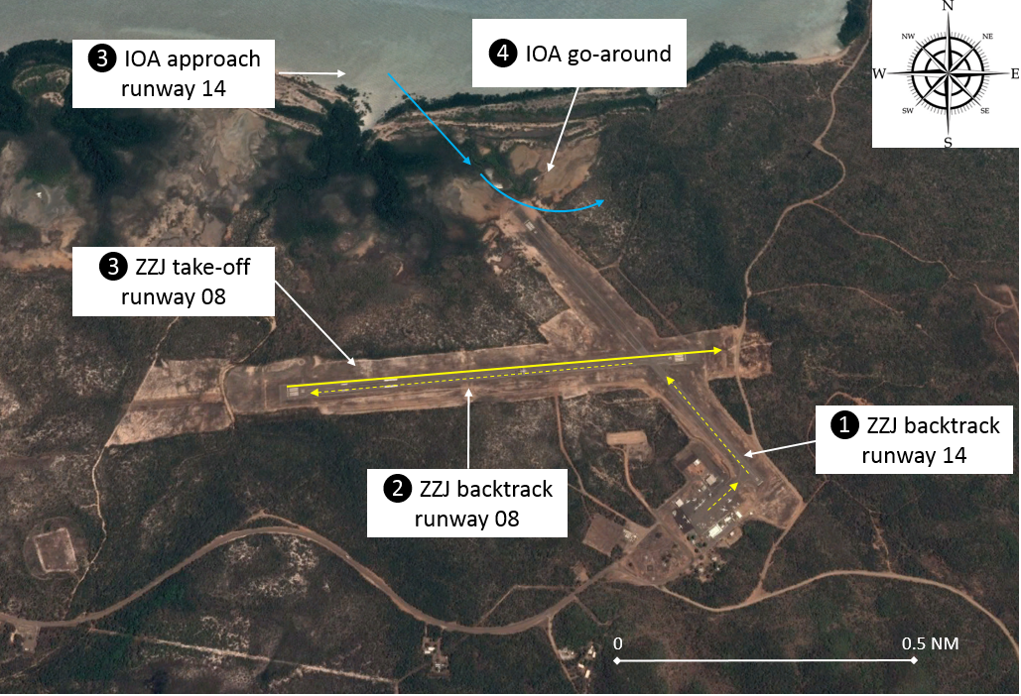
Source: Google earth, annotated by ATSB

Horn Island Airport and CTAF
The Horn Island Airport is located at the northern end of Cape York Peninsula. The airport acts as the hub for access to the outer islands in the Torres Strait. Mainland services fly into Horn Island and passengers are then transferred onto the local operators’ smaller aeroplanes and helicopters for transfer to and from the outer islands. Runway 08/26 is the main runway and runway 14/32 is shorter and narrower. Smaller aircraft, such as IOA, operate to both runways, but larger aircraft, such as ZZJ, restrict their operations to runway 08/26.
The airport apron is located adjacent to the threshold of runway 32 and there are no taxiways to separate ground movements from aircraft taking off and landing. There is also higher terrain located to the south east of the airport, which has resulted in the following additional restrictions to airport movements published in the Horn Island aerodrome chart:
Take-off runway 14 and landing runway 32 not permitted due terrain.
Consequently, the smaller local aeroplane operators’ have adopted the local practice of departing from runway 08 and landing on runway 14, weather conditions permitting.
The CTAF boundary extends laterally to 40 NM from Horn Island, which encapsulates the outer islands, and vertically from the surface to 8,500 ft.

ZZJ TCAS settings
The flight crew on board ZZJ had their TCAS set to the 12 NM range scale while backtracking runway 08. The captain reported that they could have improved their picture of the relative bearing and distance of IOA if they reduced the scale to 6 NM while backtracking runway 08. However, their normal procedure is to set the 6 NM range scale for controlled airspace and set the 12 NM range scale for departure from a non-controlled aerodrome to improve situational awareness of inbound traffic.

Right of way provision
Civil Aviation Regulation (CAR) 162 lists the rules for prevention of collision. CAR 162 paragraph 8 states:
An aircraft that is about to take-off shall not attempt to do so until there is no apparent risk of collision with other aircraft.
The captain of ZZJ reported that they relied too heavily on their TCAS and did not place sufficient importance on the ‘see’ element within the ‘see-and-avoid’ philosophy of operations at non-controlled aerodromes. Consequently, they started their take-off before sighting IOA.

Safety analysis
Prior to the near collision event, the flight crew of both aircraft were aware of the presence of the other aircraft and their approximate position. When ZZJ was backtracking runway 08, the captain was conscious of the fact that they were occupying the main runway that was being used by other aircraft in the circuit.
The broadcast from IOA, that ZZJ could depart before IOA landed, supported the motivation of the captain of ZZJ to avoid delaying their departure from runway 08. The captain of ZZJ also relied on an approximate position of IOA from their TCAS when they elected to take-off. However, as reported by the captain, the range scale set on the TCAS was 12 NM, where a 6 NM range scale could have provided a more accurate picture of the relative position of IOA.
During the take-off, the flight crew probably also misheard the broadcast from the pilot in IOA, to hold short of runway 14, and therefore did not reject the take-off. However, it was not determined if the radio broadcast was before or after ZZJ reached their decision speed (V1) to safely reject the take-off.

Findings
These findings should not be read as apportioning blame or liability to any particular organisation or individual.
- The captain of ZZJ was motivated to expedite their departure from the main runway, which in conjunction with the broadcast from IOA that they had time to take-off before IOA landed, contributed to them starting their take-off before they sighted IOA.
- The flight crew probably misheard the broadcast from the pilot of IOA to hold short of runway 14 and did not reject the take-off.
- IOA and ZZJ made the required CTAF broadcasts and were aware of the approximate position of each other prior to the near collision event.
- Concurrent operations to different runways at Horn Island is a normal local practice, which is employed to facilitate traffic movements.

ATSB comment
The ATSB notes that the horizontal and vertical dimensions for standard CTAF boundaries are published in the Aeronautical Information Publication (AIP). However, the dimensions for non-standard CTAF boundaries are currently only published in the Enroute Supplement Chart LOW.

Safety message
This serious incident highlights that pilots and operators need to consider how best to employ and integrate the sources of information available to them in order to develop an accurate mental model of a potential traffic threat. In the ‘see-and-avoid’ environment, radio broadcasts and TCAS information can be used to hone the visual scan to sight other traffic, which might pose a threat.

The ATSB SafetyWatch highlights the broad safety concerns that come out of our investigation findings and from the occurrence data reported to us by industry.
Further information on safety around non-controlled aerodromes is available from the ATSB website.
Further information on operations at non-controlled aerodromes is available from the Civil Aviation Safety Authority’s website.

General details

Occurrence details
Date and time: | 12 October 2016 – 1347 EST
Occurrence category: | Serious incident
Primary occurrence type: | Near collision
Location: | Horn Island Aerodrome, Queensland
 | Latitude: 10° 35.18’ S | Longitude: 142° 17.40’ E

Aircraft details – VH-IOA
Manufacturer and model: | Pilatus Britten-Norman LTD BN2A-20
Registration: | VH-IOA
Operator: | McGilvray Aviation PTY LTD (Cape Air Transport)
Serial number: | 842
Type of operation: | Charter - passenger
Persons on board: | Crew – 1 | Passengers – 2
Injuries: | Crew – 0 | Passengers – 0
Aircraft damage: | Nil

Aircraft details – VH-ZZJ
Manufacturer and model: | Bombardier Incorporated DHC-8-202
Registration: | VH-ZZJ
Operator: | Surveillance Australia PTY LTD (Cobham Aviation Services)
Serial number: | 551
Type of operation: | Aerial work – survey / photographic
Persons on board: | Crew – 5 | Passengers – 0
Injuries: | Crew – 0 | Passengers – 0
Aircraft damage: | Nil

Remotely Piloted Aircraft

Collision with terrain involving Lockheed Martin Stalker XE UAS

What happened
On 25 October 2016, an instructor was supervising students in the operation of a Lockheed Martin Stalker eXtended Endurance (XE) unmanned aerial system (UAS) (Figure 1) at the Avoca race track in Victoria.
Figure 1: Typical Stalker XE aircraft
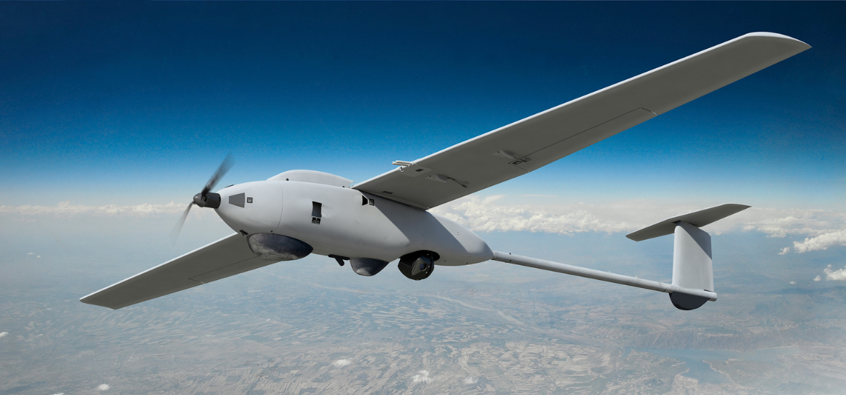
Source: UAS manufacturer
At about 1700 Eastern Daylight-saving Time (EDT), the instructor reviewed the student’s programmed mission and proceeded through the ground control station (GCS) launch wizard application. The launch wizard functions as a pre-flight checklist and ensures that all systems are ready for flight and that the mission is valid. The student then armed the aircraft for launch, pulled the aircraft back on the bungee cord and released the aircraft in accordance with the normal bungee launch procedures.
After release, the aircraft tracked straight ahead for 10 seconds according to standard operation, then climbed and commenced a right turn towards the first programmed waypoint. After passing the first waypoint, the aircraft made another right turn towards the second waypoint. About 20 seconds into the flight, the aircraft entered an uncontrolled descent from about 225 ft above ground level, and collided with the ground. The aircraft sustained substantial damage and no one was injured.

Manufacturer’s investigation

Power failure
The aircraft was powered by a lithium polymer battery. A battery adapter cable was plugged into the aircraft’s battery. The adapter cable was connected to the aircraft’s main power cable via the main power (battery) connector. The main power cable was secured into a pocket at the back of the connector pin.
After the accident, the aircraft’s negative main power cable was found to have separated from its pin in the connector.
The battery connector consisted of two mating pairs of contacts. In normal operation, all current flow passed through spring contacts on the male plug to the female contact. Spring tension increased the mating area and generated pressure upon the surfaces.
A different Stalker XE aircraft also experienced a battery connector failure about one month prior to this incident. In both incidents, the failed battery connector pins had the following problems:
- significant pitting and erosion of the outer quarter of the male contact
- heat damage to the spring contact surface
- loss of spring tension in most or all of the contact springs
- minor pitting of the outermost edge of the female contact.
It was determined that the capacitive load of the electrical system caused inrush current, and the operator payload and communication links increased both the capacitive load and the power draw. The contact damage from the inrush current initiated the failure process. Sustained current, which produced contact heating, then removed the contact temper and significantly degraded the connection. The manufacturer was able to duplicate the unsoldering failures via this mechanism.
The connector failure was likely the result of multiple factors:
- Inrush current produced pitting, erosion and metal splatter on other contact surfaces.
- The erosion and splatter then produced localised areas of very high current density.
- The current density resulted in localised hotspots that removed the spring contact temper, which produced very high resistance on that spring contact.
- The load was then distributed across the remaining spring contacts, compounding the failure rate.
- Eventually the connector resistance was high enough that the normal operating current heated the solder joint until the solder melted and the circuit was interrupted.
The first steps probably took many flight cycles to develop, while the last probably required only seconds to a few minutes of normal operating current.
The separation of the negative main power cable from its pin in the main power connector interrupted electrical power to all of the aircraft systems. This included the autopilot, motor and control surface servos.

Uncontrolled flight
The flight data stopped suddenly at 225 ft – the subsequent lack of data logging indicated a power interruption to the autopilot.
Once battery power was lost, all systems in the aircraft were inoperative and any subsequent ‘flight’ was uncontrolled. Due to the loss of electrical power to the motor and the autopilot, the aircraft was unable to glide to a safe landing.

Findings
These findings should not be read as apportioning blame or liability to any particular organisation or individual.
- The main power connector pins had sustained degradation from arcing and high temperatures due to inrush current, resulting in increased resistance.
- During the initial climb, high current across the increased resistance of the main power connector heated the negative pin to a temperature high enough to melt the solder on the negative main power cable.
- The separation of the negative main power cable from its pin in the main power connector interrupted electrical power to all aircraft systems, including the autopilot, motor and control surface servos.
- Due to the total loss of electrical power, the aircraft was unable to maintain normal flight or conduct a safe glide landing, therefore collided with the ground.

Safety action
Whether or not the ATSB identifies safety issues in the course of an investigation, relevant organisations may proactively initiate safety action in order to reduce their safety risk. The ATSB has been advised of the following safety action in response to this occurrence.

Aircraft manufacturer
As a result of this occurrence, the aircraft manufacturer has advised the ATSB that they are taking the following safety actions with regard to Stalker XE aircraft:
- All battery connectors are being replaced and sacrificial pigtails are being added to the connectors, to be replaced after a number of connections.
- The aircraft battery circuitry is being modified to prevent arcing during connection and disconnection.

General details

Occurrence details
Date and time: | 25 October 2016 – 1658 EDT
Occurrence category: | Accident
Primary occurrence type: | Collision with terrain
Location: | Avoca race track, Victoria
 | Latitude: 37° 05.28' S | Longitude: 143° 26.18' E

Aircraft details
Manufacturer and model: | Lockheed Martin Stalker XE
Serial number: | 241
Type of operation: | Aerial work – check & training
Aircraft damage: | Substantial

Australian Transport Safety Bureau
The Australian Transport Safety Bureau (ATSB) is an independent Commonwealth Government statutory agency. The Bureau is governed by a Commission and is entirely separate from transport regulators, policy makers and service providers. The ATSB’s function is to improve safety and public confidence in the aviation, marine and rail modes of transport through excellence in: independent investigation of transport accidents and other safety occurrences; safety data recording, analysis and research; fostering safety awareness, knowledge and action.
The ATSB is responsible for investigating accidents and other transport safety matters involving civil aviation, marine and rail operations in Australia that fall within Commonwealth jurisdiction, as well as participating in overseas investigations involving Australian registered aircraft and ships. A primary concern is the safety of commercial transport, with particular regard to fare-paying passenger operations.
The ATSB performs its functions in accordance with the provisions of the Transport Safety Investigation Act 2003 and Regulations and, where applicable, relevant international agreements.

Purpose of safety investigations
The object of a safety investigation is to identify and reduce safety-related risk. ATSB investigations determine and communicate the safety factors related to the transport safety matter being investigated. The terms the ATSB uses to refer to key safety and risk concepts are set out in the next section: Terminology Used in this Report.
It is not a function of the ATSB to apportion blame or determine liability. At the same time, an investigation report must include factual material of sufficient weight to support the analysis and findings. At all times the ATSB endeavours to balance the use of material that could imply adverse comment with the need to properly explain what happened, and why, in a fair and unbiased manner.

About this Bulletin
The ATSB receives around 15,000 notifications of Aviation occurrences each year, 8,000 of which are accidents, serious incidents and incidents. It also receives a lesser number of similar occurrences in the Rail and Marine transport sectors. It is from the information provided in these notifications that the ATSB makes a decision on whether or not to investigate. While some further information is sought in some cases to assist in making those decisions, resource constraints dictate that a significant amount of professional judgement is needed to be exercised.
There are times when more detailed information about the circumstances of the occurrence allows the ATSB to make a more informed decision both about whether to investigate at all and, if so, what necessary resources are required (investigation level). In addition, further publically available information on accidents and serious incidents increases safety awareness in the industry and enables improved research activities and analysis of safety trends, leading to more targeted safety education.
The Short Investigation Team gathers additional factual information on aviation accidents and serious incidents (with the exception of 'high risk operations), and similar Rail and Marine occurrences, where the initial decision has been not to commence a 'full' (level 1 to 4) investigation.
The primary objective of the team is to undertake limited-scope, fact gathering investigations, which result in a short summary report. The summary report is a compilation of the information the ATSB has gathered, sourced from individuals or organisations involved in the occurrences, on the circumstances surrounding the occurrence and what safety action may have been taken or identified as a result of the occurrence.
These reports are released publically. In the aviation transport context, the reports are released periodically in a Bulletin format.
Conducting these Short investigations has a number of benefits:
- Publication of the circumstances surrounding a larger number of occurrences enables greater industry awareness of potential safety issues and possible safety action.
- The additional information gathered results in a richer source of information for research and statistical analysis purposes that can be used both by ATSB research staff as well as other stakeholders, including the portfolio agencies and research institutions.
- Reviewing the additional information serves as a screening process to allow decisions to be made about whether a full investigation is warranted. This addresses the issue of 'not knowing what we don't know' and ensures that the ATSB does not miss opportunities to identify safety issues and facilitate safety action.
- In cases where the initial decision was to conduct a full investigation, but which, after the preliminary evidence collection and review phase, later suggested that further resources are not warranted, the investigation may be finalised with a short factual report.
- It assists Australia to more fully comply with its obligations under ICAO Annex 13 to investigate all aviation accidents and serious incidents.
- Publicises Safety Messages aimed at improving awareness of issues and good safety practices to both the transport industries and the travelling public.

Pushback is a procedure during which an aircraft is pushed back, away from an airport gate or bay, by an external tug.
The nose gear bypass pin is installed during the pushback sequence to bypass the normal aircraft steering, allowing the tug to control aircraft steering.
PAN PAN: an internationally recognised radio call announcing an urgency condition which concerns the safety of an aircraft or its occupants but where the flight crew does not require immediate assistance.
Pilot Flying (PF) and Pilot Monitoring (PM): procedurally assigned roles with specifically assigned duties at specific stages of a flight. The PF does most of the flying, except in defined circumstances; such as planning for descent, approach and landing. The PM carries out support duties and monitors the PF’s actions and the aircraft’s flight path.
Flight level: at altitudes above 10,000 ft in Australia, an aircraft’s height above mean sea level is referred to as a flight level (FL). FL 170 equates to 17,000 ft.
Yawing: the motion of an aircraft about its vertical or normal axis.
Feathering: the rotation of propeller blades to an edge-on angle to the airflow to minimise aircraft drag following an in-flight engine failure or shutdown.
PAN PAN: an internationally recognised radio call announcing an urgency condition which concerns the safety of an aircraft or its occupants but where the flight crew does not require immediate assistance.
SOAP is a method to test the health of engines by performing laboratory testing of the engine oil. A sample of oil showing an increase in parts per million of iron material could be a warning of impending failure. The chemical composition of any metal particles in the oil sample is compared to various engine parts to detect the location of abnormal wear.
A chip detector is a device, often a permanent magnet, for gathering metal chips from the engine oil to provide early warning of an impending failure. A magnetic drain plug is a removable chip detector.
An airways clearance authorises a flight to operate in controlled airspace along a designated track or route at a specified level to a specified point or flight planned destination (AIP ENR 1.1-2 para 3.6).
https://www.atsb.gov.au/publications/investigation_reports/2007/aair/ao-2007-064/
https://www.atsb.gov.au/publications/investigation_reports/2009/aair/ao-2009-007/
Cessna 208 aeroplanes are powered by a single turboprop engine.
Rotation: the positive, nose-up, movement of an aircraft about the lateral (pitch) axis immediately before becoming airborne.
PAN: an internationally recognised radio call announcing an urgency condition which concerns the safety of an aircraft or its occupants but where the flight crew does not require immediate assistance.
Feathering: the rotation of propeller blades to an edge-on angle to the airflow to minimise aircraft drag following an in-flight engine failure or shutdown.
MAYDAY: an internationally recognised radio call announcing a distress condition where an aircraft or its occupants are being threatened by serious and/or imminent danger and the flight crew require immediate assistance.
Aerodynamic stall occurs when airflow separates from the wing’s upper surface and becomes turbulent and results in reduced lift. The stall is preceded by a mild, aerodynamic buffet, which increases in intensity as the stall is approached.
The damage to a propeller alone cannot accurately quantify the power produced by an engine. There are many inconsistencies in the way propellers bend and twist under impact loads. Some variables include terrain type and surface, angle and speed of the aircraft at impact (Manual of aircraft accident and incident investigation Part III — Investigation ICAO Doc 9756-AN/965, is available from the US Naval Safety Centre website).
Vortex generators re-energise the airflow over an aerofoil. They are usually placed where the airflow starts to lose laminar flow and becomes turbulent. The result is that airflow sticks to the wing better, permitting flight at lower airspeeds with improved control authority if installed and maintained correctly Civil Aviation Safety Authority (CASA) AWB 02-056 Issue 1 - Vortex Generators and Aerodynamic Configuration Control for Small Single and Twin Engined Aircraft, is available from the CASA website.
Collective: a primary helicopter flight control that simultaneously affects the pitch of all blades of a lifting rotor. Collective input is the main control for vertical velocity.
QNH: the altimeter barometric pressure subscale setting used to indicate the height above mean seal level.
Translational lift is additional lift gained from induced airflow through the main rotors gained from forward airspeed. It reduces the power required for rotor thrust and becomes noticeable as the helicopter experiences about 12–14 kt of airspeed.
Out of ground effect: helicopters require less power to hover when in ‘ground effect’ then when out of ‘ground effect’ due to the cushioning effect created by the main rotor downwash striking the ground. The height of ‘ground effect’ is usually defined as more than one main rotor diameter above the surface. This is 33 ft for the R44.
Standard atmospheric pressure is 1013 hPa.
Angle of attack is the angle between the rotor blade chord line and resultant relative wind. A larger angle of attack produces more drag and therefore requires more engine power.
Collective: a primary helicopter flight control that simultaneously affects the pitch of all blades of a lifting rotor. Collective input is the main control for vertical velocity.
IOA and ZZJ were both operating under instrument flight rules, which is why IOA received traffic information on ZZJ while operating outside controlled airspace.
Horn Island Airport experienced a temporary loss of power on the day of the incident. None of the transmissions from the incident aircraft were captured on the available CTAF recorded data.
Inrush current, input surge current or switch-on surge is the maximum, instantaneous input current drawn by an electrical device when first turned on (Wikipedia).
Tempering involves heating steel to a specific temperature to achieve certain properties such as hardness and elasticity and to remove brittleness.

