
ATSB Transport Safety Report
Aviation Short Investigations
AB-2016-068
Final – 27 July 2016

Aviation Short Investigations Bulletin
Issue 49

Released in accordance with section 25 of the Transport Safety Investigation Act 2003

Publishing information

Published by: Australian Transport Safety Bureau
Postal address: PO Box 967, Civic Square ACT 2608
Office: 62 Northbourne Avenue Canberra, Australian Capital Territory 2601
Telephone: 1800 020 616, from overseas +61 2 6257 4150 (24 hours)
Accident and incident notification: 1800 011 034 (24 hours)
Facsimile: 02 6247 3117, from overseas +61 2 6247 3117
Email: atsbinfo@atsb.gov.au
Internet: www.atsb.gov.au

© Commonwealth of Australia 2016



Ownership of intellectual property rights in this publication
Unless otherwise noted, copyright (and any other intellectual property rights, if any) in this publication is owned by the Commonwealth of Australia.

Creative Commons licence
With the exception of the Coat of Arms, ATSB logo, and photos and graphics in which a third party holds copyright, this publication is licensed under a Creative Commons Attribution 3.0 Australia licence.

Creative Commons Attribution 3.0 Australia Licence is a standard form license agreement that allows you to copy, distribute, transmit and adapt this publication provided that you attribute the work.

The ATSB’s preference is that you attribute this publication (and any material sourced from it) using the following wording: Source: Australian Transport Safety Bureau

Copyright in material obtained from other agencies, private individuals or organisations, belongs to those agencies, individuals or organisations. Where you want to use their material you will need to contact them directly.

Contents
Jet aircraft
Fumes event involving Airbus A320, VH-VNO 2
Turboprop aircraft
Flight below minimum permitted altitude involving Cessna 441, VH-EQU 6
Near collision between Fairchild SA227, VH-MYI and Cessna 150, VH-RZP 10
Engine fire involving a Fairchild SA227, VH-UZI 17
Piston aircraft
Engine failure involving Jabiru J430, VH-SZQ 22
Birdstrike involving Glasair Sportsman GS-2, N666GM 29
Engine malfunction and collision with terrain involving Piper PA-23, VH-BIQ 33
Loss of control and collision with terrain involving Cessna 182S, VH-PCO 36
VFR into IMC involving Piper PA-28, VH-BDB 40
Helicopters
Collision with terrain involving Robinson R22, VH-RGY 46

Jet aircraft

Fumes event involving Airbus A320, VH-VNO

What happened
On 1 March 2016, at 0640 Eastern Standard Time, a Tiger Airways Airbus A320 aircraft, registered VH-VNO (Figure 1), departed Brisbane, Queensland, on a scheduled passenger service to Melbourne, Victoria. On board were the captain, the first officer, four cabin crew members, and 63 passengers.
Figure 1: Tiger Airways Airbus A320, VH-VNO
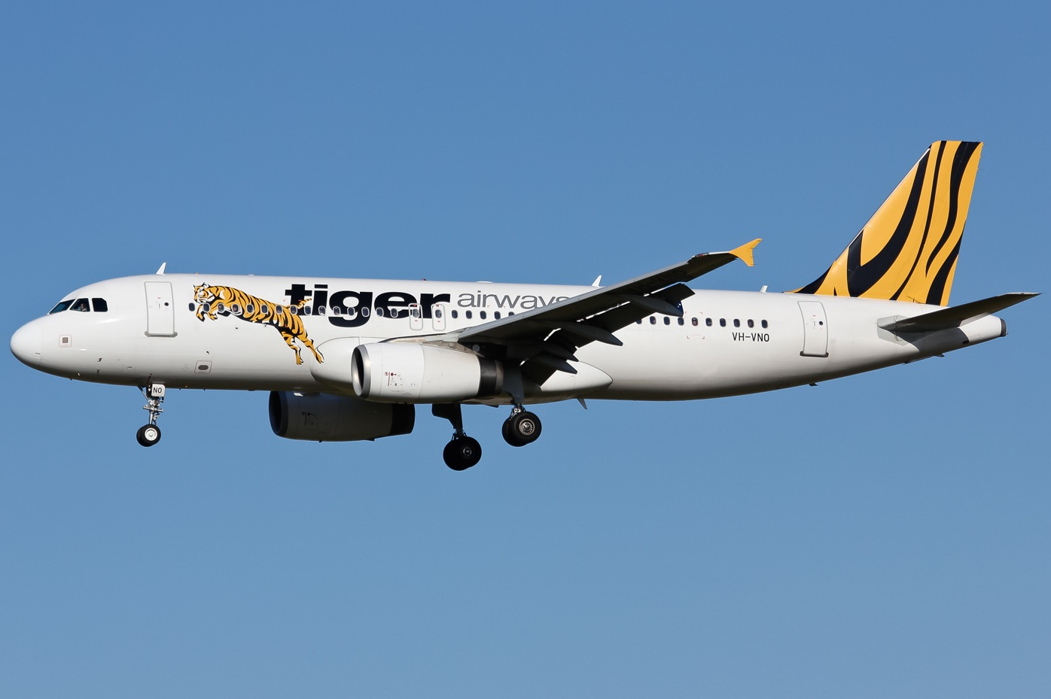
Source: Victor Pody
At about 0900 Eastern Daylight-saving Time (EDT), when the aircraft was abeam Parkes, New South Wales, the cabin crew detected a strong odour in the rear of the cabin, and notified the captain. The cabin crew were unsure what the smell was, but they later described it as being like that of an extinguished cigarette. The odour dissipated soon after. About 10 minutes later, it returned and the cabin crew again advised the flight crew.
The cabin crew conducted their normal procedures in response to fumes in the cabin. This included filling bins with water to quench any possible fire, and checking lavatories, galley and the rear of the cabin in an attempt to find the source of the fumes. They also assessed whether there was any evidence of heat or fire.
As the cabin crew were unable to locate the source of the fumes or to find any heat source, the captain further asked them to check the overhead lockers and the floor above the cargo hold. They were still unable to find the source.
In accordance with standard operations with fewer than 115 passengers on board, the flight crew had the cabin air on the low flow setting. In the absence of smoke, they elected to set the airflow to high and see if that removed the odour from the aircraft. The fumes subsequently subsided.
At 0933 EDT, the aircraft was about 211 km north of Melbourne, at flight level 320. The flight crew had been cleared by air traffic control (ATC) to commence their descent for Melbourne. At that time, the cabin manager advised the captain that the fumes had returned and the odour was very strong. They also advised that three cabin crew members were feeling unwell, and that one had vomited.
The captain and first officer then reviewed the situation. They assessed that due to the cabin crew becoming ill, and the source of the fumes still unknown, they would contact ATC, declare a PAN, and request direct tracking to Melbourne. The crew also requested radar vectoring to reduce the workload required to reprogram the flight management system from the previously cleared route already entered into the system.
The cabin manager then advised the captain that the odour was still very strong. The captain recommended that all passengers be moved forwards away from the odour, which was at the rear of the cabin. The captain advised the cabin manager that they had declared an emergency and requested a direct track to Melbourne, and switched the seatbelt sign on.
The air traffic controller asked how many people were unwell and would require ambulance on arrival. The captain discussed with the cabin manager before responding that three cabin crew members and no passengers were unwell. The captain advised the passengers that fire vehicles and ambulance would be present for their arrival at Melbourne Airport.
During the approach, the captain advised ATC that they expected to conduct a normal landing and taxi clear of the runway via a high-speed taxiway. They would then stop and evaluate whether they would continue to taxi to the bay or whether an evacuation of the aircraft would be necessary.
To allow ease of access by emergency vehicles, the control of all runways had been handed from the tower controller to the surface movement controller. Aircraft movements were temporarily suspended, therefore no other aircraft were cleared to take-off or land at the airport. The aircraft landed at 0958 EDT.
The captain had directed the cabin manager to check the rear of the cabin after the aircraft taxied clear of the runway, and advise whether the odour was still there. The cabin manager reported that it was not. The captain then spoke to the commander of the aviation rescue and firefighting service, advised that they would continue to taxi to the bay, and requested that they follow the aircraft. The captain then requested a clearance from ATC to taxi to the bay. The captain also advised the passengers of the situation.
Once parked at the bay, the flight crew elected not to start the auxiliary power unit because they had been unable to determine the source of the fumes or to exclude any potential fire hazard. The captain advised the cabin crew and passengers that the cabin would go dark and the emergency lighting would come on. After shutting the engines down, the captain advised the fire commander that other than sick members of the cabin crew, everything was normal. The captain then left the cockpit to address the passengers, who disembarked normally. The fire crew did not find any source of fumes or fire, nor did a subsequent engineering inspection reveal the source.

Safety message
This incident demonstrates effective crew resource management techniques to deal with an abnormal and evolving situation.
In the event of smoke or fire, the emergency procedures are clear, time is of the essence, and a MAYDAY call is required. In this incident, however, the seriousness of the situation, the source of the fumes, and the potential risk of the situation, was difficult to assess. The crew’s decision to declare a PAN enabled air traffic control to provide assistance, without the immediacy that would have been required in the case of smoke or fire. As the situation unfolded, the flight crew continued to assess their options based on the information available. They made contingency plans in case things escalated or worsened, such as identifying the nearest airport for an emergency landing if required.
The third time the cabin crew reported the odour, and also became unwell, the flight crew had commenced descent, and the workload was very high. The flight crew demonstrated effective decision making and prioritisation based on the information available and the situtation at hand. Throughout the approach to Melbourne, the flight crew communicated with each other, the cabin crew, the passengers, and air traffic control, which kept all parties informed and allowed appropriate assistance to be given.

General details

Occurrence details
Date and time: | 1 March 2016 – 0933 EDT
Occurrence category: | Incident
Primary occurrence type: | Fumes
Location: | 211 km N Melbourne Airport, Victoria
 | Latitude: 35° 48.55' S | Longitude: 145° 18.52' E

Aircraft details
Manufacturer and model: | Airbus A320
Registration: | VH-VNO
Operator: | Tiger Airways
Serial number: | 4053
Type of operation: | Air transport high capacity – Passenger
Persons on board: | Crew – 6 | Passengers – 63
Injuries: | Crew – 0 | Passengers – 0
Aircraft damage: | Nil

Turboprop aircraft

Flight below minimum permitted altitude involving Cessna 441, VH-EQU

What happened
On 3 August 2015 at about 0410 Eastern Standard Time (EST), a Cessna 441 aircraft, registered VH-EQU, departed Scone Airport for a positioning flight to Illawarra Regional Airport (Wollongong Airport), New South Wales. The flight was to be conducted as a multi-crew operation with the pilot flying (PF) occupying the left seat, and the pilot monitoring (PM) occupying the right seat.
Prior to departure, the pilots conducted a pre-flight briefing noting that the weather forecast for the Wollongong area included a warning for severe turbulence below 8,000 ft. The departure and cruise were uneventful. After commencing descent into Wollongong, the PF briefed the PM for an area navigation (RNAV) instrument approach and landing to runway 16 (Figure 1). The approach was planned to be hand flown in darkness under clear skies with a westerly wind of 25–30 kt, reducing to a light breeze on the ground.
The aircraft arrived overhead position WOLND (Figure 1) at about 5,000 ft on descent to 3,700 ft. Due to the strong westerly wind, flying conditions were turbulent and the PF reported that it was quite difficult keeping the aircraft’s wings level. Approaching WOLNI, the PF levelled the aircraft and maintained 3,700 ft as planned. The aircraft was then slowed down to permit the extension of flap and landing gear.
Figure 1: Cessna 441, VH-EQU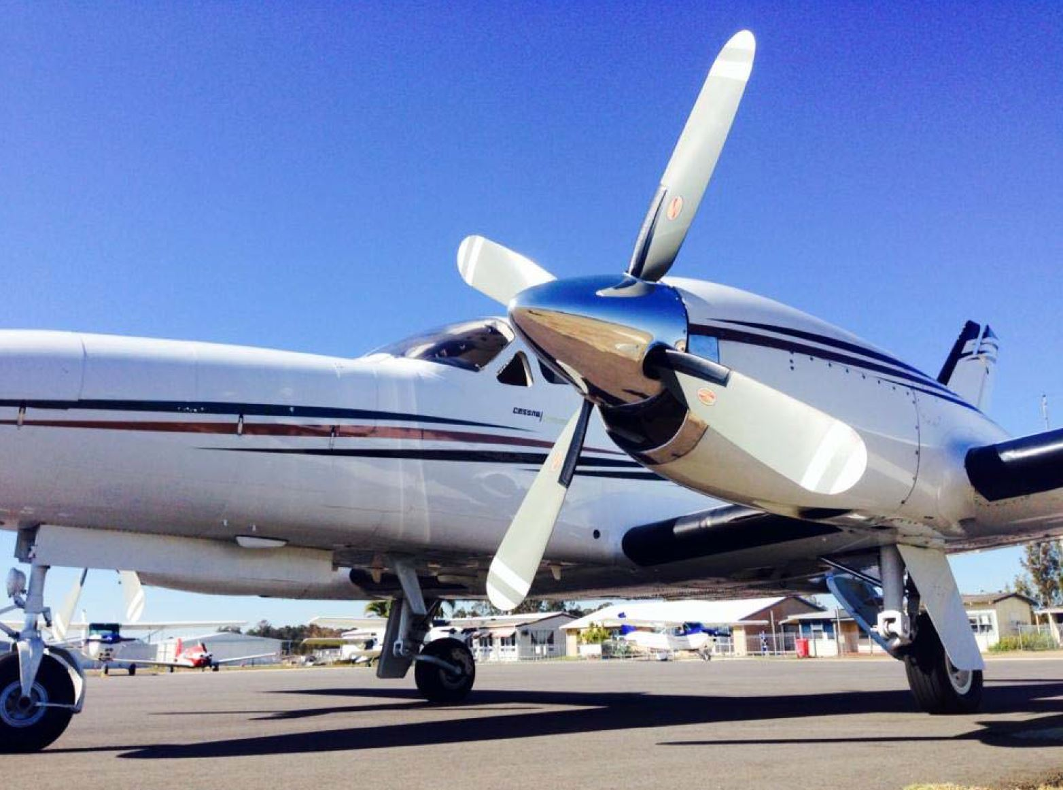
Source: Aircraft owner, modified by the ATSB
In accordance with the approach, the PF recommenced descent at 2.2 NM prior to position WOLNF. Due to the steeper than normal approach path angle (3.7 degrees as opposed to the usual 3.0 degrees), the PF reported establishing a descent rate of about 1,000 feet per minute (fpm). The PM reported that they were expecting a descent rate of about 900 fpm. Air traffic control surveillance data showed the descent rate established was somewhere between 1,000 and 1,500 fpm.
Shortly before WOLNF and as the aircraft approached 2,700 ft, the PM called ‘two thousand seven hundred’ with the expectation that the PF would maintain that altitude until passing WOLNF. However, the descent continued and a few seconds later, the terrain alerting and warning system (TAWS) generated visual and aural ‘CAUTION-TERRAIN’ alerts. These alerts were generated as the system detected that the flight path was projected to come within 300 ft of an obstacle or terrain.
Figure 2: Wollongong RNAV(GNSS) approach to RWY 16 showing approximate flight path profile (green/red dotted line) based on air traffic control surveillance data
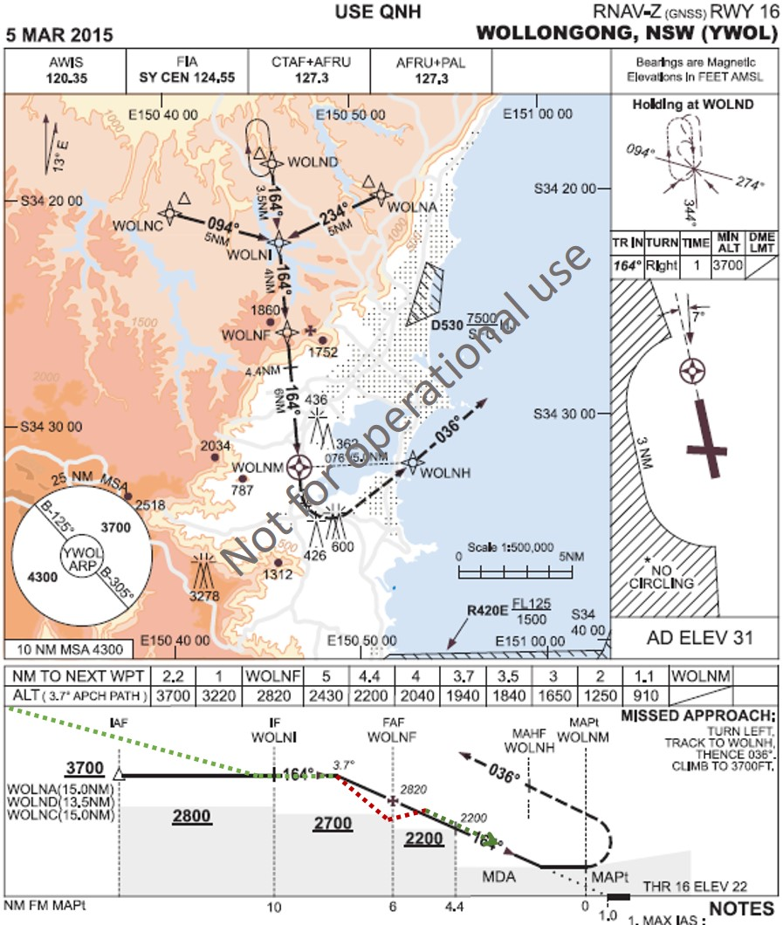
Source: Airservices Australia, modified by the ATSB

Pilot flying comment
The PF’s company duties included aircraft charter pilot and flight instructor. The PF’s flying experience included 230 hours operating Cessna 441 aircraft (16 hours in the last 90 days) and 6,930 total flying hours.
The PF recalled working hard trying to keep the aircraft’s wings level, which may have distracted them from monitoring the descent profile adequately. The PF recalled thinking that they may have been slightly low on profile approaching WOLNF, but was startled when the terrain warning sounded. The PF had not participated in any TAWS training, even though they had flown the aircraft (fitted with TAWS equipment) for the previous 12 months.

Pilot monitoring comment
The PM company duties included aircraft charter pilot and flight instructor. The PM’s flying experience included 350 hours operating Cessna 441 aircraft and 3,400 total flying hours.
The PM believed that the when the TAWS alert activated, the aircraft was at an altitude somewhere between 2,600 ft and 2,500 ft and about 0.5 NM before WOLNF. The time between being below 2,700 ft, having the TWAS alert and an appropriate response was less than 10 seconds.
The PM reported having completed TAWS training with a previous employer. The PM believed that following the TAWS warning, they should have applied full power, climbed at maximum rate and conduct a missed approach in accordance with the operator’s procedures.

Fatigue management
Prior to the flight, both pilots had completed 2 days free of duty. They reported being well rested and obtaining about 8 hours sleep each night.
On the morning of the flight, the pilots reported waking up around 0300. They advised that they generally found it counterproductive to try and get to sleep early and therefore only received about 5 hours of sleep.
Despite the limited amount of sleep, both pilots reported being alert during all stages of the flight.

ATSB comment
The aircraft was fitted with a terrain awareness and warning system (TAWS) designed to reduce the risk of flight into terrain. While a TAWS was not required for the particular type of operation, the lack of TAWS training probably explains the nature of the PFs response to the terrain alert.
Pilots and operators of aircraft are encouraged to be appropriately trained in the use of all equipment fitted to their aircraft.

Safety action
Whether or not the ATSB identifies safety issues in the course of an investigation, relevant organisations may proactively initiate safety action in order to reduce their safety risk. The ATSB has been advised of the following proactive safety action in response to this occurrence.

Aircraft operator
As a result of this occurrence, the aircraft operator has advised the ATSB that all pilots now receive TAWS training.

Safety message
Due to the early start combined with inadequate sleep the night before, despite reporting otherwise, the pilots were likely fatigued. Pilots need to be aware that obtaining less than 7-8 hours sleep a night increases the risk of operating with a level of fatigue known to have a demonstrated effect on performance.
Pilots also need to condsider the effect flying in the early hours of the morning has on their performance. Their body is in a circadian low period which could lead to periods of inpaired alertness and delayed reaction times.

The ATSB continues to be concerned about flight below minimum descent altitudes. When conducting an approach in instrument meteorological conditions, which includes darkness, pilots must ensure the approach is conducted in accordance with the prescribed procedure. In this case, the pilots were required to manage the vertical profile to ensure the aircraft remained at or above the minimum descent altitude, thereby ensuring clearance from terrain and obstacles.
Descent below the minimum descent altitude compromises the minimum terrain clearance requirements and increases the risk of controlled flight into terrain (CFIT).

General details

Occurrence details
Date and time: | 3 August 2015 – 0441 EST
Occurrence category: | Incident
Primary occurrence type: | Flight below minimum descent altitude
Location: | Near Wollongong Airport, NSW

Aircraft details
Manufacturer and model: | Cessna Conquest
Registration: | VH-EQU
Serial Number: | 441–0035
Type of operation: | Private – Test and Ferry
Persons on board: | Crew – 2 | Passengers – 0
Injuries: | Crew – 0 | Passengers – 0
Aircraft damage: | Nil

Near collision between Fairchild SA227, VH-MYI and Cessna 150, VH-RZP

What happened
On 28 February 2016 at about 1642 Eastern Daylight-saving Time (EDT), a Cessna 150 aircraft, registered VH-RZP (RZP), departed from King Island Airport, Tasmania, for a flight to Barwon Heads Airport, Victoria (Figure 1). On board were a pilot and passenger.
The pilot had elected not to submit a flight plan for the visual flight rules private flight. They planned to remain outside controlled airspace but make scheduled reports to air traffic control (ATC) on the Melbourne Centre frequency during the overwater component of the flight.
At 1645, when passing through 1,600 ft above mean sea level, the pilot broadcast a departure call on the King Island common traffic advisory frequency (CTAF) using the only radio in the aircraft.
Figure 1: Approximate flight paths of Cessna 150 VH-RZP and SA227 VH-MYI
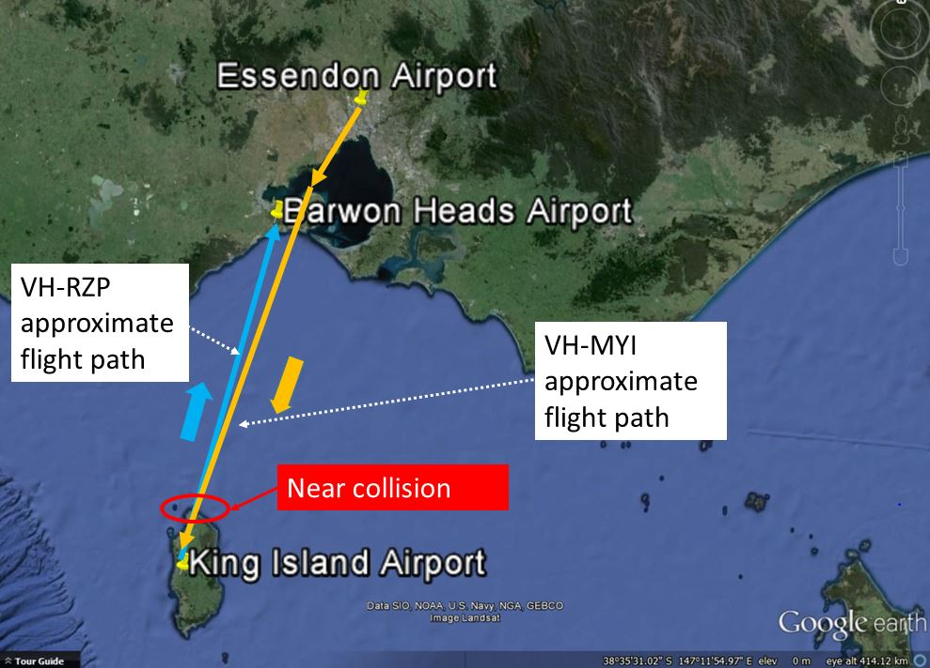
Source: Google earth annotated by the ATSB
About two minutes later, the crew of a regular public transport (RPT) aircraft (’Aircraft 2’) also broadcast on the CTAF. The crew advised that they were at 30 NM inbound to King Island and on descent through FL 115. The pilot of RZP responded to this broadcast, and reported RZP’s position and their intentions. After a brief radio discussion, the pilot of RZP agreed to advise the crew of Aircraft 2 when RZP was close to the northern coast of the island (Figure 1). The crew of Aircraft 2 had temporarily stopped their descent at 6,500 ft until they could confirm that they had safely passed RZP.
At 1650 the crew of a RPT Sharp Airlines Fairchild SA227 aircraft, VH-MYI (MYI), also made a 30 NM inbound broadcast on the CTAF. The pilot in command (PIC) was the pilot monitoring for this sector, and handling the radio calls using two radios, one on the CTAF, and one on the Melbourne Centre frequency. At the time, MYI was on descent from FL 110. The crew of Aircraft 2 responded to this broadcast, with an update of their position and current intentions.
At the same time as the pilot in MYI was broadcasting on the CTAF, the pilot in RZP contacted ATC to arrange the overwater component of their flight. RZP was now about 17 NM from the King Island Airport and had selected the Melbourne Centre frequency on their radio. Therefore, the pilot of RZP did not hear the inbound broadcast by the pilot of MYI. The call to ATC included details of RZP’s current position, the current passing altitude of 4,400 ft, and the intention to continue the climb to 5,500 ft. As they were still in the climb, the aircraft had a relatively high nose attitude, which restricted the pilot’s forward vision.
Air traffic control (on Melbourne Centre frequency) confirmed with the crew of both inbound RPT aircraft (still monitoring both frequencies) that they had heard RZP’s radio call. The crew of Aircraft 2 responded that they had, and when ATC asked again, the crew of MYI (who at the time had been broadcasting on the CTAF) advised that they had also heard the broadcast.
Air traffic control then confirmed with the pilot of RZP that they had heard both inbound RPT aircraft’s broadcasts. The pilot of RZP (still in the climb) advised ATC that they were aware of both aircraft and that Aircraft 2 had just passed above them.
Almost concurrently, the flight crew in both Aircraft 2 and MYI were calling the pilot of RZP on the CTAF, attempting to establish RZP’s current position. The pilot in RZP then momentarily switched back to the CTAF and contacted Aircraft 2 to inform them that they had just passed above RZP.
The crew of MYI unsuccessfully tried again, on the CTAF, to establish the position and altitude of RZP. MYI did not have a traffic alert and collision avoidance system (TCAS) installed so although RZP was transponder equipped, the crew in MYI had to rely on radio transmissions to ascertain the other aircraft’s position.
Not obtaining a response from RZP (as the pilot of RZP had switched the radio frequency back to Melbourne Centre) and unable to determine RZP’s exact position, the crew of MYI elected to temporarily stop their descent at 5,300 ft.
Shortly after, as RZP had reached the top of climb and the pilot was reconfiguring the aircraft, the passenger alerted the pilot to the approaching aircraft (MYI) on a reciprocal heading. About the same time, the crew of MYI reported seeing RZP ‘on a reciprocal heading and within a 100 ft of their altitude and about 200–300 m away’. The pilot of RZP quickly manoeuvred to the right, but the aircraft had passed MYI before the crew of MYI were able to react. There was a further radio exchange between the two crews after the pilot of RZP momentarily switched back to the CTAF.
Both RZP and MYI continued to their respective destinations and landed safely. Aircraft 2 had already landed some minutes earlier.
Table 1 below provides a summary of the radio calls made on both the King Island CTAF and the Melbourne Centre frequency.
Table 1: Summary of radio calls made on CTAF and Melbourne Centre
Calls made on King Island CTAF | Time | Calls made on Melbourne Centre
RZP makes a departure call advising traffic on their current altitude, the altitude they were climbing to and tracking intentions | 1644:58 | MYI contacts Melbourne Centre with altitude
 | 1645:47 | ATC contacts MYI to pass IFR traffic to them
Aircraft 2 makes an inbound call at 30 NM and then arranges with RZP to report when they cross the northern end of King Island | 1646:41
 | 1648:38 | MYI advises they have begun their descent
MYI makes an inbound call at 30 NM | 1650:07 | RZP contacts Melbourne Centre to arrange their overwater sector. They advise that they are on climb to 5,500 ft.
 | 1650.35 | ATC contact both MYI and Aircraft 2 to ensure they have heard RZP’s call
 | 1650:49 | Aircraft 2 confirms they have
Aircraft 2 makes a broadcast advising of their distance from King Island Airport and requesting a distance from King Island Airport from RZP | 1650 .56
 | 1651:04 | ATC contacts MYI to confirm they are aware of RZP
 | 1651:07 | MYI has to be contacted a second time and then confirms they have heard RZP
MYI requests that RZP broadcast their altitude | 1651:10 | ATC contacts RZP to ensure they are aware of both Aircraft 2 and MYI on descent to King Island with an indication of where each aircraft is in relation to the coast of King Island
 | 1651.26 | RZP confirms they have heard all traffic and that Aircraft 2 has just passed above them
RZP contacts Aircraft 2  Aircraft 2 requests that RZP advise them of their distance from King Island Airport  RZP advises Aircraft 2 has just passed above their aircraft | 1651.53
MYI attempts to contact RZP advising their position and requesting their altitude | 1652.14
 | 1652:49 | ATC contacts Aircraft 2 to advise them they are no longer being monitored on frequency
MYI attempts to contact RZP again | 1652.32
 | 1652:50 | Aircraft 2 responds
 | 1652:52 | ATC attempts to contact MYI to advise them they are no longer being monitored on frequency
 | 1652:57 | ATC again contacts MYI to cancel contact
 | 1653:00 | MYI responds
MYI attempts to contact RZP again | 1653.08
RZP contacts MYI advising them that they have just passed them | 1653.38

Weather
The King Island Terminal Aerodrome Forecast (TAF) valid from 1300 to 0100 the next day included a south-westerly wind of 15 kts, visibility of 10 km or greater, and showers of light rain with 6–7 okta of cloud at 3,000 ft.
One of the King Island automated weather station reports (METAR) released during this period, reported a wind from the south-west at 14 kts, greater than 10 km of visibility and overcast cloud at 1,900 ft.

Cessna 150, VH-RZP - Pilot experience and comments
The pilot held a Private Pilot Licence and had about 640 hours of total aeronautical experience.
The pilot reported the following:
- They were familiar with King Island and regularly flew from Barwon Heads to King Island and return in this aircraft.
- The pilot’s recollection of the flight was that they had made all the appropriate radio calls both on the CTAF and on the Melbourne Centre frequency.
- The pilot recalled being advised by ATC that there were two inbound RPT aircraft, but did not have a full understanding of the position of MYI in relation to RZP.
- The pilot was unaware of MYI until they had switched to Melbourne Centre frequency to commence the overwater reporting segment.
- The pilot advised that although there was cloud around the King Island Airport, they were able to remain clear of cloud during the climb to 5,500 ft, and that it was clear blue sky above the cloud from about 3,000 ft.
- RZP was fitted with one radio, therefore could only be tuned to one frequency at a time (in this case, either Melbourne Centre or the CTAF). The pilot felt that this had probably contributed to the communication breakdown.
- The transponder in RZP was on and working. The pilot was under the impression that an RPT aircraft would be able to ‘see’ RZP on TCAS, or similar equipment.
- They used an iPad with a popular navigation application, and were able to maintain the flight-planned track far more accurately than relying on navigating using a map. There was no traffic awareness facility on this software application.
- The pilot commented that in future they would not fly an almost reciprocal track to the inbound IFR aircraft. Instead, they intend to track a coastal route once departing King Island and then track to a position west of Barwon Heads in order to provide sufficient separation.

Fairchild SA227, VH-MYI – Pilot experience and comments
The pilot in command (PIC) had almost 4,000 hours total aeronautical experience with just over 1,700 hours on SA227 aircraft. The PIC advised the following:
- Due to the forecast and in flight conditions of overcast layers of cloud for the descent, the crew had elected to conduct a Global Navigation Satellite System (GNSS) arrival, with a circling approach on to runway 28.
- As per the company standard operating procedures, all communication with company ground personnel at King Island was completed prior to the top of descent.
- The crew had incorrectly assumed that because RZP was a VFR aircraft, they would therefore be staying below the extensive layers of cloud and commencing the overwater segment well below MYI’s descent profile. The crew reported that the inflight conditions they were experiencing of layers of overcast cloud had only re-enforced the belief that RZP, being VFR, would be under the layers of cloud and therefore not a conflict.
- This particular SA227 had yet to be fitted with ADS-B. The pilot advised that much of the operator’s fleet had already been fitted with this technology, but MYI was scheduled for fitment in the near future. This aircraft was also not fitted with TCAS.
- The pilot commented that King Island is a very busy airport, with an increasing number of commercial flights operating there. To date, the pilot had not had an issue operating there as the self-separation required was predominantly between other IFR commercial aircraft, and the system had worked well.

ATSB comment
This serious incident highlights the issues with different performance aircraft operating in the vicinity of non-controlled airports. Although the crew in all three aircraft were making all the required broadcasts, in this occurrence, the broadcasts were being made within seconds of each other on different frequencies. This meant that the crew of both RZP and MYI had missed the opportunity to gain a full appreciation of the other’s position, resulting in a near collision.
In the last five years, the ATSB has received almost 100 reports of near collisions, where the pilots have reported that they were in the vicinity of a non-controlled airport. The ATSB is currently working on an update of the research report into safety in the vicinity of non-controlled aerodromes (previously published in 2010). A revised iteration is expected to be released in the 2016/17 financial year.
The ATSB is also compiling a special aviation short investigation bulletin involving several recent near collisions in the vicinity of non-controlled aerodromes.
Much of the information the ATSB has gathered through the reporting process and through related investigations points to a lack of understanding between pilots of different operation types operating to and from non-controlled aerodromes. Although broadcasting and reporting on the radio often occurs, the situational appreciation of the other aircraft’s performance and positions has not occurred.
Situational awareness around high traffic routes in Class G airspace and non-controlled airports remains the responsibility of the pilot in command. The ATSB encourages pilots to consider other operations in a shared facility such as non-controlled aerodromes. The use of all available resources to confirm the intent of other aircraft by questioning transmissions which had not been fully heard or understood, as in this case, may avert a serious incident such as this.

Safety action
Whether or not the ATSB identifies safety issues in the course of an investigation, relevant organisations may proactively initiate safety action in order to reduce their safety risk. The ATSB has been advised of the following proactive safety action in response to this occurrence, bearing in mind the VH-RZP was a private operations aircraft.

Sharp Airlines
As a result of this occurrence, Sharp Airlines has advised the ATSB that they are taking the following safety actions:
To highlight human factors issues and the risks associated with operating into and out of King Island Airport, the details of the incident will be included in the company’s quarterly newsletter.
Future flight crew human factors training courses will include the human factors associated with this occurrence.

Safety message
The ATSB SafetyWatch highlights the broad safety concerns that come out of our investigation findings and from the occurrence data reported to us by industry.
The ATSB’s Avoidable Accident series includes a publication, A Pilot’s Guide to safety in the vicinity of non-towered aerodromes. This publication captures many issues that occur around non-controlled aerodromes.
Section 4 of CASA’s Civil Aviation Advisory Publication (CAAP 166-1(3)) encourages pilot’s to consider issues surrounding the traffic mix in the vicinity of non-controlled aerodromes. Although the definition used for CTAF in this publication indicates a lateral dimension of 10 NM, Table 2 notes that higher performance aircraft will be making broadcasts earlier than this 10NM boundary. It is therefore important for all CTAF users, particularly pilots of those aircraft in the lower performance category, to understand this information.
The Airservices Australian Aeronautical Publication (AIP) GEN 2.2-6, defines a CTAF as:
‘A designated frequency on which pilots make positional broadcasts when operating in the vicinity of a non-controlled aerodrome.’
This definition may provide a more useful way for pilots to understand operations in and around non-controlled aerodromes.

General details

Occurrence details
Date and time: | 28 February 2016 – 1650 EDT
Occurrence category: | Serious incident
Primary occurrence type: | Near Collision
Location: | 31 km N of King Island Airport, Tasmania
 | Latitude: 39° 36.00' S | Longitude: 143° 57.20' E

VH-MYI
Manufacturer and model: | Fairchild Industries Inc. SA 227 DC
Registration: | VH-MYI
Operator: | Sharp Aviation Pty Ltd
Serial number: | DC-869B
Type of operation: | Air Transport Low Capacity - Passenger
Persons on board: | Crew – 2 | Passengers – 1
Injuries: | Crew – 0 | Passengers – 0
Aircraft damage: | Nil

VH-RZP
Manufacturer and model: | Cessna Aircraft Company 150G
Registration: | VH-RZP
Serial number: | 15066544
Type of operation: | Private - Pleasure / Travel
Persons on board: | Crew – 1 | Passengers – 1
Injuries: | Crew – 0 | Passengers – 0
Aircraft damage: | Nil

Engine fire involving a Fairchild SA227, VH-UZI

What happened
On 22 March 2016, the pilot of a Fairchild SA227 aircraft, registered VH-UZI, operated a freight charter flight from Mackay Airport to Brisbane Airport, Queensland. The flight was uneventful. After landing, the pilot calculated that about 100 lb (45 kg) of additional fuel had been used during the flight to that planned, with 1,100 lb rather than 1,200 lb of fuel remaining. As that amount was within the allowable deviation, the pilot was not required to and did not report the discrepancy.
During a transit check of the aircraft, maintenance personnel at Brisbane Airport found evidence of a substantial fuel leak in the left wheel well of the aircraft. Further investigation found fuel pooling in the cowls, and about 400 ml of fuel spilled out when the cowls were opened. The maintainers found evidence of fire damage to the engine combustion case and a number of components forward of the firewall (Figure 1). The upper engine mount, fuel manifold, adjacent components and the engine frame had evidence of high temperature damage.
The pilot was unaware of the engine fire, as no fire warning had been generated (see Fire detection system).
Figure 1: Fire damage to the left engine
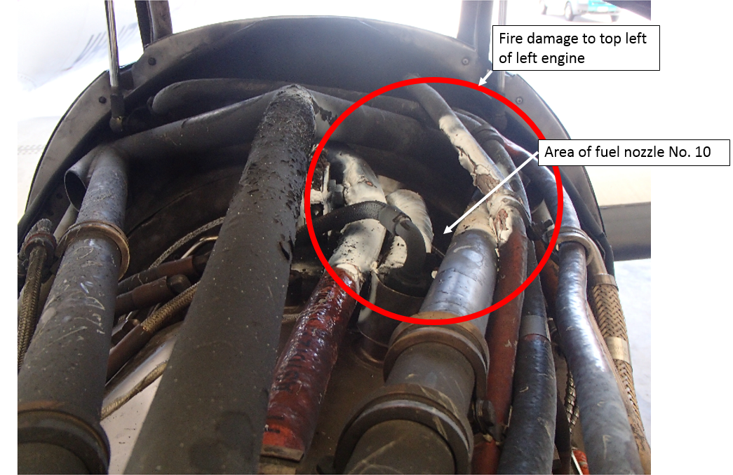
Source: Aircraft operator

Engineering report
The post-incident inspection found evidence of fire in the area of the number 10 fuel nozzle. The fuel leak was due to a leaking flexible fuel manifold hose in the area where it is swaged into the end fitting of the secondary manifold at the number 10 fuel nozzle (Figure 2).
Figure 2: Leaking flexible fuel manifold hose
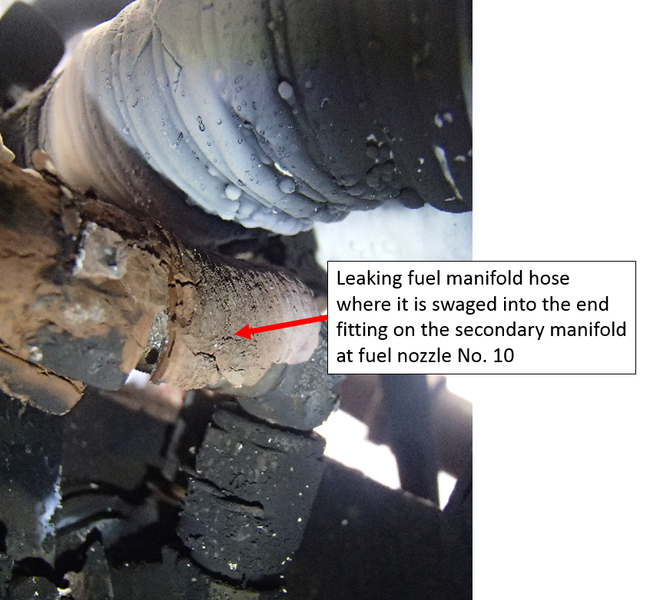
Source: Aircraft operator
A fuel nozzle change had been carried out on the left engine during the last maintenance check, and engine ground runs were then carried out with no leaks detected.
A functional check of the engine fire detection system was conducted after the incident in accordance with the aircraft maintenance manual with no defects evident.

Airworthiness bulletin
The Civil Aviation Safety Authority issued Airworthiness Bulletin (AWB) 73-006 in August 2011. This was in response to three service difficulty reports regarding fuel leaks from the fuel manifold hose, and one associated engine fire. Another 14 fuel leaks and 3 engine fires due to the failure of the same hose had been reported to the equivalent US and Canadian authorities since 1990.
The AWB commented that these manifolds did not have a life limit, but were subject to removal after a specified number of hours for a fuel nozzle inspection. That frequent removal may have contributed to cracks. The flexible portion of the manifold was concealed and could not be inspected visually.
The AWB (non-mandatory) recommendations included:
- every time the manifolds are installed, they should be leak tested
- when the manifolds are removed for a scheduled fuel nozzle inspection they should be sent to the maintenance provider with the nozzles for inspection and testing
- special attention should be paid to removal and installation, as improper practices may contribute to cracking.

Maintenance conducted
The relevant maintenance inspections conducted by the operator prior to the incident covered the replacement of engine flammable fluid lines forward of the firewall (except the nozzle manifold hose which leaked in this incident), cleaning and testing of the fuel nozzles, fuel nozzle assembly inspection and a detailed inspection of the plumbing. The inspection included a visual check of fuel nozzle flexible manifold hoses for condition and ground run leak checks. The engine repair agency advised that periodic pressure leak testing of the manifolds was conducted after a maximum of 3,600 flight hours.
At the time of the incident, the operator’s system of maintenance did not cover all aspects of the recommended practices specified in AWB 73-006. The operator did not find any evidence that they had carried out an assessment of that bulletin.

Fire detection system
The aircraft had a fire detection system, however, there were no sensors in the immediate area of the leak. As such (and noting that the fire detection system tested serviceable following the incident), the system was ineffective in alerting the pilot to the fire. Without the fire detection system being activated, the pilot was not aware of the issue.

Safety action
Whether or not the ATSB identifies safety issues in the course of an investigation, relevant organisations may proactively initiate safety action in order to reduce their safety risk. The ATSB has been advised of the following safety action in response to this occurrence.

Aircraft operator
As a result of this occurrence, the aircraft operator has advised the ATSB that they are taking the following safety actions.

Continuing airworthiness
The aircraft operator has introduced procedures in accordance with the recommendations specified in Airworthiness Bulletin 73-006.

Safety message
This incident highlights the importance of assessing any recommendations relating to maintenance. A recommendation is generally made in response to an event and complying with procedures specified may avoid a similar incident occurring.

General details

Occurrence details
Date and time: | 22 March 2016 – 2319 EST
Occurrence category: | Incident
Primary occurrence type: | Fire
Location: | near Brisbane, Queensland
 | Latitude: 27° 23.05' S | Longitude: 153° 07.05' E

Aircraft details
Manufacturer and model: | Fairchild Industries Incorporated SA227-AT
Registration: | VH-UZI
Serial number: | AT-570
Type of operation: | Charter – Freight
Persons on board: | Crew – 1 | Passengers – 0
Injuries: | Crew – 0 | Passengers – 0
Aircraft damage: | Minor

Piston aircraft

Engine failure involving Jabiru J430, VH-SZQ

What happened
On 19 November 2015, at about 1455 Eastern Standard Time (EST), a Jabiru J430 aircraft, registered VH-SZQ (SZQ), departed Kingaroy for Goondiwindi, Queensland (Qld). The pilot was the only person on board the private flight.
Earlier that day, the pilot had departed Bundaberg, Qld, where the aircraft engine had undergone maintenance that involved the installation of six new engine cylinder barrels and new piston rings. To ensure that the new cylinders barrels and rings would wear together to form a good seal, the pilot adjusted the engine RPM about every 15 minutes and closely monitored the engine oil pressure, oil temperature, cylinder head temperature (CHT) and exhaust gas temperature (EGT) gauges. Each of the six cylinders had a CHT and EGT sensor installed.
During the cruise at about 6,500 ft, and about 40 minutes after departing Kingaroy, abeam Dunmore, the pilot heard a noise coming from the aircraft engine, which then started to vibrate. The pilot moved the engine throttle control to the idle position, and about 8 seconds later the pilot heard a metallic noise and the engine stopped.
The pilot established the aircraft in a glide and looked for a suitable forced landing area. An airstrip was identified on an electronic world aeronautical chart (WAC), about 4 NM to the left of track, which the pilot initially navigated towards. The pilot was unable to locate the strip and subsequently turned towards a property where they could see people, houses, sheds and a highly visible white road (Figure 1).
Figure 1: Map showing the relevant features of the landing area
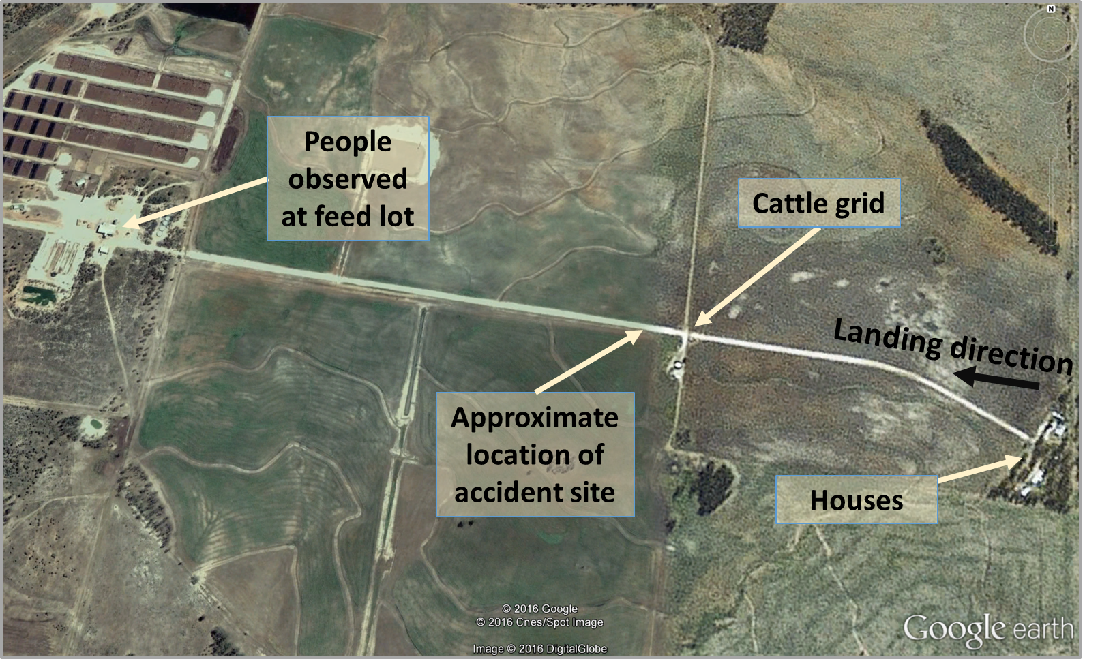
Source: Google earth, modified by the ATSB
At about 4,000 ft, the pilot selected a landing area on the road between the houses and a cattle grid (landing area A in Figure 2). SZQ entered on the downwind leg for a left circuit with the final approach towards the west. The pilot identified power lines close to the road (landing area A) and as they were unsure if they crossed the road, selected the road beyond the cattle grid as the land area (landing area B in Figure 2). The pilot completed the downwind and forced landing checks, and left the electrical master switch on to adjust the flap position when required.
At about 50 feet on final approach, the pilot was able to see that the power lines were far enough away from the road of landing area A that they would not be a hazard, and elected to land on the initial landing area selected. The pilot selected full flap and selected the electrical master switch off. The pilot side-slipped the aircraft to descend quicker. Consequently, the pilot realised that the aircraft’s speed was too fast to land on landing area A and extended to the second landing area, landing area B, and climbed slightly to clear the cattle grid.
The left main landing gear collided with the grid and failed, partially remaining attached to the aircraft. The pilot flared for a landing and the left landing gear dug into the ground and swung the aircraft to the left. The aircraft subsequently collided with a fence and came to a stop about 100 m beyond the cattle grid. The pilot exited the aircraft. The pilot was not injured. The aircraft was substantially damaged.
Figure 2: Diagram representing the circuit pattern and landing areas
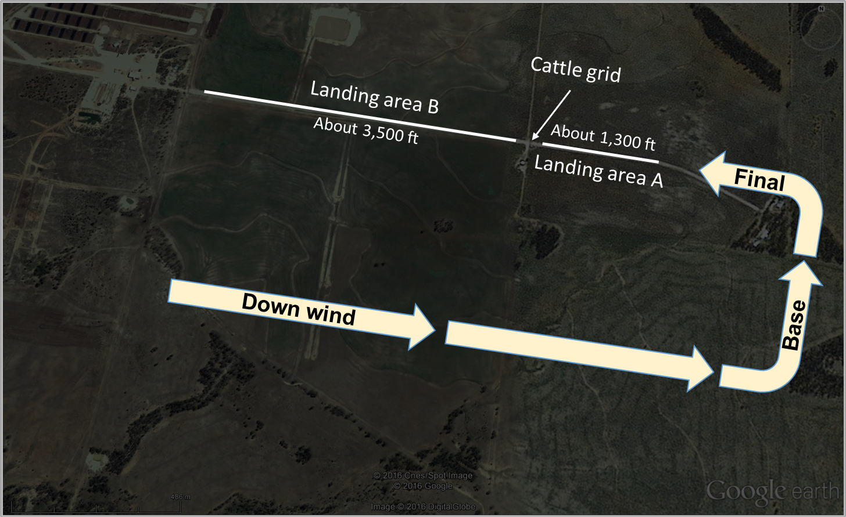
Source: Google earth, modified by the ATSB

Pilot comment
The pilot reported that there was thick smoke in the area from fires some distance away. The smoke only affected the horizontal visibility, which was reduced to 6 km. The wind was light with no obvious signs to determine the local wind direction. The temperature was about 28 ⁰C.
The pilot indicated that there was about 12 minutes from when the engine stopped to landing so they had time to analyse the situation. The pilot felt prepared for the forced landing due to the quality of the flight instruction they had received over the years. The pilot reported that no distress call was broadcast to air traffic control.
The pilot reported that prior to the departure from Bundaberg, three circuits were conducted in SZQ. After landing, maintenance personnel inspected the engine and no defects were reported. The pilot did not notice any issues with the engine prior to the failure.
The pilot indicated that the engine total time in service since new was about 756 hours and the time since a bulk strip/rebuild was about 187 hours.

Engine certification
The aircraft was an amateur-built Jabiru J430 and was operated as an experimental aircraft, issued with an experimental certificate. The original equipment manufacturer (OEM) (Jabiru Aircraft) manufactured the aircraft engine. The engine was installed on the aircraft in 2006 at the time of the aircraft build. In 2013 during an engine bulk strip/rebuild, part of the engine was modified with the installation of non-OEM parts resulting in the engine having a unique configuration. As the aircraft was an amateur-built aircraft, the original owner/builder certified for the installation of those parts. The annual inspection of the engine that was conducted prior to the most recent maintenance was conducted at an aircraft maintenance organisation.

Examination of the failed engine at the engine OEM
The failed engine was first examined at the engine OEM, and the Civil Aviation Safety Authority (CASA) was present at the examination. The engine examination identified the reason for the engine failure as a defect in the valve train where the valve head had made contact with the piston, resulting in significant secondary damage to the number 6 piston and cylinder. The three most likely reasons for the failure were identified by CASA as:
- The most recent maintenance event introduced a foreign body or dislodged existing deposits (of carbon) into the system, allowing debris to enter the valve guide/stem resulting in a sticking valve with the subsequent resulting damage of piston to valve contact.
- A sticking number 6 exhaust valve due to reduced clearances between the valve guide/stem. The effect of thermal expansion with non-OEM parts suggests that there is a possibility that original design clearances were not maintained.
- Incorrect clearances within the valve train, resulting in overheating of the valve stem and subsequent necking and cracking at the base of the stem, releasing the valve head into the cylinder. This was assessed as the least likely failure mode, as the levels of observed blackening (overheating) under the rocker covers was considered to be of a degree that would not result in this type of failure.
The examination concluded that the damage observed had the hallmarks of a sticking valve as opposed to a burned valve. Due to the substantial secondary damage destroying most of the evidence, an absolute conclusion could not be made.

Engine examination at the organisation that assisted in the last maintenance on the engine
The organisation that assisted the original owner/builder to bulk strip/rebuild the engine in 2013, and assisted in the most recent maintenance, conducted a second separate examination of the failed engine and noted the following:
- In 2013, the original owner/builder was provided assistance to bulk strip/rebuild the engine (builder assist bulk strip/rebuild), and some CAMit Aero Engine (CAE) components were installed. This did not include replacing the pistons.
- The maintenance immediately prior to the engine failure was to fit new CAE cylinder barrels and rings and engine oil inhibiting jets to the intake ports. The new owner (not the original owner/builder) advised that the engine EGT was too high and a different carburettor main fuel jet was installed.
- The number 6 cylinder failed resulting in the engine stopping.
- The head of the number 6 exhaust valve was separated from the stem. The valve stem fracture area had severe mechanical damage after its separation but there was no sign of a fatigue fracture. The valve stem was ‘S’ bent in the semi-closed position which would indicate that the valve was not fully open when a possible mechanical collision with the piston was encountered. There was no evidence of significant heat damage to the valve stem (Figure 3).
- The number 6 piston had completely dis-integrated (Figure 4).

Figure 3: Failed valve head and valve stem
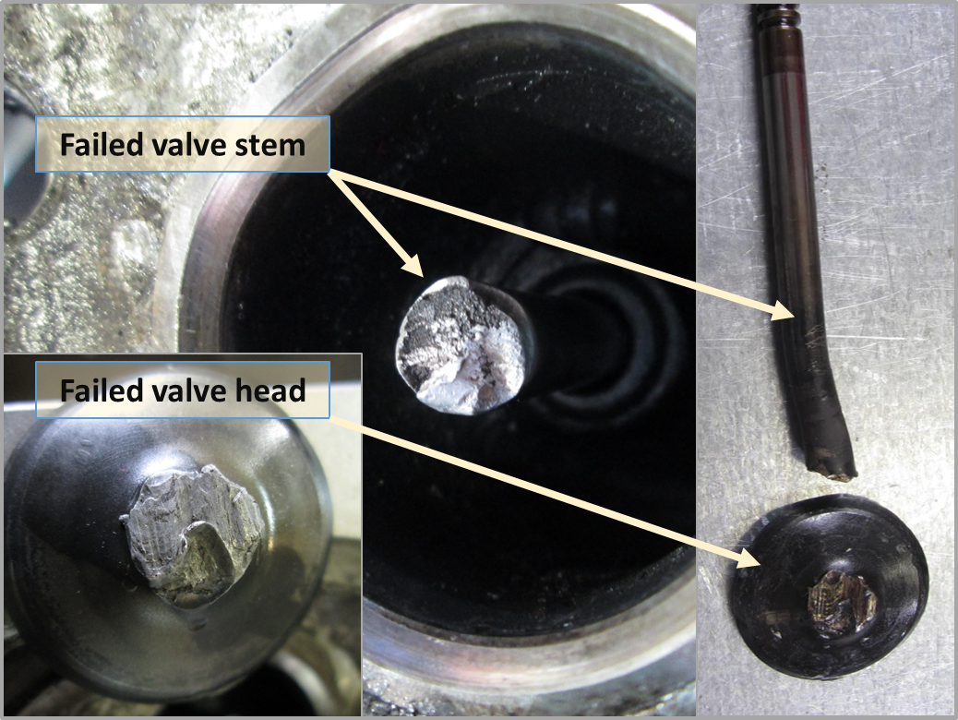
Source: Organisation that assisted in the last maintenance, modified by the ATSB
Figure 4: Recovered parts of the number 6 piston
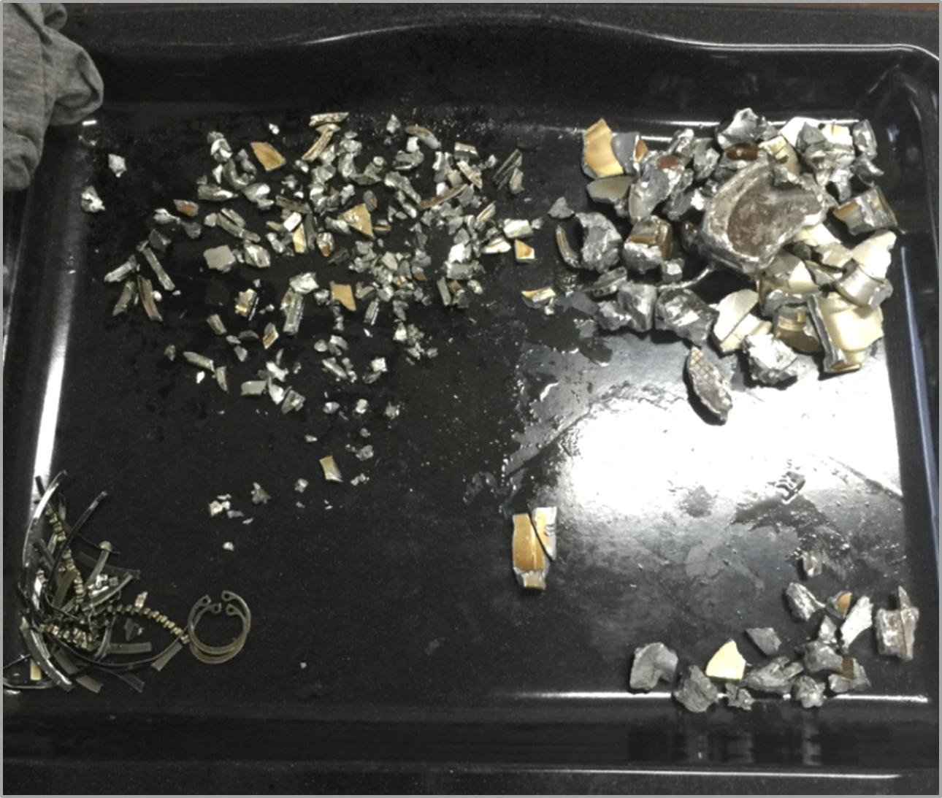
Source: Organisation that assisted in the last maintenance
- No damage was observed in the valve train such as bent pushrods or damaged rocker arms and adequate clearance was evident in the valve guide.
- It is possible that this engine had been run at a high EGT during maximum power settings since the engine bulk strip/ rebuild.
- Four small pieces of piston skirt were identified and showed signs that they were fractured before the failure. The shiny, peened surface of the fracture faces appeared to indicate cyclic compressive forces to a crack surface during engine operation.
- An inspection of the remaining pistons for evidence of cracks revealed that the five other pistons were also cracked before the engine failed (Figure 5). The cracks all initiate at a stress raiser between the piston skirt and the piston-pin boss web. This stress raiser is machined into the piston during original manufacture for jigging purposes.
- It is most likely that an initial partial failure of the number 6 piston skirt allowed piston debris to lodge between one side of the head of the valve and the valve seat. The next stroke of the piston would then collide with the partially closed valve bending the valve head about the obstruction and generating enough leverage to fracture the head off the valve stem; initiating the final destruction of the cylinder components.
- The high EGTs reported would indicate that detonation could have been encountered on multiple occasions, which would apply excessive stress at the stress raisers on the piston skirts.
Figure 5: Location of crack detected in all five pistons and example of crack location shown on a piston assembly
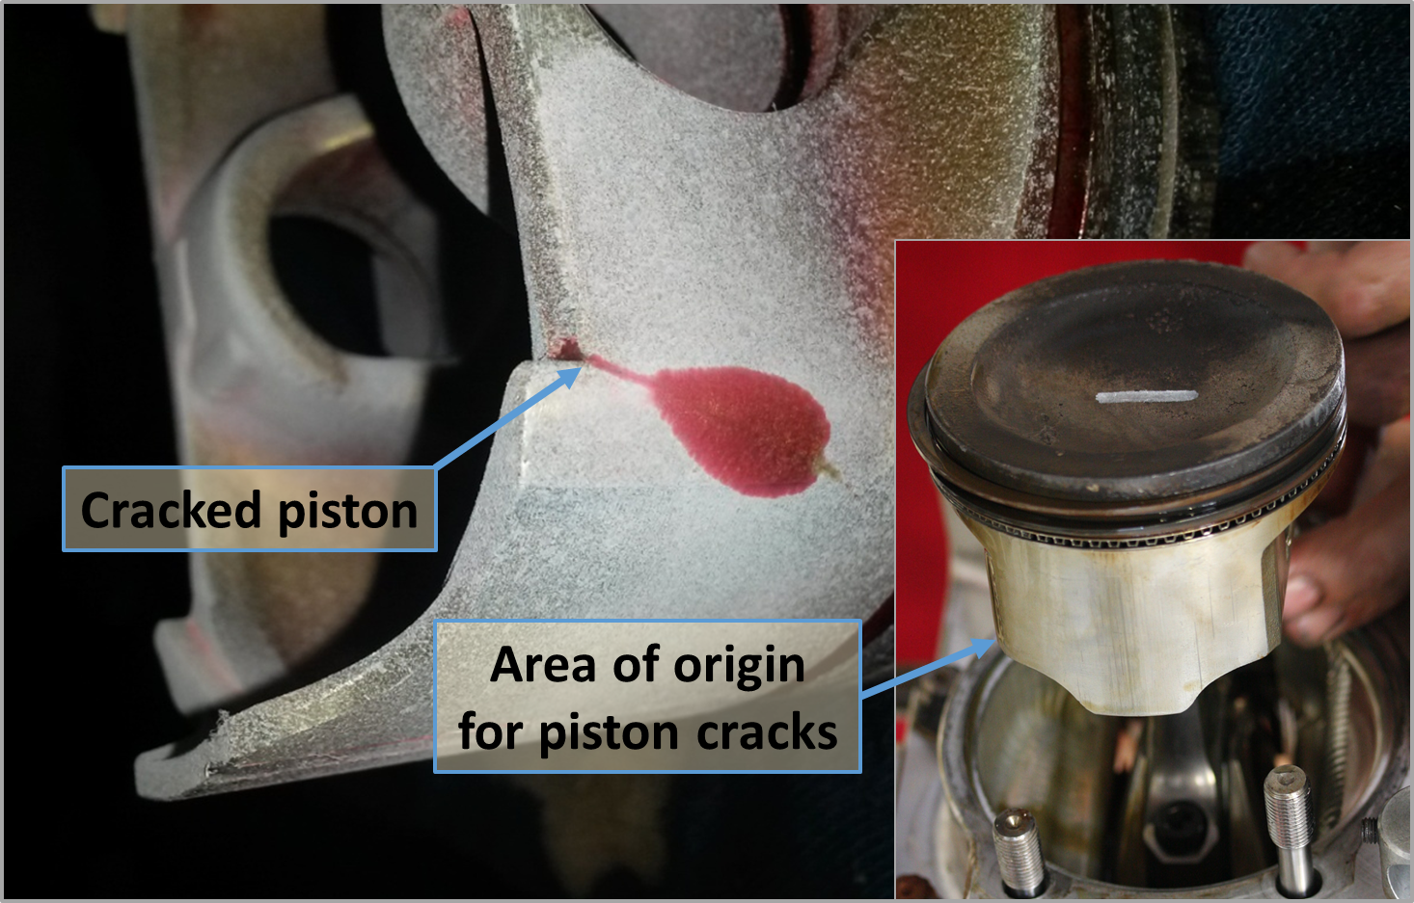
Source Organisation that assisted in the last maintenance and CASA, modified by the ATSB

Engine fuel type
The owner reported that the aircraft’s engine had been operated for a period of time on Australian premium unleaded motor spirit (MOGAS) of 95 RON (Research Octane Number). A little while prior to the accident, the owner identified a Jabiru service letter Alcohol, Lead, Compression Ratio: Fuel Guidance JSL007-6 effective date 12 August 2015 and has since only been using Australian aviation gasoline (AVGAS). The service letter is applicable to experimental models, in all models and variants of Jabiru engines and is available from the Jabiru website.
The service letter discussed that when burning a fuel in a piston engine, one of the most important characteristics of the fuel is how much load it can take without detonation. Detonation results in excess temperature and pressure in the engine and in extreme cases can break pistons or cause other damage very quickly. The service letter notes that operators use MOGAS at their own risk and recommends where possible the use of AVGAS. AVGAS is a fuel specifically designed for aircraft use and is subject to very strict documentation and quality assurance. The vast majority of MOGAS blends have lower octane ratings and are therefore less resistant to detonation than AVGAS blends. Many automotive MOGAS blends rely on highly volatile components. During storage, those volatiles can be lost rapidly and the fuel’s performance can degrade significantly in a relatively short period. The service letter notes that it is possible for MOGAS to lose several points from its octane rating while stored, leaving the engine vulnerable to detonation.
The organisation that assisted in the last maintenance indicated that it is possible that light detonation on previous flights may have overstressed the piston at the stress raiser and initiate a fatigue failure of the number 6 piston. The examination of the engine pistons and cylinders did not extend to analysing the combustion deposits for evidence of detonation from previous flights.

Safety action
Whether or not the ATSB identifies safety issues in the course of an investigation, relevant organisations may proactively initiate safety action in order to reduce their safety risk. The ATSB has been advised of the following proactive safety action in response to this occurrence.

Organisation that assisted in the last maintenance
As a result of this occurrence, the organisation that assisted in the last maintenance has advised the ATSB that they are taking the following safety actions:
- All CAE pistons will be modified to minimise the stress raiser that was found in the non-CAE pistons installed on SZQs engine, which will reduce the detonation sensitivity of the pistons.
- A survey of CAE engine owners will be conducted asking questions relating to their engine EGTs to gauge the risk of similar failures.
- Maintenance advice to check all reused pistons for cracks and to modify the stress raiser will become standard practice.
- A test engine has been subjected to similar conditions to enable more accurate failure mode analysis in the future.

Safety message
Pilots should consider the effect an in-flight engine failure at different altitudes has on the time available to manage that failure and identify a suitable forced landing area. In this instance, the pilot had about 12 minutes from the engine failure to landing and was able to consider the options, with enough time to manoeuvre towards a different area (road on property) when the first was not suitable. Regularly updating forced landing options during a flight is particularly important in the event of a time critical situation.
CASA Flight Safety Australia magazine July-August 2007 article Emergency: staying in control is available from the CASA website. The article discusses that reporting an emergency is important when time permits, just in case not everything goes to plan. It is not an inconvenience: it’s what air traffic controllers are trained and qualified to do. They are skilled in dealing with emergencies and providing professional appropriate assistance. Where emergency situations arise, an early in-flight emergency notification will assist in expediting the desired outcome – a safe landing.
The accident also highlights the importance to owners and operators to remain aware of information published by the aircraft and engine manufacturer.
The ATSB has recently published an analysis of reported engine failures: Engine failures and malfunctions in light aeroplanes (AR-2013-107) and is available from the ATSB website. That report found that over the six years between 2009 and 2014, there were 322 engine failures or malfunctions involving single-engine piston aeroplanes up to 800 kg maximum take-off weight. Valve train related fractures were one of the most common failures found.

General details

Occurrence details
Date and time: | 19 November 2015 – 1600 EST
Occurrence category: | Accident
Primary occurrence type: | Engine failure
Location: | 85 km WSW of Oakey Airport, Queensland
 | Latitude: 27° 40.92' S | Longitude: 150° 55.73' E

Aircraft details
Manufacturer and model: | Jabiru J430
Registration: | VH-SZQ
Serial number: | 313
Type of operation: | Private – Test & Ferry
Persons on board: | Crew – 1 | Passengers – 0
Injuries: | Crew – 0 | Passengers – 0
Damage: | Substantial

Birdstrike involving Glasair Sportsman GS-2, N666GM

What happened
On 24 December 2015, the pilot of a Glasair Sportsman GS-2, registered N666GM, was conducting a private flight from Southport, Queensland, to Moruya, New South Wales (NSW). The pilot was the only person on board.
The pilot landed at Mudgee, NSW, to add fuel, before continuing to Moruya. While en route between Mudgee and Moruya, the aircraft collided with a large bird, believed to be a wedge-tailed eagle. At the time of the birdstrike, the aircraft was cruising at about 5,500 ft above mean sea level, over mountainous terrain, and below a solid layer of cloud. The autopilot was engaged, but not in a mode that would hold a set altitude. The airspeed was about 140 kt.
The bird broke through the windscreen on the left side of the aircraft and struck the pilot. The collision left the pilot with serious facial injuries and they were temporarily unable to see (due to the effects of the impact). The pilot had been wearing a headset and spectacles, which were both dislodged and damaged during the collision.
Following the birdstrike, the aircraft entered an uncommanded and rapid descent. The extreme wind-rush and noise, combined with the effects of their serious injuries, meant that the pilot was not immediately aware that the aircraft was descending.
Despite the extreme circumstances, the pilot recovered sufficiently to manually override the autopilot and control the aircraft sufficiently to prevent a collision with terrain. Although the pilot continued to have difficulty seeing, they were able to apply full power and establish the aircraft in a climb. Following recovery from the initial urgency of the situation, the pilot was able to settle the aircraft in level flight, clear of the surrounding terrain.
The pilot elected to leave the autopilot engaged to assist with aircraft control, because the circumstances made it extremely difficult to continuously monitor airspeed and the flight path of the aircraft. With the autopilot still engaged, the pilot made overriding manual corrections to the flight path as required.
The pilot was able to locate the microphone of the headset by following the headset cord (by hand). The headset itself was substantially damaged and the pilot could only locate the microphone and one broken ear-cup. The pilot transmitted a MAYDAY call using the damaged headset, hopeful that the microphone was functional despite the apparent damage. Air traffic control (ATC) received the MAYDAY call at about 1300 Eastern Daylight-saving Time (EDT) (see later section titled Air traffic control aspects).
Under the circumstances, the pilot was unable to ascertain an accurate position, so just referenced Mudgee and Moruya in the MAYDAY call. Damage to the headset prevented the pilot receiving transmissions, so they were unable to hear any acknowledgement of the MAYDAY call, and consequently were unsure if the transmission was successful. In addition to the MAYDAY call, the pilot attempted to communicate with an associate via a text message, in the hope that their associate may be able to alert relevant authorities.
The pilot succeeded in navigating the aircraft away from the more mountainous terrain. The aircraft was still tracking towards Moruya, but because Moruya was over an hour away, and with high terrain en route, the pilot began considering diversion options. By referencing an iPad mounted in the cockpit, the pilot was able to identify a built-up area, and track towards that area in anticipation of being able to locate an aerodrome. The pilot sent another text message to their associate with updated information, and made another MAYDAY call. Although uncertain at the time, the pilot believed that the built up area was the city of Bathurst, and was broadly aware of the location of Bathurst Airport relative to the city.
The pilot had been flying with the autopilot engaged, holding a high nose attitude, at relatively low airspeed (with the engine at full power) to try to reduce the wind rush and noise. The pilot had also selected half flap, to provide some margin over the aerodynamic stall speed. Although concerned about aircraft controllability and the effect of their injuries, the pilot disconnected the autopilot in order to navigate the aircraft towards the anticipated location of the airport. While handling the aircraft carefully, mindful that the birdstrike may have damaged the wings and/or tail section of the aircraft, the pilot was able to locate and overfly Bathurst Airport.
Although unable to see the windsock, the pilot decided that runway 35 was the preferred runway under the circumstances. The pilot made another emergency (MAYDAY) call and positioned the aircraft for a landing via a wide circuit. Despite continuing problems with the wind-rush and noise, and the effect their injuries, the pilot concentrated on maintaining a safe airspeed during the approach, and landed successfully.
After landing, the Airport Safety Officer met the aircraft and provided the pilot with parking instructions. The pilot shut the aircraft down and medical services were called. Aside from the damage to the windscreen (Figure 1) and some relatively minor marks around the propeller, there appeared to be no other damage to the aircraft. The remains of the bird were retrieved from the cockpit (Figure 2).
Figure 1: Damage to the aircraft windscreen
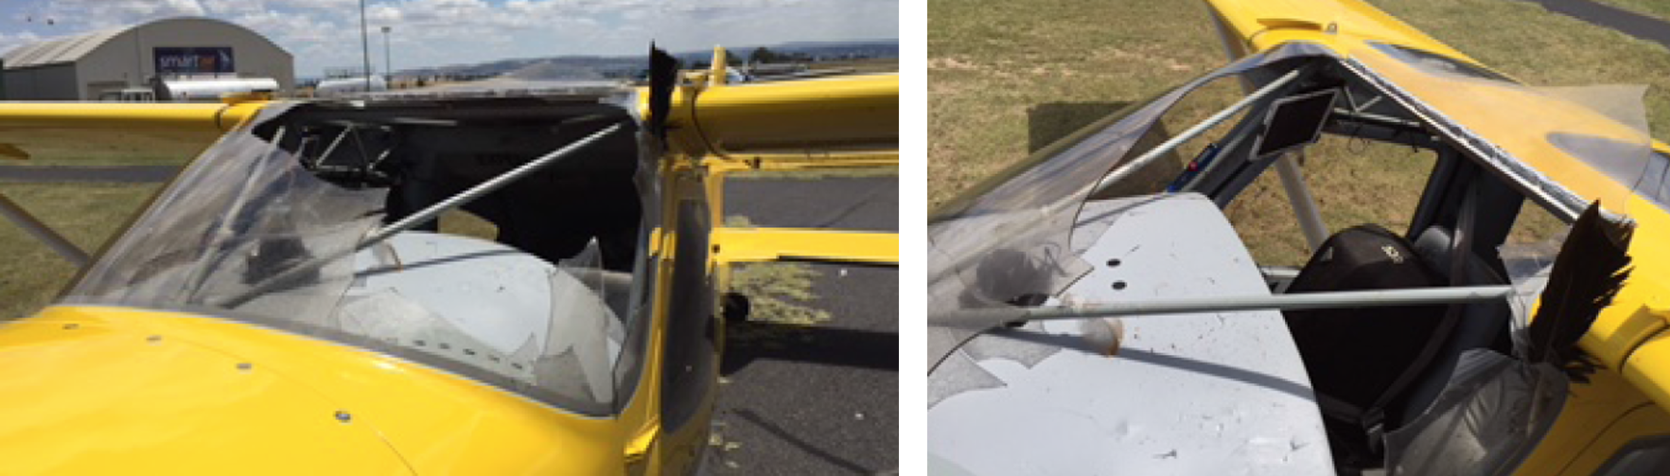
Source: Bathurst Airport Staff
Figure 2: Some of the bird remains retrieved from the cockpit

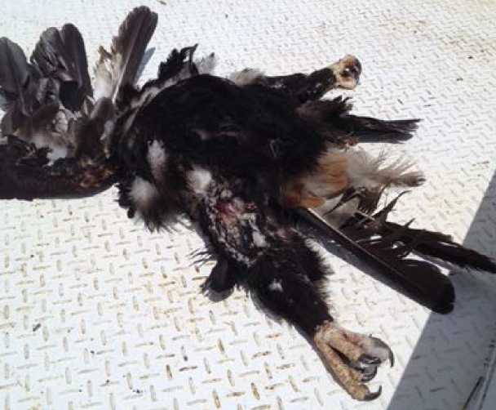
Source: Pilot

Pilot comments – use of the autopilot
At the time of the birdstrike, the autopilot was set to hold the heading selected by the pilot, and neutral/zero vertical speed (level flight). This was in anticipation of entering a climb and manoeuvring when a suitable gap appeared in the overlying cloud cover. In this mode, however, the autopilot allowed the aircraft to descend rapidly following the birdstrike. The pilot believed that had the autopilot been set to hold a specific altitude, the aircraft may have maintained that altitude rather than entering an uncommanded descent. Under the circumstances, given the extent to which the pilot was incapacitated (particularly immediately following the birdstrike), altitude hold mode may have been preferable.
Additionally, the pilot believed that continuing to use the autopilot following the birdstrike was a good strategy, given the effect of their injuries and their inability to see clearly. While use of the autopilot reduced the likelihood of a loss of control, the pilot was still able to manually override the autopilot to adjust the flight path of the aircraft as required.

Air traffic control aspects
The pilot’s initial MAYDAY call indicated that the aircraft had been involved in a birdstrike and that the pilot was unable to see. The call also included reference to aircraft control difficulties and mentioned Mudgee and Bathurst. ATC acknowledged the call and initiated a Distress Phase. ATC requested the callsign and location of the aircraft, which were not included or not clear from the MAYDAY call, but there was no response from the pilot. ATC attempted to establish contact with the incident pilot through the pilot of another aircraft who also heard the MAYDAY call, but those attempts were also unsuccessful. ATC also asked the pilots of other aircraft in the area to maintain a listening watch on relevant frequencies.
The pilot of the incident aircraft transmitted another MAYDAY call about a minute after the initial call, indicating that the aircraft was over hills and the windscreen was broken. The pilot added that they had no headset, and repeated that they were unable to see. No further calls or details were received by ATC from the pilot.
Among other activities in response to the situation, ATC contacted the Airport Safety Officer at Bathurst Airport to see if they were aware of any aircraft that was missing or experiencing difficulty. At that point, the Airport Safety Officer was unaware of the situation, and unable to provide any information.
At about 1330, the Airport Safety Officer at Bathurst airport contacted ATC to advise that an aircraft with a broken windscreen was in the process of landing. Several minutes later, they called ATC again, this time to inform them that the aircraft had landed at Bathurst. The Airport Safety Officer was able to provide more relevant information, following which ATC cancelled the DISTRESFA.

ATSB comment
In 2014, the ATSB published a research report (AR-2014-075) titled Australian aviation wildlife strike statistics. The report provides some insights into the nature and characteristics of birdstrikes, and comments that a birdstrike involving a general aviation aircraft is more likely to cause aircraft damage than a birdstrike involving an air transport category or military aircraft.
The August 2010 edition of the Flight Safety Foundation magazine, AeroSafety World, includes an article titled Bird Strike Mitigation Beyond the Airport. The article includes some comments relevant to this occurrence, including:
While general aviation airplanes typically do not have the same engine ingestion concern as transport category jets, their overall design and certification make them much less able to resist damage from bird strikes. Mid-size to large birds can penetrate the windshields and can cause pilot incapacitation or disorientation, resulting in loss of control. The drag caused by the loss of the windshield has also resulted in accidents because enough thrust is not always available to overcome the huge drag increase. Likewise, collision-caused deformation of wing or tail surfaces can increase stall speed considerably and affect handling qualities, especially at slower speeds.
If birds are encountered en route, on climb or descent, the flight crew should pull up — consistent with good piloting technique — to pass over the birds. If birds see the aircraft, they will treat it as an obstacle, but may misjudge the closing speed because the threat is usually beyond their experience.
Birds may turn or dive as avoidance maneuvers, but they rarely climb. So pulling up is the best and fastest avoidance maneuver.

Safety message
Birdstrikes continue to present a serious hazard to aviation, and can cause substantial damage. Such damage has the potential to significantly adversely affect the performance and handling qualities of an aircraft. In this case, despite the damage to the aircraft and their injuries, the pilot effectively managed an extremely challenging situation, resulting in a positive outcome.
This accident highlights to pilots the importance of regular position updates with respect to in-flight diversion options. An ongoing awareness of diversion options may assist pilots in dealing effectively with a stressful and challenging in-flight emergency, particularly where time is critical.
When declaring an emergency, pilots are encouraged to relay as much relevant information as reasonably possible. Although in this event, the damage to the aircraft and injuries to the pilot made all communications very difficult, positional information and information with respect to the intentions of the pilot may be critical to an effective response by emergency services.

General details

Occurrence details
Date and time: | 24 December 2015 – 1300 EDT
Occurrence category: | Accident
Primary occurrence type: | Birdstrike
Location: | near Bathurst, New South Wales
 | Latitude: 33° 24.6’ S | Longitude: 149° 39.1’ E

Aircraft details
Manufacturer and model: | Glasair Sportsman GS-2
Registration: | N666GM
Serial number: | 7324
Type of operation: | Private – Pleasure/Travel
Persons on board: | Crew - 1 | Passengers - 0
Injuries: | Crew - 1 (Serious) | Passengers - 0
Aircraft damage: | Minor

Engine malfunction and collision with terrain involving Piper PA-23, VH-BIQ

What happened
The owner and maintainer of a Piper PA-23 aeroplane, registered VH-BIQ, who was also a pilot, had received a special flight permit (from a person authorised by the Civil Aviation Safety Authority to issue such permits) to ferry the aircraft from Mareeba, Queensland, to Darwin, Northern Territory, for a 100-hourly inspection.
On the morning of 5 March 2016, the pilot conducted a local flight from Mareeba Airport, to check everything was functioning normally on the aircraft, in preparation for the planned flight to Darwin. The pilot reported that the aircraft performed normally during the take-off and climb to about 2,500 ft above mean sea level (AMSL). However, witnesses reported that at least one engine was running roughly during taxi and take-off, and that the aircraft appeared to climb poorly after take-off. After departing the airport, the pilot reported performing a number of in-flight checks of the aircraft, including retracting and extending the landing gear.
At about 1200 Eastern Standard Time (EST), the aircraft was returning to the airport when the pilot observed the left engine revolutions per minute (RPM) decrease from about 2,300 RPM to 2,000 RPM, which was still above idle power. The pilot conducted a series of actions to try to rectify the power loss, including checking the fuel mixture and full range of the throttle, but the aircraft descended rapidly. As the aircraft continued to descend, the pilot set the aircraft attitude to maintain an airspeed of 70 kt, which was the nominated glide speed for the aircraft.
As the aircraft descended to about 200 ft above ground level, the pilot realised that the landing gear was extended. The pilot reduced the power to idle and conducted a forced landing. The aircraft collided with cane fields, crossed a road and collided with a tree, resulting in substantial damage (Figure 1). The pilot, who was the only occupant of the aircraft, initially exited the aircraft without injury. A small quantity of fuel in the cross-feed line ignited briefly, but the flame quickly extinguished. After assessing that there was then minimal risk of a fire, the pilot returned to the aircraft and in the process sustained a minor injury.

Pilot comments
The pilot provided the following comments:
- The temperature was 33 °C, with light rain falling, and the aerodrome was at an elevation of 1,560 ft AMSL. These conditions may have contributed to the aircraft being unable to maintain altitude even while the right engine continued to produce normal power. The pilot also elected not to feather the left propeller as the engine was still producing some power. The extended landing gear created substantial drag and further reduced the aircraft’s ability to maintain altitude.
- Some debris may have been present in the fuel that blocked the injectors, resulting in partial loss of power. It was possible that fuel had dried out in the distributor valve, creating a gum, which was then loosened and picked up in the fuel.

Figure 1: Accident site showing damage to VH-BIQ
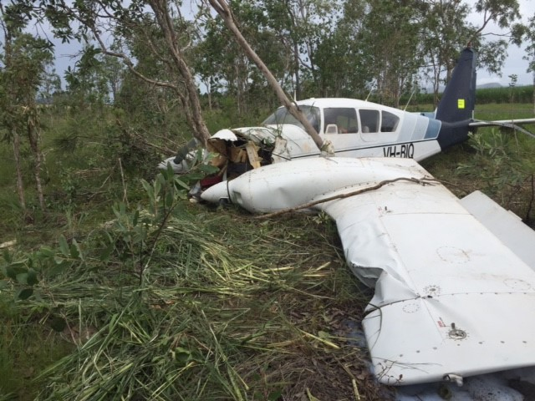
Source: Aircraft owner

Safety message
The partial or complete failure of one engine in a light twin-engine aircraft can present a number of issues for a pilot to manage. Immediate actions include maintaining control of the aircraft, while assessing the aircraft’s ability to climb or maintain altitude, and configuring the aircraft for maximum available performance.
Reducing the drag by retracting landing gear and flaps, and by feathering the propeller of the failed engine, need to be considered as they may assist in maintaining altitude, but may be extended for approach and landing.
The aircraft’s ability to maintain altitude depends on the pilot’s timely and correct actions, as well as factors that affect aircraft performance such as heat, high humidity and altitude. The local conditions and aircraft configuration may reduce the capability of the aircraft such that a forced landing is the only option available. In this situation, good decision making such as selecting a suitable landing site as soon as possible, which way to turn and avoiding manoeuvring at low level, is essential.
Pilots need to be situationally aware at all times, and be able to impose good judgement and well developed skills to accomplish the flight objectives. Pilot actions or inactions may reduce perceived safety margins and increase the probability of adverse operational events. The CASA training resource Safety Behaviours: Human Factors for Pilots includes guidance for pilots in situational awareness, decision making, threat and error management and airmanship.

General details

Occurrence details
Date and time: | 5 March 2016 – 1200 EST
Occurrence category: | Accident
Primary occurrence type: | Collision with terrain
Location: | near Mareeba, Queensland
 | Latitude: 17° 03.37' S | Longitude: 145° 20.00' E

Aircraft details
Manufacturer and model: | Piper Aircraft Corporation PA-23-250
Registration: | VH-BIQ
Serial number: | 27-7654075
Type of operation: | Private – Test & Ferry
Persons on board: | Crew – 1 | Passengers – 0
Injuries: | Crew – 1 (Minor) | Passengers – 0
Damage to aircraft: | Substantial

Loss of control and collision with terrain involving Cessna 182S, VH-PCO

What happened
On the morning of 20 March 2016, the pilot of a Cessna 182S aircraft, registered VH-PCO, conducted a private flight from Moorabbin Airport to Tooradin Airfield, Victoria, with two passengers on board. The aircraft took off from runway 17 Right at Moorabbin, and the wind during the 21 NM flight was south-easterly at about 10 kt. The runway in use at Tooradin was 04 (Figure 1), and the pilot reported that the landing at the end of that flight was uneventful.
Figure 1: Tooradin Airfield
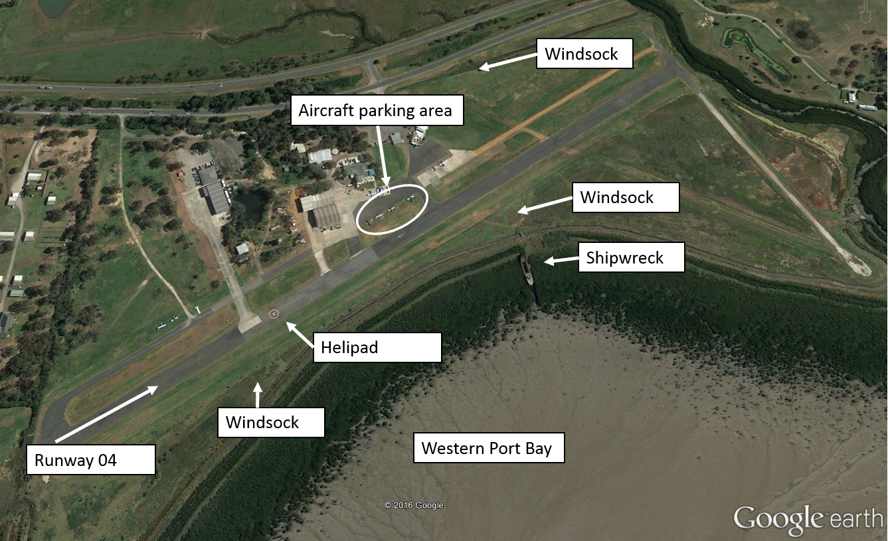
Source: Google earth, annotated by the ATSB
After landing at Tooradin, the pilot prepared to conduct a scenic flight to Wonthaggi, Wilsons Promontory and return, with three passengers on board. While on the ground at Tooradin, the pilot was concerned that the wind had increased since their arrival, therefore obtained an updated weather forecast and the actual weather at Tyabb, which was about 12 NM south-west of Tooradin. The pilot also obtained the latest weather report for Moorabbin, where the wind was from 120° at 11 kt, and runway 13 was in use.
Based on that information, the pilot assessed that it was suitable to go ahead with the planned flight, but also made the contingency plan to divert to Moorabbin if the strength of the crosswind at Tooradin was not suitable for a landing on their return.
The pilot reported that the flight was normal. At about 1320 Eastern Daylight-saving Time (EDT), the aircraft returned to Tooradin, and the pilot elected to join the circuit on a right downwind for runway 04. While on the downwind circuit leg, the pilot and the front seat passenger observed a windsock, which was located near the runway 04 threshold (near the helipad). The pilot stated that the windsock indicated that the wind was blowing straight down the runway, and elected to continue the approach.
After turning onto final approach, the pilot selected full flap (40°). When at about 300 ft above ground level, the pilot confirmed that the windsock still indicated a headwind, and continued the approach. The pilot reported that as the main wheels touched down, about 300 m beyond the runway threshold, the aircraft veered left off the runway onto the grass.
The pilot immediately commenced a go-around by applying full power and raising the aircraft’s nose in an attempt to clear aircraft parked on the grass ahead. The stall warning horn sounded, and the pilot assessed that the aircraft was not climbing and that its landing gear may collide with the parked aircraft.
The pilot therefore reduced the power to idle and the aircraft landed heavily to the north of the runway. The aircraft then struck three other aircraft that were parked on a grassed area between the runway and a sealed taxiway.
The aircraft sustained substantial damage and the pilot and passengers were uninjured (Figure 2).
Figure 2: Accident site showing damage to VH-PCO
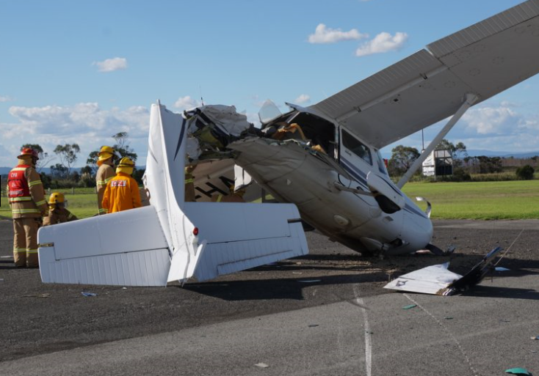
Source: Country Fire Authority Victoria

Pilot experience and comments
The pilot had a total of 168.8 hours of aeronautical experience, including 5.4 hours in the Cessna 182S.
The pilot provided the following comments:
- Prior to the flight, the pilot assessed the wind using the windsock to the north of the field and the torn windsock near the shipwreck. On final approach, the pilot referenced the windsock near the runway 04 threshold (near the helipad).
- In hindsight, they should have retracted the flaps to 20° for the go-around.
- There was no indication of a crosswind during the approach.

Weather observations
There was no automatic weather station at Tooradin. The nearest weather data recorded by the Bureau of Meteorology was at Moorabbin and Frankston, and the ATSB obtained the 1-minute weather data for those locations. The runway at Tooradin was situated adjacent to Western Port Bay, and the runway direction in use was 04. The pilot and an instructor at Tooradin reported that the wind at Tooradin was generally not the same as that experienced at Moorabbin.
Around the time of the accident, the wind at Frankston was varying in direction from 096° to 143°, from 6 to 10 kt, gusting to 15 kt. An instructor at Tooradin reported that throughout the day, the wind was about 7 to 9 kt, some of which was crosswind, as it was blowing at about a 45° angle to the runway.
The instructor also reported that the main windsock for the airfield was to the north of the field, and there were two windsocks on the southern side of the strip – one located near the helipad and the other, which was torn but still indicating accurately, adjacent to the shipwreck (Figure 1).

Safety action
Whether or not the ATSB identifies safety issues in the course of an investigation, relevant organisations may proactively initiate safety action in order to reduce their safety risk. The ATSB has been advised of the following safety action in response to this occurrence.

Aircraft operator
Although the accident flight was a private flight, the aircraft operator, as a training organisation, has advised the ATSB that as a result of this occurrence, they are taking the following safety actions:

Improving the delivery of training in crosswind circuits and go-arounds
The aircraft operator is reviewing
- what grade instructors are authorised to conduct training in crosswind conditions
- which aerodrome the lessons are delivered at
- the minimum crosswind component for the lessons
- where it is delivered within the training syllabus
- the contents of training notes and sequence briefing
- how they allocate testing officer to ensure there is no student input.
The operator has also asked flight testing officers to emphasise crosswind and go-around techniques.

Presentation to company pilots
The operator has arranged for a senior airline captain to deliver a presentation to company pilots on stabilised approaches, selection of the touchdown zone, and appropriate responses to non-normal situations.

Carriage of airsick bags
Aircraft folders will be equipped with airsick bags, to reduce the effect a sick passenger may have on a pilot’s workload.

Review of Emergency Response Plan
While the operator assessed that their emergency response plan was effective in this incident, they have identified some improvements to be implemented.

Safety message
A report prepared by the US Aircraft Owners and Pilots Assocation, Cessna 182 Skylane Safety Highlights, stated that the number of accidents for the aircraft type was inversely proportional to the number of hours a pilot had accumulated, and the majority of accidents involved pilots with less than 400 hours’ total time. Landing was the most accident-prone phase of flight. The report also stated that the maximum demonstrated crosswind component for most Cessna 182 aircraft was 15 kt – most pilots should consider that as limiting until they are highly proficient in crosswinds. The aircraft’s Pilot Operating Handbook suggested procedures for landing in crosswinds, including that they should be performed with the minimum flap setting necessary for the field length.
The Flight Safety Foundation Approach-and-landing accident reduction tool kit Briefing note 6.1 – Being prepared to go around, stated that the importance of being go-around-prepared and go-around-minded must be emphasised because a go-around is not a frequent occurrence.

General details

Occurrence details
Date and time: | 20 March 2016 – 1324 EDT
Occurrence category: | Accident
Primary occurrence type: | Collision with terrain
Location: | Tooradin (ALA), Victoria
 | Latitude: 38° 12.93' S | Longitude: 145° 25.42' E

Aircraft details
Manufacturer and model: | Cessna Aircraft Company 182S
Registration: | VH-PCO
Serial number: | 18280501
Type of operation: | Private – Pleasure/Travel
Persons on board: | Crew – 1 | Passengers – 3
Injuries: | Crew – 0 | Passengers – 0
Aircraft damage: | Substantial

VFR into IMC involving Piper PA-28, VH-BDB

What happened
On 29 March 2016, the pilot of a Piper PA-28-181 aeroplane, registered VH-BDB, conducted a private flight from Aldinga, South Australia, to Hay, New South Wales (NSW), under the visual flight rules (VFR). After refuelling in Hay, the pilot planned the next VFR flight to Bankstown, NSW.
The pilot obtained the latest weather forecast for the area, and for Bankstown and Bathurst airports. As the weather forecast for Bankstown indicated conditions would be marginal for VFR flight, the pilot planned for an alternate landing at Bathurst.
The aircraft departed Hay and tracked towards Katoomba, NSW. When about 30 minutes from Katoomba, the pilot, who was the only person on board, contacted a flight instructor who was on the ground at Bankstown Airport for an appraisal of the current weather conditions. Based on the forecast and the instructor’s comments, the pilot continued an indirect track towards Glenbrook via Katoomba and then planned to track to Bankstown (Figure 1).
Figure 1: Radar image annotated with approximate track of VH-BDB and relevant locations
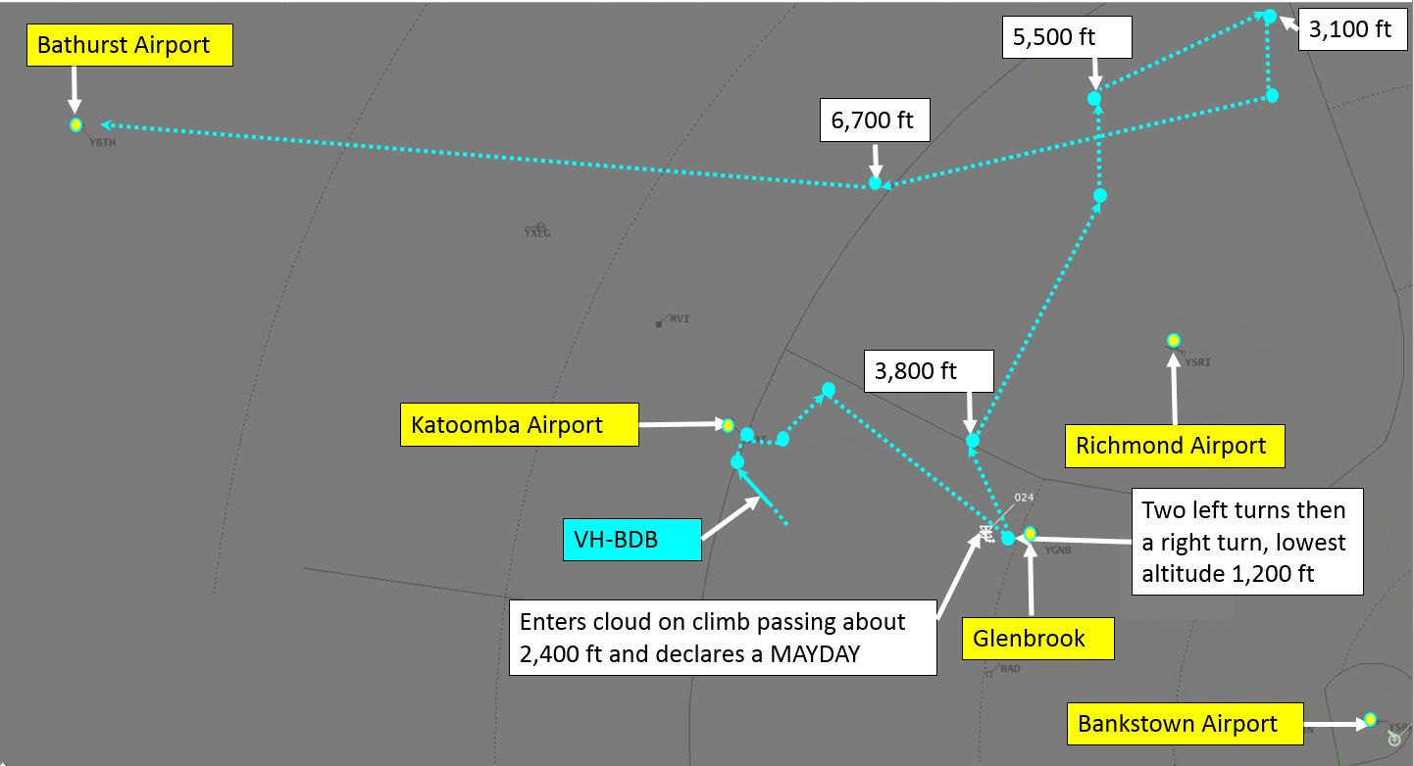
Source: Airservices Australia – annotated by the ATSB
At about 1511, the pilot saw the cloud appear to be closing in on the planned track ahead. The pilot scanned from the left to the right and assessed that it would not be possible to continue on their current track and remain clear of cloud, so commenced a right turn. The aircraft then entered cloud.
At about 1512, the pilot contacted Bankstown Tower air traffic control and declared a mayday. By the time the pilot had completed the transmission, the aircraft had flown clear of the cloud. About 90 seconds later, the pilot advised the tower controller that they had stabilised flight and that the aircraft was then at 3,000 ft tracking into the Richmond restricted airspace without a clearance, to remain clear of cloud. According to the radar data, the aircraft entered Richmond airspace at about 1515, on climb passing 3,800 ft. The tower controller coordinated with Sydney Approach to provide the pilot with a clearance, then advised the pilot to contact Sydney Approach for assistance.
At about 1516, the approach controller assigned the aircraft a discrete transponder code, and asked the pilot to advise their current situation regarding visibility, and their intentions. The pilot responded that they were then on top of cloud and unable to find a way down. The pilot elected to continue tracking to the north where the weather was clearer and away from the rising ground to the west. The aircraft tracked north and then north-east (Figure 1).
The pilot then advised that the aircraft’s current altitude was 5,000 ft and climbing. The controller responded with a clearance to continue on their current heading at 5,000 ft, which was well above the radar lowest safe altitude on that track, and to advise if a change in level or heading was required. The controller subsequently advised the pilot to remain in visual meteorological conditions (VMC) and to deviate around cloud if necessary.
At about 1519, the controller contacted Richmond and Williamtown air traffic control to obtain updated weather information to assist the pilot. The controller at Williamtown responded that it was hard to tell what the cloud was like due to the rain, but that there was a lower cloud band to the west than to the north-east.
About 2 minutes later, the pilot advised the controller that they could see the ground and were assessing their options to get down under the cloud. The controller asked the pilot to confirm that they could maintain separation from the cloud and terrain while descending through the gap.
The pilot then advised that they required a left turn to remain clear of cloud, and the controller asked the pilot to confirm they were maintaining 5,000 ft as the transponder was not displaying altitude. The pilot realised that they had inadvertently selected the altitude mode on the transponder off and switched it on, then advised the controller they were now maintaining 5,500 ft and required further left turn.
The aircraft was then heading west, and the pilot stated to the controller that their best option would be to get over the escarpment and divert to Bathurst. The controller asked the pilot what the aircraft’s remaining fuel endurance was, but the pilot was unable to calculate the endurance due to the high workload to remain clear of cloud.
At about 1525, the aircraft was 10 NM north of Richmond aerodrome. The pilot advised that there was a large opening to their right and advised that they were turning onto a heading of 050° and shortly after, advised they were commencing a descent. The controller responded that the radar lowest safe altitude in the area was 3,500 ft and asked the pilot to confirm they were able to maintain visual contact with terrain on descent. The pilot confirmed they could maintain VMC through the gap in the cloud and was then cleared to descend visual with terrain.
At about 1527, the controller advised that they had confirmation of visual conditions towards Bathurst. The pilot stated that they would assess over the next 5 miles. In response to a request for their endurance, the pilot stated that they were busy keeping clear of cloud, and would get back with the endurance shortly. The aircraft was then tracking north-east at 5,000 ft, and descended to 4,200 ft by about 1529. The controller then advised that the radar lowest safe altitude on the aircraft’s track was now 2,500 ft and confirmed the pilot was still visual with terrain. A minute later, the aircraft had descended to about 3,500 ft, and the controller advised that the radar lowest safe altitude was 2,700 ft on the aircraft’s current heading, and again asked the pilot to confirm they were still visual with terrain and that at their current rate of descent, they had plenty of space to remain in VMC. The pilot responded that they were still visual with terrain but needed a left turn to remain clear of cloud. The controller responded that the pilot could turn as required, and advised the pilot that the main thing was to maintain in VMC. The aircraft descended to 3,000 ft during the left turn.
At about 1532, the pilot stated that Bathurst was ‘starting to look good’. The controller again reminded the pilot to maintain VMC at all times. The pilot responded that the gaps were closing up every time they approached one. The aircraft climbed and tracked west-south-west. The controller asked whether the pilot was using carburettor heat. Then the controller advised that the weather was CAVOK at Bathurst and probably just climbing above the cloud, maintaining VMC and tracking to Bathurst would be the best plan from the information available at that stage. Again, the controller stated that the main thing was to stay in VMC.
The pilot then turned the aircraft onto a heading direct to Bathurst. The controller advised that they were now well above the lowest safe altitude in the area, and requested the fuel endurance. The pilot advised that they had sufficient fuel endurance to Bathurst with 45 minutes reserve and at present, were focused on flying the aircraft but could work out the actual endurance once clear of the cloud.
At about 1538, the controller advised that the aircraft had about 56 miles to run to Bathurst and was heading in a good general direction. The pilot reported that they had 5 km terrain visibility and were going to be doing a bit of cloud dodging to maintain the altitude (the aircraft was still at 6,700 ft).
At 1542, the controller asked whether they were visual with terrain in any direction and the pilot responded that they were visual with terrain directly below and behind, and bits ahead through quite a large gap in the cloud. The controller advised that there was report of overcast at Bathurst at 9,500 ft. Three minutes later, the controller asked how the weather directly in front looked, and whether the pilot had seen anywhere they might be able to descend to Bathurst. The pilot responded that everything was opening up ahead.
The aircraft exited controlled airspace at about 1546 tracking direct to Bathurst at 6,700 ft. At about 1550, the pilot reported they were commencing descent into Bathurst. The controller confirmed that the pilot would be able to maintain visual with terrain and advised the pilot to contact air traffic control on the area frequency.
The aircraft landed on runway 17 at Bathurst without further incident.

Weather information

Aerodrome terminal information service
The aerodrome terminal information service (ATIS) current at Bankstown around the time of the incident included that pilots were to expect an instrument approach, the runways were wet, visibility was 5,000 m in rain, and there were layers of cloud with bases at 1,500 and 2,000 ft.

Forecast
The relevant area forecasts valid for the flight included Area 20 and Area 21. The forecast weather was for multiple layers of cloud, including low cloud with a base of 1,000 ft AMSL. The visibility included reducing to 4,000 m in showers of rain. At Mt Victoria, about 9 NM north-northwest of Katoomba, there was a forecast of cloud on the ground and showers of rain.
The forecast for Bankstown Airport included showers of rain with cloud bases at about 2,000 ft, with the chance of lower cloud at 1,000 ft. Bathurst Airport forecast included precipitation and the chance of low cloud 800 ft above the aerodrome.

Pilot comments
The pilot provided the following comments:
- The aircraft was only in cloud for about 3 to 5 seconds, and the pilot felt confident in using the instruments to maintain control of the aircraft.
- When the aircraft entered cloud, instead of turning right, in hindsight the pilot thought they should have moved the aircraft to the right of the corridor between clouds and then turned left to remain clear of cloud.
- Air traffic control was ‘brilliant’ – the pilot did not feel alone, and was looked after. The controller provided the radar lowest safe altitude in the location, and the pilot found it reassuring. The visibility was about 5–6 km, and it was helpful to know that the weather was more open ahead.
- The weather conditions were in accordance with the forecast to Katoomba, but around Glenbrook, the pilot was expecting a cloud base of about 1,500 to 2,000 ft above ground level (AGL), but it was more like 500 ft AGL.
- Based on the forecast, the pilot assessed that the weather conditions were marginal, but it may be possible to land at Bankstown. The pilot had planned to divert to Bathurst if it did not look possible to get to Bankstown in VMC.

Safety message
This incident highlights the benefits of seeking assistance from ATC when a pilot is in difficulty. It enabled ATC to provide appropriate assistance including clearance into controlled airspace, and to prioritise their resources. Airservices Australia commented that under the circumstances, it would have been more effective for the pilot to broadcast a MAYDAY on the area frequency than on Bankstown Tower frequency. On the area frequency, ATC would have been able to provide more immediate and direct assistance.
Pilots are encouraged to make conservative decisions when considering how forecast weather may affect their flight. If poor weather is encountered en route, timely and conservative decision making may be critical to a safe outcome. VFR pilots are also encouraged to familiarise themselves with VMC criteria detailed in the Aeronautical Information Publication (AIP) Australia, and carefully consider available options where forecast or actual conditions are such that continued flight in VMC cannot be assured.
The ATSB SafetyWatch highlights the broad safety concerns that come out of our investigation findings and from the occurrence data reported to us by industry. Flying with reduced visual cues such as in this occurrence remains one of the ATSB’s major safety concerns.
The ATSB publication Accidents involving Visual Flight Rules pilots in Instrument Meteorological Conditions, lists three key messages for pilots:
- Avoiding deteriorating weather or instrument meteorological conditions (IMC) requires thorough pre-flight planning, having alternate plans in case of an unexpected deterioration in the weather, and making timely and decisions to turn back or divert.
- Pressing on into IMC with no instrument rating carries a significant risk of severe spatial disorientation due to powerful and misleading orientation sensations in the absence of visual cues. Disorientation can affect any pilot, no matter what their level of experience.
- VFR pilots are encouraged to use a personal minimums checklist to help identify and manage risk factors that include marginal weather conditions.
Also available from CASA’s online store are:
Weather to Fly DVD – highlights the dangers of flying in cloud and ways to avoid VFR into IMC.
Flight Planning – always thinking ahead. A flight-planning guide designed to help you in planning and conducting your flight. This guide includes a personal minimums checklist.
A similar incident occurred on 21 April 2016, and the pilot advised ATC they had entered cloud and requested assistance. The controller identified the aircraft using ADS-B and provided heading and turn guidance to the pilot. The aircraft landed safely.

General details

Occurrence details
Date and time: | 29 March 2016 – 1512 EDT
Occurrence category: | Incident
Primary occurrence type: | VFR into IMC
Location: | 33 km W of Bankstown Airport, New South Wales
 | Latitude: 33° 45.75' S | Longitude: 150° 41.08' E

Aircraft details
Manufacturer and model: | Piper Aircraft Corporation PA-28
Registration: | VH-BDB
Serial number: | 2843425
Type of operation: | Private – Pleasure/Travel
Persons on board: | Crew – 1 | Passengers – 0
Injuries: | Crew – 0 | Passengers – 0
Aircraft damage: | Nil

Helicopters

Collision with terrain involving Robinson R22, VH-RGY

What happened
On 21 March 2016, at about 1200 Eastern Standard Time (EST), the pilot of a Robinson R22 helicopter, registered VH-RGY, prepared to conduct a private ferry flight from Richmond Airport to Bow Park Station, Queensland. The pilot was the only person on board. The helicopter had been parked at the airport for 12 days, with the doors on.
As the pilot rolled the throttle on to start the helicopter’s engine, the pilot discovered the adhesive holding the foam cover of the throttle twist grip had deteriorated and become like grease (Figure 1). The pilot then slid the cover forwards on the collective control to grip the steel column.
Figure 1: Cockpit of Robinson R22, VH-RGY, after the accident
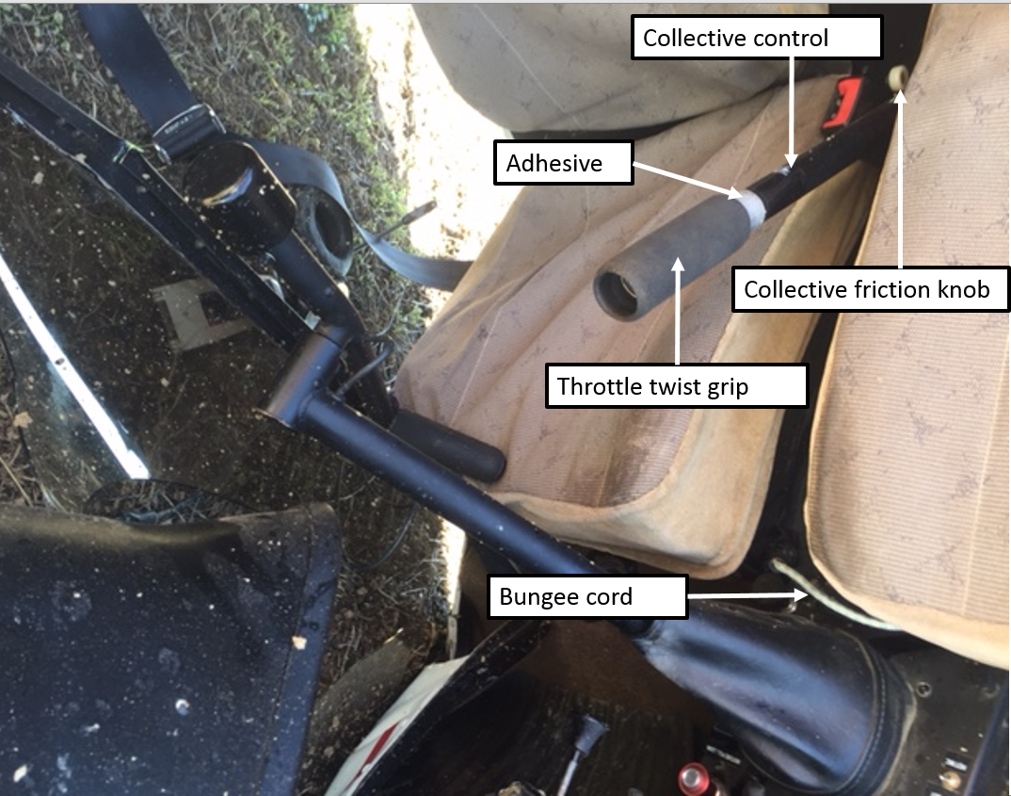
Source: Pilot
After starting the engine, the driver of the vehicle that had taken the pilot to the airport radioed to tell the pilot that the pilot’s drink bottle was still in the vehicle, and that they would meet the pilot with the drink bottle at the airport exclusion fence.
The pilot reported that they looped the bungee cord fitted to the helicopter over the collective control. The pilot then exited the helicopter, leaving the engine running and the rotor blades turning, and walked about 4 m to the fence. Within about 30 seconds, the pilot heard the helicopter engine RPM increase, and turned and ran back towards the helicopter. The pilot and driver then observed the helicopter rotate away from the direction of the pilot, lift up, into and over the fence and land on its side on the other side of the fence, damaging the fence.
The helicopter sustained substantial damage (Figure 2). The pilot, who was outside of the helicopter was uninjured.
Figure 2: Damage to VH-RGY (after removal from accident site)
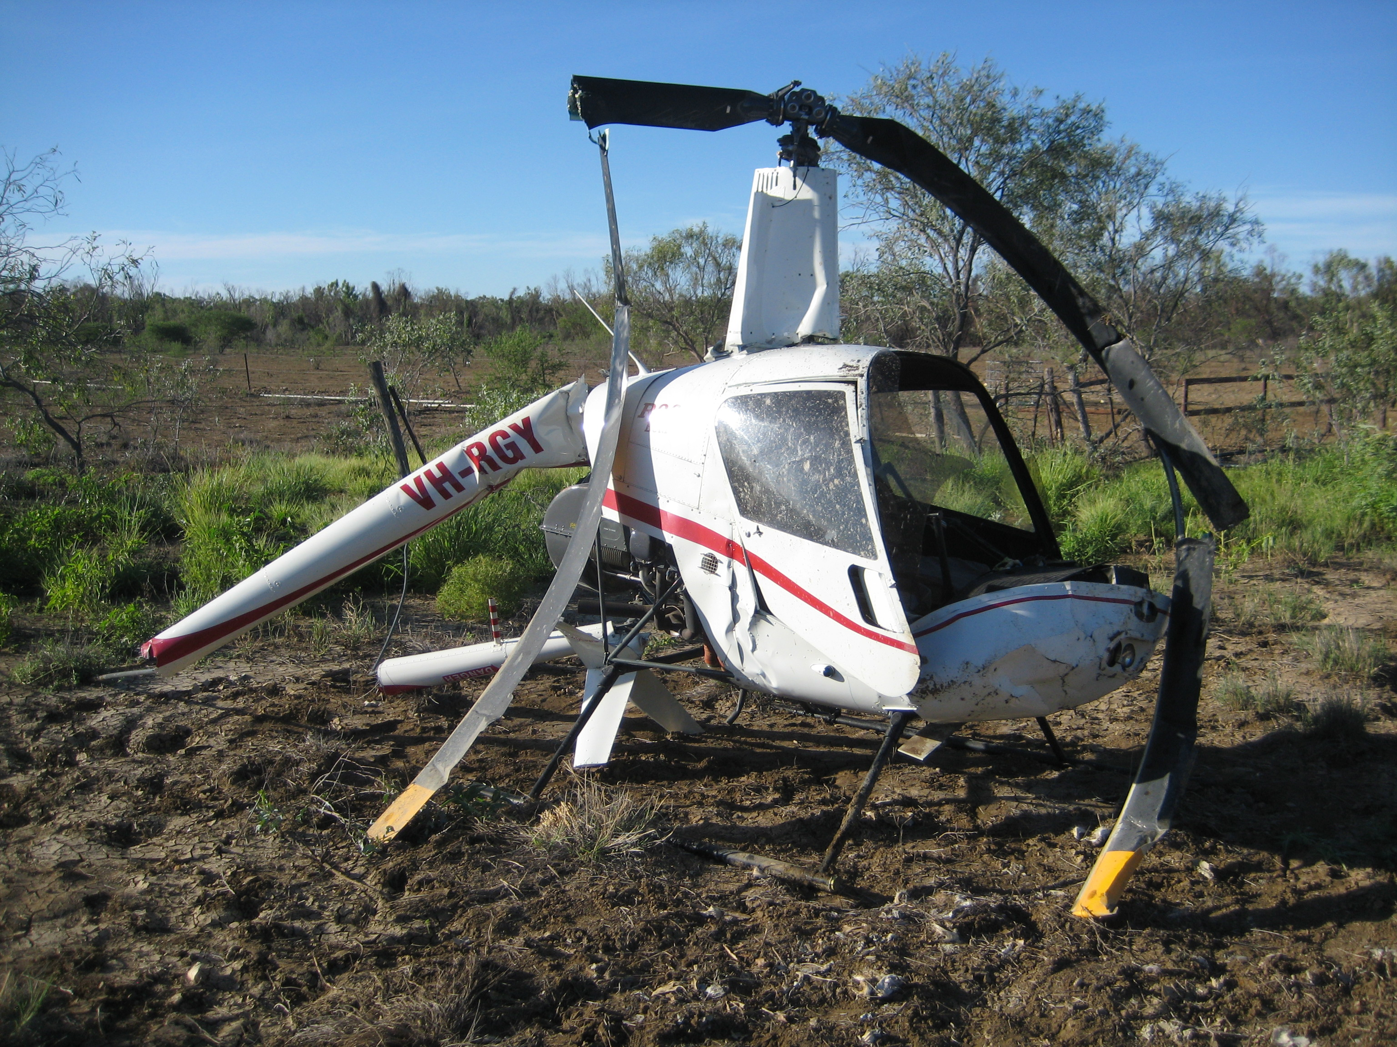
Source: Queensland Police Service

Pilot comments
The pilot reported that they had not had any issues with the adhesive before, despite operating in temperatures over 40 °C, but they did not usually have the doors on. However, even though the temperature was about 35 ⁰C on the day of the accident, the helicopter had been parked for 12 days with the doors on, and the temperature inside the cabin was much hotter. Additionally, there had been rain during the period the helicopter was parked at the airport, increasing the humidity inside the cabin. The pilot believed that the temperature (and possibly combined with high humidity) inside the helicopter must have exceeded the adhesive’s limit. The pilot was unsure whether the adhesive, which had been applied during a rebuild of the helicopter about two years earlier, was the approved adhesive for the grip.
The pilot assessed that because the grip had slid forwards on the collective control, the bungee cord may not have been far enough over the steel column, and it then slid further forwards, allowing the collective to rise, and the helicopter then lifted off.

Adhesive for grip
The R22 Illustrated Parts Catalogue specified Part Number B270-15 Adhesive to be used to install the grip. The specified adhesive was clear, and was manufactured by 3M, with part number 2262. According to the Technical Data for 3M Plastic Adhesive 2262, when the adhesive was tested for ‘plus 7 days’ at 140 °F (60 °C), it failed ‘in adhesion to the indicated substrate (steel)’.
Given the helicopter was parked for over 7 days, with doors on and in hot and humid conditions, this testing suggests that if the approved adhesive was used on the collective grip, it was likely to fail.

Helicopter manufacturer comments
A representative from Robinson Helicopter Company (RHC) advised that the bungee cord was not an RHC installation, nor part of the type design. The post-accident photo (Figure 1) shows that the collective friction knob was in the OFF position, which indicates that the pilot had not applied it. (When tightened to the ‘locked’ position, the collective friction knob is designed to prevent the collective from moving from the position it was locked in.) However, they emphasised that the safest way to prevent similar incidents is to never leave the flight controls unattended while the engine is running.
They had received no other reports of similar events with the grip adhesive. They also commented that a thorough pre-flight check would likely alert the pilot to any issue with the collective grip.

Safety message
Pre-flight checks are designed to ensure the helicopter is capable of operating correctly. To ensure safety of flight, any discovery of an unservicability should be dealt with before flight.
Leaving any vehicle unattended with the engine running carries considerable risk. The Normal Procedures in the R22 Pilot’s Operating Handbook (POH) includes the caution: ‘Never leave helicopter flight controls unattended while engine is running.’ The POH also includes a number of important safety tips and notices. One safety notice with relevance to this accident is Safety Notice 17, which includes the following text:
NEVER EXIT HELICOPTER WITH ENGINE RUNNING
Several accidents have occurred when pilots momentarily left their helicopters unattended with the engine running and rotors turning. The collective can creep up, increasing both pitch and throttle, allowing the helicopter to lift off or roll out of control.

General details

Occurrence details
Date and time: | 21 March 2016 – 1500 EST
Occurrence category: | Accident
Primary occurrence type: | Collision with terrain
Location: | Richmond Airport, Queensland
 | Latitude: 20° 42.12' S | Longitude: 143° 06.88' E

Helicopter details
Manufacturer and model: | Robinson Helicopter Company R22 Beta
Registration: | VH-RGY
Serial number: | 1445
Type of operation: | Private – Test & Ferry
Persons on board: | Crew – 0 | Passengers – 0
Injuries: | Crew – 0 | Passengers – 0
Aircraft damage: | Substantial

Australian Transport Safety Bureau
The Australian Transport Safety Bureau (ATSB) is an independent Commonwealth Government statutory agency. The Bureau is governed by a Commission and is entirely separate from transport regulators, policy makers and service providers. The ATSB’s function is to improve safety and public confidence in the aviation, marine and rail modes of transport through excellence in: independent investigation of transport accidents and other safety occurrences; safety data recording, analysis and research; fostering safety awareness, knowledge and action.
The ATSB is responsible for investigating accidents and other transport safety matters involving civil aviation, marine and rail operations in Australia that fall within Commonwealth jurisdiction, as well as participating in overseas investigations involving Australian registered aircraft and ships. A primary concern is the safety of commercial transport, with particular regard to fare-paying passenger operations.
The ATSB performs its functions in accordance with the provisions of the Transport Safety Investigation Act 2003 and Regulations and, where applicable, relevant international agreements.

Purpose of safety investigations
The object of a safety investigation is to identify and reduce safety-related risk. ATSB investigations determine and communicate the safety factors related to the transport safety matter being investigated. The terms the ATSB uses to refer to key safety and risk concepts are set out in the next section: Terminology Used in this Report.
It is not a function of the ATSB to apportion blame or determine liability. At the same time, an investigation report must include factual material of sufficient weight to support the analysis and findings. At all times the ATSB endeavours to balance the use of material that could imply adverse comment with the need to properly explain what happened, and why, in a fair and unbiased manner.

About this Bulletin
The ATSB receives around 15,000 notifications of Aviation occurrences each year, 8,000 of which are accidents, serious incidents and incidents. It also receives a lesser number of similar occurrences in the Rail and Marine transport sectors. It is from the information provided in these notifications that the ATSB makes a decision on whether or not to investigate. While some further information is sought in some cases to assist in making those decisions, resource constraints dictate that a significant amount of professional judgement is needed to be exercised.
There are times when more detailed information about the circumstances of the occurrence allows the ATSB to make a more informed decision both about whether to investigate at all and, if so, what necessary resources are required (investigation level). In addition, further publically available information on accidents and serious incidents increases safety awareness in the industry and enables improved research activities and analysis of safety trends, leading to more targeted safety education.
The Short Investigation Team gathers additional factual information on aviation accidents and serious incidents (with the exception of 'high risk operations), and similar Rail and Marine occurrences, where the initial decision has been not to commence a 'full' (level 1 to 4) investigation.
The primary objective of the team is to undertake limited-scope, fact gathering investigations, which result in a short summary report. The summary report is a compilation of the information the ATSB has gathered, sourced from individuals or organisations involved in the occurrences, on the circumstances surrounding the occurrence and what safety action may have been taken or identified as a result of the occurrence.
These reports are released publically. In the aviation transport context, the reports are released periodically in a Bulletin format.
Conducting these Short investigations has a number of benefits:
- Publication of the circumstances surrounding a larger number of occurrences enables greater industry awareness of potential safety issues and possible safety action.
- The additional information gathered results in a richer source of information for research and statistical analysis purposes that can be used both by ATSB research staff as well as other stakeholders, including the portfolio agencies and research institutions.
- Reviewing the additional information serves as a screening process to allow decisions to be made about whether a full investigation is warranted. This addresses the issue of 'not knowing what we don't know' and ensures that the ATSB does not miss opportunities to identify safety issues and facilitate safety action.
- In cases where the initial decision was to conduct a full investigation, but which, after the preliminary evidence collection and review phase, later suggested that further resources are not warranted, the investigation may be finalised with a short factual report.
- It assists Australia to more fully comply with its obligations under ICAO Annex 13 to investigate all aviation accidents and serious incidents.
- Publicises Safety Messages aimed at improving awareness of issues and good safety practices to both the transport industries and the travelling public.

At altitudes above 10,000 ft in Australia, an aircraft’s height above mean sea level is referred to as a flight level. Flight level 320 equates to 32,000 ft.
An internationally recognised radio call announcing an urgency condition which concerns the safety of an aircraft or its occupants but where the flight crew does not require immediate assistance.
Mayday is an internationally recognised radio call for urgent assistance.
The TAWS included a forward-looking terrain avoidance function along and below the aircraft’s lateral and vertical flight path. In the event of a potential conflict with terrain, the system provided the pilots with visual and aural alerts.
Visual flight rules are a set of regulations which allow a pilot to only operate an aircraft in weather conditions generally clear enough to allow the pilot to see where the aircraft is going.
Scheduled reports are an option to meet search and rescue requirements for aircraft who do not meet the normal CAR 258 requirements for overwater flight. Information available in the Aeronautical Information Publication ENR 1.1.100.
At altitudes above 10,000 ft in Australia, an aircraft’s height above mean sea level is referred to as a flight level (FL). FL 370 equates to 37,000 ft.
Pilot flying (PF) and pilot monitoring (PM) are procedurally assigned roles with specifically assigned duties at specific stages of a flight. The PF does most of the flying, except in defined circumstances; such as planning for descent, approach and landing. The PM carries out support duties and monitors the PF’s actions and aircraft flight path.
Traffic collision avoidance system (TCAS) is an aircraft collision avoidance system. It monitors the airspace around an aircraft for other aircraft equipped with a corresponding active transponder and gives warning of possible collision risks.
A meteorological unit of measurement giving the amount of cloud present at any one location.
Overcast means a total sky coverage of this cloud (100%).
ADS-B, or automatic dependent surveillance – broadcast, automatically broadcasts the precise location of the aircraft via a digital data link. The data can be used by other aircraft and ATC to show the aircraft’s position and altitude on display screens without the need for radar.
At the time of this publication, these aerodromes were known as non-towered. CASA have since updated this definition to include all aerodromes/airports where a control service is not currently in place. This can apply to Class C or D airports when Tower is not operating.
Forged shape.
Flight manoeuvre where the flight path is inclined downwards and there is a steady loss of height without significant change in airspeed. The longitudinal axis of the aircraft is markedly displaced from the flightpath.
Detonation is the uncontrolled explosion of the fuel/air mixture in the combustion chamber of a piston engine cylinder, as distinct from an even and progressive burning. Light to medium detonation may result in some mechanical damage.
The aircraft was over mountainous terrain at the time of the birdstrike, suggesting that the height above ground level was substantially less than 5,500 ft.
MAYDAY is an internationally recognised radio call for urgent assistance.
Aerodynamic stall is a term used when the wing is no longer producing enough lift to support the weight of the aircraft.
A Distress Phase (DISTRESFA) is an emergency phase declared by ATC when there is reasonable certainty that the aircraft and its occupants are threatened by grave and imminent danger and require immediate assistance.
The pilot remembered making more emergency calls than the two initial MAYDAY calls, but ATC did not receive the later calls.
Tooradin Airfield is an aircraft landing area (ALA).
Visual flight rules (VFR) are a set of regulations which allow a pilot to only operate an aircraft in weather conditions generally clear enough to allow the pilot to see where the aircraft is going.
Mayday is an internationally recognised radio call for urgent assistance.
Lowest safe altitude (LSALT) is the lowest altitude which will provide safe terrain clearance at a given place.
VMC is determined by the minimum flight visibility and minimum horizontal and vertical distances from cloud that the pilot in command (PIC) must maintain within certain classes of airspace..
Ceiling and visibility OK, meaning that the visibility, cloud and present weather are better than prescribed conditions. For an aerodrome weather report, those conditions are visibility 10 km or more, no significant cloud below 5,000 ft or cumulonimbus cloud and no other significant weather within 9 km of the aerodrome.
An automated pre-recorded transmission indicating the prevailing weather conditions at the aerodrome and other relevant operational information for arriving and departing aircraft.
Instrument meteorological conditions (IMC) describes weather conditions that require pilots to fly primarily by reference to instruments, and therefore under Instrument Flight Rules (IFR), rather than by outside visual references. Typically, this means flying in cloud or limited visibility.
A primary helicopter flight control that simultaneously affects the pitch of all blades of a lifting rotor. Collective input is the main control for vertical velocity. The collective control of the Robinson R22 incorporates a throttle mechanism designed to increase engine revolutions per minute (RPM) automatically as collective is applied.

