
ATSB Transport Safety Report
Aviation Short Investigations
AB-2016-044
Final – 27 May 2016

Aviation Short Investigations Bulletin
Issue 48

Released in accordance with section 25 of the Transport Safety Investigation Act 2003

Publishing information

Published by: Australian Transport Safety Bureau
Postal address: PO Box 967, Civic Square ACT 2608
Office: 62 Northbourne Avenue Canberra, Australian Capital Territory 2601
Telephone: 1800 020 616, from overseas +61 2 6257 4150 (24 hours)
Accident and incident notification: 1800 011 034 (24 hours)
Facsimile: 02 6247 3117, from overseas +61 2 6247 3117
Email: atsbinfo@atsb.gov.au
Internet: www.atsb.gov.au

© Commonwealth of Australia 2016



Ownership of intellectual property rights in this publication
Unless otherwise noted, copyright (and any other intellectual property rights, if any) in this publication is owned by the Commonwealth of Australia.

Creative Commons licence
With the exception of the Coat of Arms, ATSB logo, and photos and graphics in which a third party holds copyright, this publication is licensed under a Creative Commons Attribution 3.0 Australia licence.

Creative Commons Attribution 3.0 Australia Licence is a standard form license agreement that allows you to copy, distribute, transmit and adapt this publication provided that you attribute the work.

The ATSB’s preference is that you attribute this publication (and any material sourced from it) using the following wording: Source: Australian Transport Safety Bureau

Copyright in material obtained from other agencies, private individuals or organisations, belongs to those agencies, individuals or organisations. Where you want to use their material you will need to contact them directly.

Contents
Turboprop aircraft
Engine malfunction involving Cessna 208B, VH-LNH 2
Flap system failure leading to loss of control involving Cessna 208 9
Near collision involving Cessna 210L, VH-TCI, and Cessna 208,
VH-PGA 14
Piston aircraft
Landing accident involving Cessna 180C, VH-FDH 20
Wheels up landing, involving a Nanchang CJ-6, VH-ALO 24
Incorrect configuration resulting in a collision with terrain involving Cessna R182, VH-PFZ 28
Helicopters
Foreign object damage involving an Eurocopter AS365 N3 Dauphin,
VH-WPX 33
Collision with terrain involving a Robinson R22, VH-HWJ 38
Wirestrike and collision with terrain involving Robinson R22, VH-LYW 41
Hot Air Balloons
Wirestrike involving Kavanagh G 450 balloon, VH-RUW 45

Turboprop aircraft

Engine malfunction involving Cessna 208B, VH-LNH

What happened
On 8 August 2015 at about 0930 Western Standard Time (WST), a Cessna 208B, registered VH-LNH, departed Kununurra, Western Australia, on a scenic flight to the Bungle Bungle Range. On board were the pilot and 12 passengers. The weather was fine and clear, with an easterly wind blowing at about 13 knots. The pilot conducted all normal pre-flight procedures, including an engine run-up to confirm that the engine and other systems were functioning normally.
The flight departed from runway 12 and made a right turn to the south to follow the standard Kununurra to Bungles departure route. After levelling at about 700 ft above mean sea level (about 550 ft above ground level), the pilot reduced engine power and propeller RPM for a level segment of the departure. The pilot then commenced a commentary for the benefit of the passengers.
Soon after the pilot commenced the commentary, when the aircraft was about 1.5 NM south of the airport, engine oil appeared on the windscreen. The pilot turned back towards the airport but oil on the windscreen soon turned into an opaque film, substantially limiting forward visibility. Additionally, a number of engine instrument indications were abnormal and white smoke began to enter the cabin through cockpit vents. Although the smoke dissipated quickly, the pilot continued to monitor for any signs of a fire in the engine compartment.
The pilot made a MAYDAY call on the Kununurra CTAF, broadcasting that the engine had failed and that the aircraft was returning to land on runway 12. The pilot of another aircraft operating in the area at the time heard the MAYDAY call and relayed relevant information to Air Traffic Control (ATC) (located in Brisbane), who initiated an emergency response.
At around the same time that the pilot made the MAYDAY call, they also attempted to ascertain the extent of the engine malfunction. Advancing the power lever produced a change in engine sound and an increase in engine torque. Although the propeller was turning, there was no audible response and no apparent change in propeller RPM when the pilot advanced the propeller lever. The pilot also noted that the engine low oil pressure light was illuminated, and deduced that the propeller had probably feathered as a consequence of engine oil loss.
The pilot found that the engine/propeller were capable of providing a small amount of positive thrust (but not sufficient to maintain level flight), so established the aircraft in descent, holding a speed of about 85 to 95 knots. The pilot elected to leave the flaps set at 10 degrees, which was the same position that was set at the time the engine problem first became apparent. The pilot assessed that the aircraft could reach runway 12, but with little margin.
Another aircraft operated by the same company as the aircraft involved in the incident was about to depart Kununurra, and had lined up on runway 12. Upon hearing the MAYDAY call, the pilot of that aircraft vacated the runway. The incident pilot advised the pilot in the other aircraft (vacating the runway) of the nature of their predicament, particularly the extent to which forward visibility was affected, and sought their assistance. The incident pilot also advised the Airport Safety Officer on the CTAF that assistance may be required after landing, and advised the passengers that an emergency landing at Kununurra was required.
With forward visibility substantially limited, the pilot maintained orientation using ground based navigation aids, GPS information and the view of landmarks from the side windows. The dark shape of a nearby waterway to the south of the airport was evident, but forward visibility was so poor that the pilot was unable to effectively identify roadways or cleared areas through the windscreen.
With some directional guidance from the pilot of the aircraft that had vacated the runway, and by reference to navigational instruments, the incident pilot was able to position the aircraft on final approach to runway 12. The turn onto final approach was made through about 100 degrees, at around 150 ft above ground level, and required about 50 degrees angle of bank. The pilot elected to leave the flap setting at 10 degrees throughout the approach and for the landing. The aircraft landed firmly, with the pilot unable to effectively judge flare height due to the restricted visibility.
After landing, the pilot found that forward visibility was obscured to the extent that they were unable to taxi safely. The Airport Safety Officer moved alongside the aircraft in a vehicle to guide the pilot to the next taxiway exit. When safely clear of the runway, the pilot contacted ATC and cancelled the MAYDAY.
The time from take-off to landing was about 2 minutes and 15 seconds. From the time the pilot broadcast a MAYDAY call to the time of landing was about 1 minute and 20 seconds. At its furthest point, the aircraft was about 2.3 NM south of the airport.
After exiting the runway and coming to a stop, the pilot completed the engine shut-down checks. No reaction was felt or heard when the pilot selected the propeller lever to the feather position as part of the shutdown procedure (normally, there was an audible change as the pitch of the propeller changed). After exiting the aircraft, the pilot found that the propeller was in the feather position, and had seized. The extent of oil loss was also apparent, with oil smeared over much of the forward fuselage, particularly the engine cowls and windscreen (Figure 1).
Figure 1: Photographs of VH-LNH after the aircraft had landed, with oil visible on the engine cowl and forward fuselage
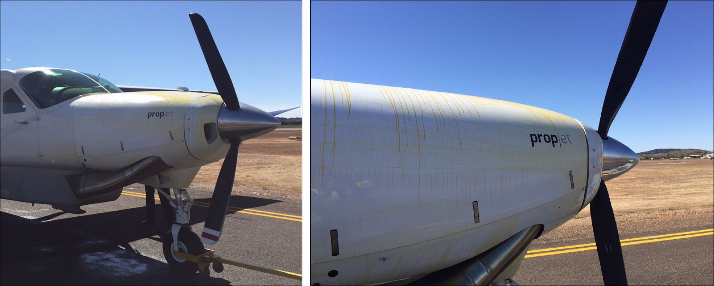
Source: Aircraft operator
Aside from the apparent engine and propeller system problem, there was no damage to the aircraft and the pilot and passengers were uninjured.
Subsequent on-site inspection of the engine by engineering staff revealed that an oil leak had developed at a join between the oil transfer elbow and oil transfer tube at the forward end of the engine. This assembly was part of a larger assembly that transferred oil under pressure to the reduction gearbox at the front of the engine. One of the oil transfer elbow mounting lugs (that secured the elbow to engine assembly) was found to be fractured, allowing the oil transfer elbow to move and unseat the O-ring between the elbow and the tube (Figures 2 and 3).
Figure 2: Photograph (in situ) showing fractured oil transfer elbow mounting lug and the unseated O-ring seal
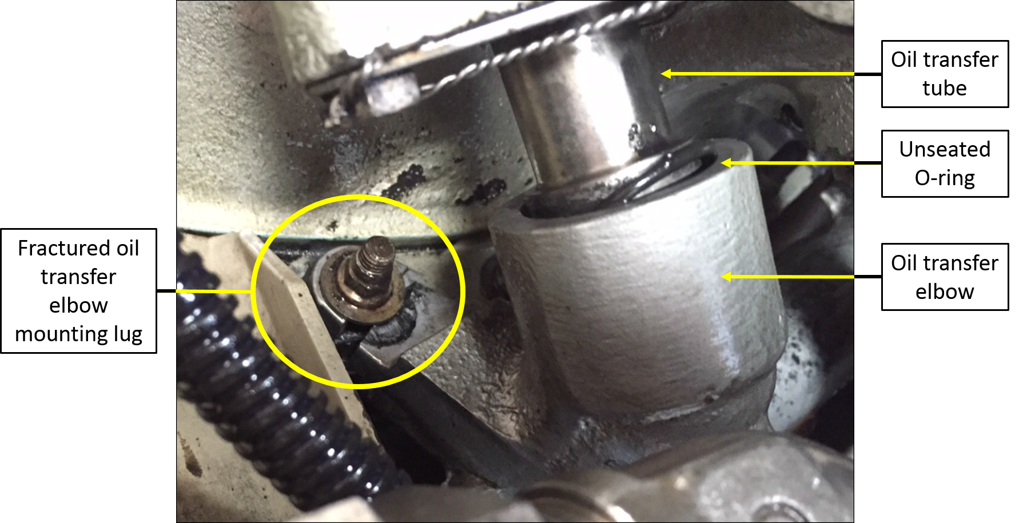
Source: Aircraft operator (annotations by the ATSB)
Figure 3: Oil transfer elbow assembly
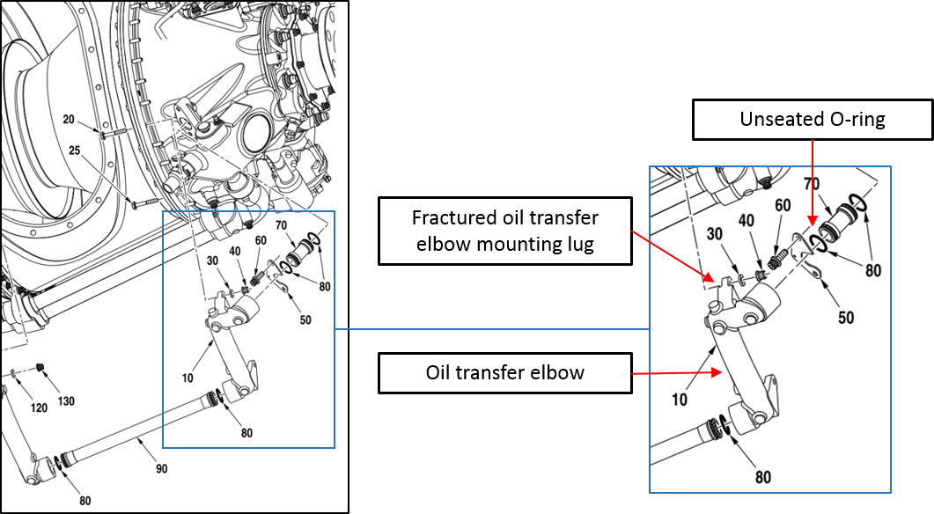
Source: Engine manufacturer (annotations by the ATSB)

Technical follow-up
Following the incident, the operator submitted a Service Difficulty Report (SDR) to CASA. The engine was removed from the aircraft by the operator and dispatched to a repair and overhaul facility for further examination. The oil transfer elbow (with cracked mounting lug) was removed and sent to the engine manufacturer for detailed analysis. The results of those examinations are summarised in the following paragraphs.

Engine teardown
The engine teardown did not reveal any unrelated engine abnormalities that might have contributed to the oil transfer elbow mounting lug fracture. Among other things, the report noted that there was little or no engine oil remaining in the engine and that the reduction gearbox could only be turned with considerable force (more than the amount of force that would normally be required). The report also noted that the propeller shaft would not rotate.
Inspection of the engine confirmed that an oil transfer elbow mounting lug had fractured and the report noted that the ‘hardware holding it in place was loose’. The lug was found to have completely broken through, and it was noted that a segment of the lug was missing (Figure 4). The report also noted that the O-ring (see Figures 2 and 3) had moved.
Figure 4: Fractured lug (the figure on the right shows that a segment of the lug was missing)
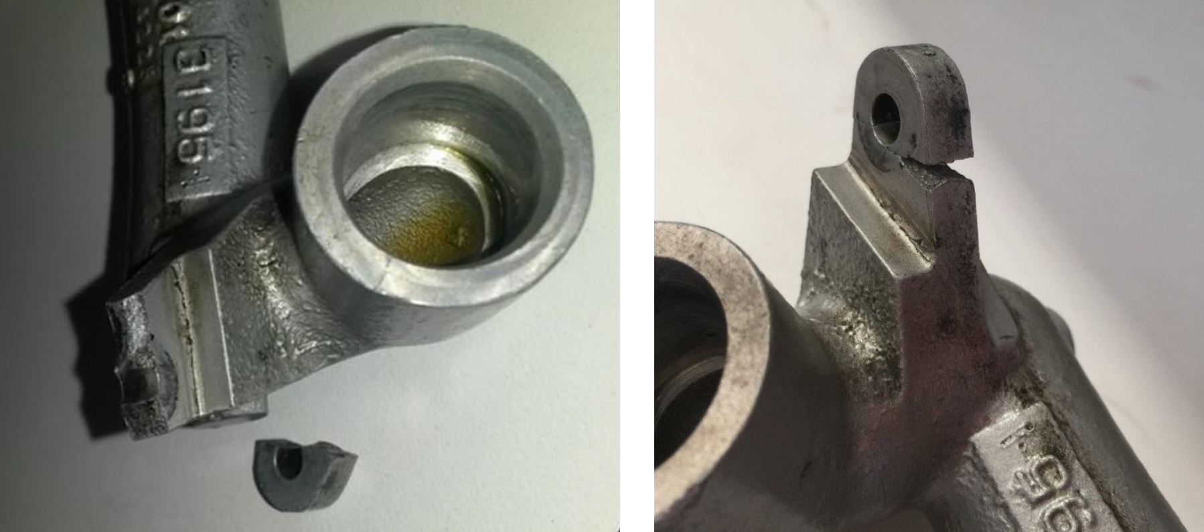
Source: Pacific Turbine (left) and CASA (right)

Mounting lug fracture analysis
The manufacturer’s examination of the fractured oil transfer elbow mounting lug and associated securing assembly allowed them to draw a number of conclusions, including:
- The fracture of the lug occurred due to fatigue originating from multiple locations on the side of the mounting lug that meets with the face of the mounting flange. The fatigue mode was found to be high-cycle, under unidirectional bending.
- Wear and imprint marks on the securing assembly (bolt, nut and washer) and the fractured lug suggested that the bolt was sitting askew in the bore of the flange to which the elbow mounting lug was secured. The report commented that this wear pattern was consistent with a lack of pre-load on the bolt.
- The lack of pre-load on the bolt that secured the mounting lug to the flange was considered to be the initiating factor that led to fracture of the mounting lug. The reason for the lack of pre-load on the bolt could not be ascertained.
- Impact marks were identified on the oil transfer elbow, which may have been caused by interference from tooling used to conduct unrelated maintenance in the vicinity of the oil transfer elbow. This damage was found to be superficial which suggested that it played no part in fracture of the mounting lug.

CASA comments
At the time that this report was prepared, CASA was continuing to consider relevant information, including the manufacturer’s fracture analysis report. Notwithstanding their ongoing consideration of relevant information, CASA did not believe that there was any conclusive evidence of a lack of pre-load on the bolt. CASA commented to the effect that the typical signs of an incorrectly torqued fastener were not evident, and noted that the separated portion of the lug remained in place after the lug had fractured – that was unlikely if there was a lack of pre-load on the bolt. CASA also commented to the effect that incorrect installation of the oil transfer elbow (mounting lug), rather than incorrect installation of the mounting lug bolt, may have been the origin of the problem. CASA reported that this is a scenario that is known to have occurred in practise.

Engine teardown facility comments
Staff from the engine teardown facility suggested that the following may assist in preventing similar occurrences:
- Paint-free lug and flange mating surfaces: Paint on the elbow mounting lug and/or the mating face of the flange to which the lug is secured may wear with working and vibration. This wear has the potential to loosen the fastener and amplify the effects of vibration on lug security.
- Lug strengthening: The construction of the elbow transfer tube is such that the mounting lug itself is substantially narrower than the stem leading to the lug (see Figure 4). Added thickness/material depth would strengthen the lug.
- Expanded and mandated inspection: Mandating inspection of the elbow mounting lug (see CASA Airworthiness Bulletin 72-004 below), and including oil transfer elbow mounting lug inspection as a specific task during relevant engine servicings.

Related background information

Similar occurrences
ATSB investigations AO-2010-005, AO-2008-005 and AO-2010-003 identified the failure of the same oil transfer elbow fitting that fractured in the case of this occurrence. In two cases (AO-2008-005 and AO-2010-005), the investigations found that oil transfer elbow mounting lug failures were a consequence of other unrelated engine problems (compressor turbine blade failures). In one case (AO-2010-003), both oil transfer elbow mounting lugs were fractured, but the cause of those fractures could not be conclusively determined.
Advice from the engine manufacturer suggested that there have been a number of oil transfer elbow mounting lug failures reported over the past 15 years, including those investigated by the ATSB. In most cases, either a vibration source or mechanically induced damage was found to be a contributor. The manufacturer identified the possibility that tooling could interfere with the elbow fitting during removal and installation of nearby engine components.

Possible sources of oil transfer elbow damage – manufacturer comments
During the course of the investigation (but aside from the specific nature of the mounting lug fracture in this case), the engine manufacturer highlighted possible sources of oil transfer elbow damage that could ultimately lead to mounting lug fracture. While these comments may not be specifically relevant in this case, they are noteworthy and warrant the attention of organisations involved in the logistics of transporting and/or maintenance of PT6A-114A and similar engines:
- Pratt and Whitney Canada Service Information Letter. In 2008, the manufacturer issued a Service Information Letter (SIL Gen PT6A-026 applicable to all PT6A engines) to remind operators of the precautions to be taken when installing, removing and performing maintenance on external engine tubes, lines and fittings. The letter pointed out that:
Investigations of incidents in service (including in-flight shut downs) have determined that mishandling tubes and fittings during normal maintenance activities can subject these components to distortion or stresses beyond normal utilisation, leading to fracture during subsequent operation.
- Reduction gearbox chip detector removal/installation. The engine manufacturer commented that the proximity of the oil cooler and reduction gearbox magnetic chip detector may be a factor if tooling used to install or remove those components is allowed to interfere with the oil transfer elbow, and induce mechanical stress on the mounting lug. To that end, the reduction gearbox maintenance manual (in the areas dealing with removal and installation of the magnetic chip detector) included the following caution:
AVOID FORCING OR CONTACT WITH THE OIL PRESSURE TRANSFER ELBOW WHEN YOU REMOVE THE CHIP DETECTOR. DAMAGE TO THE ELBOW MOUNTING LUGS CAN OCCUR RESULTING IN LOSS OF ELBOW RETENTION AND OIL LEAKAGE.

CASA Airworthiness Bulletin 72-004
In 2010, CASA released an Airworthiness Bulletin (AWB) AWB 72-004 which identified a possible link between the incorrect installation of an engine mount bracket assembly (vibration isolator), and fatigue cracking in the oil transfer elbow fitting. The AWB identified the possibility that fatigue failure of the oil transfer elbow fitting may be linked to unusual vibration caused by incorrect installation of the engine upper vibration isolator. The AWB went on to recommend that operators inspect the relevant vibration isolators for correct installation, and inspect oil transfer elbow fittings for any signs of cracking.

Safety action
Whether or not the ATSB identifies safety issues in the course of an investigation, relevant organisations may proactively initiate safety action in order to reduce safety risk. The ATSB understands that the following safety actions are being considered in response to this occurrence.

Engine manufacturer
After reviewing the circumstances surrounding this incident (and noting concerns that the oil transfer elbow may be interfered with or damaged during unrelated engine maintenance in the area of the elbow), the engine manufacturer is considering adding information in relevant publications and issuing a Service Information Letter. Publication amendments are likely to draw attention to the need to refer to relevant instructions if the oil transfer elbow is removed/replaced during fuel nozzle replacement. The Service Information Letter is likely to provide information and warnings with respect to the possibility of damage to the oil transfer elbow during engine maintenance. The Service Information Letter is also likely to include information and warnings related to removal and installation (or other disturbance) of the oil transfer elbow.

Civil Aviation Safety Authority
At the time this report was written, CASA was continuing to consider relevant information, which may lead to a re-issue of AWB 72-004.

Operator
Prior to this incident, the operator was already in the practice of periodically inspecting the area of the fractured lug (although those inspections did not alert the operator to the problem in this case), In response to this incident, the operator intends to expand the periodic inspection to include removal of the bolt and an inspection of the internal radius of the mounting lug for signs of crack development.

Safety message
The manner in which the pilot handled a very difficult set of circumstances provides some positive examples for other pilots to consider.
- The pilot maintained positive control of the aircraft, despite the challenging circumstances. The adage ‘aviate-navigate-communicate’ continues to prove a fundamentally effective prioritisation guide for pilots.
- The pilot used available resources including other pilots, ATC, and the Airport Safety Officer, to assist in dealing with the circumstances. The combined efforts of those involved clearly contributed to a favourable outcome. The principles of effective crew resource management extend to all operations, including single pilot operations.
- The pilot conducted a pre-flight emergency self-briefing. Even though it may be impractical to consider all possible emergency scenarios during a pre-flight emergency self-briefing, having a general plan in mind may be important, particularly when confronted with a time-critical and stressful situation.
The incident highlights also the importance of care and attention to detail when conducting maintenance on aircraft engines and accessories. This is particularly important where critical components are known to be susceptible to damage through interference from tooling or mishandling. Manufacturers, regulatory authorities, operators and aircraft maintenance organisations all have fundamentally important roles to play in maintenance of the highest practicable standards of airworthiness.
General details

Occurrence details
Date and time: | 8 August 2015 – 0932 WST
Occurrence category: | Serious incident
Primary occurrence type: | Engine failure or malfunction
Location: | Near Kununurra Airport, Western Australia
 | Latitude: 15° 48.7’ S | Longitude: 128° 42.3’ E

Aircraft details
Manufacturer and model: | Cessna 208B
Registration: | VH-LNH
Serial number: | 208B0590
Type of operation: | Charter - Passenger
Persons on board: | Crew – 1 | Passengers – 12
Injuries: | Crew – 0 | Passengers – 0
Damage: | Nil (damage contained to engine)

Flap system failure leading to loss of control involving Cessna 208,
VH-VZJ
What happened
On 10 November 2015, at 1200 Eastern Standard Time (EST), a Cessna 208B aircraft, operated as regular public transport Flight 525 by West Wing Aviation, departed Palm Island Airport for Townsville Airport, Queensland. On board were the pilot and eight passengers.
At about 1250 pm, as the aircraft neared Townsville in instrument meteorological conditions (IMC), air traffic control (ATC) issued the pilot with a runway 07 area navigation (RNAV) instrument approach. The pilot configured the aircraft, and commenced the instrument approach. The pilot reported that approaching the final approach fix, the aircraft was configured with the second stage (20°) of flap, and a power setting of about 1200 ft/lb of torque, resulting in an airspeed of about 125 kt.
Shortly after, at about 1,000 ft above ground level (AGL), the pilot broke visual, and selected the third stage of flap (30°) in preparation for landing. However, this selection of flap resulted in a ‘muffled bang’ from outside the aircraft, which the pilot described as sounding like a tyre blow out. The pilot also reported that the aircraft banked ‘violently’ and steeply to the left.
The pilot immediately attempted to reduce the steep angle of bank and regain control by applying opposite (right) aileron. However, the aircraft continued to roll left, with the subsequent secondary aerodynamic effect of yaw to the left. Descending through about 700 ft, and with the aircraft now travelling at about a 45° angle left of the extended runway centreline and still not responding, the pilot applied full opposite rudder. There was some response from the aircraft to this control input, but the pilot reported it was still not ‘under control’.
The pilot immediately retracted the flaps from 30° to 20°, which resulted in them being able to reduce the angle of bank and regain partial control. The pilot alerted ATC that assistance on the ground might be required after landing.
During this sequence of events, the aircraft had travelled so far off course that the pilot was unable to see the runway even though the aircraft remained in visual conditions. The pilot was able to manoeuvre the aircraft onto an oblique approach and land without further incident. Emergency services followed the aircraft as it was taxied clear of the runway to parking. There were no injuries to those on board, and no damage to the aircraft.

Pre-flight and pre-take-off checks
The pilot reported conducting a thorough daily inspection prior to the first flight of the day. This included fully extending the flaps to check all the eyelets, rods and flap travel. During the pre-take-off checks, the pilot also individually checked each stage of flap to check for correct operation. There were no abnormalities.

Initial post-incident inspection
During the taxi to parking, the pilot fully retracted the flaps. With the flaps flush against the trailing edge of the wing, initially, neither the pilot nor the aircraft maintenance engineer could pinpoint the reason for the control issue. However, when the engineer gave the left flap a shake, it fell freely down, unattached on the inboard side. After removing some wing access panels, the engineering inspection discovered a loose flap bell crank retaining bolt.

The Cessna 208B Flap System
The operator provided the following information (modified by the ATSB).
The Cessna 208B flap system is comprised of both mechanical and electrical components. The cockpit flap control selection lever, operated by the pilot, provides input to the flap switch actuator, which controls the primary flap motor. Allowing the pilot to select any flap position between 0 and 30 degrees, with detents at UP, 10, 20 and FULL down settings. The flap actuator assembly drives a bell crank, through a series of pushrods, connecting rods, interconnecting rods, and other bell cranks.
In the event that the primary flap system fails, there is an independent standby switch and motor.
Figure 1: VH-WZJ inboard aft flap bell crank assembly
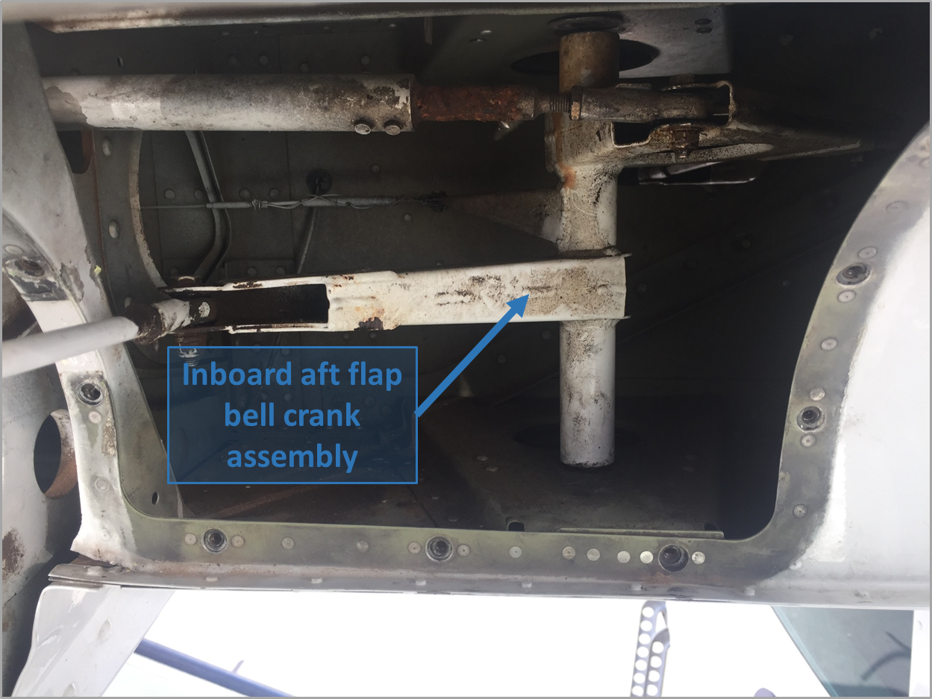

Source: Operator, modified by the ATSB

Operator report
The operator conducted both a ‘hard / overweight landing’ inspection and a ‘severe air turbulence or severe manoeuvres’ inspection after the incident. The operator also sought maintenance guidance from the aircraft manufacturer.
The operator advised that a flap bolt had come loose allowing the lower part of the rear aft bell crank to move free. An inspection indicated that the pivot bolt may not have been lubricated for a long period of time.
The aft bell crank as referenced to in (Figure 2) showed that the assembly is secured into location with a single bolt securing into an anchor nut assembly on the bottom. According to the operator, there was no secondary locking system.
Figure 2: Diagram showing the location of the left wing flap inboard aft bell crank assembly
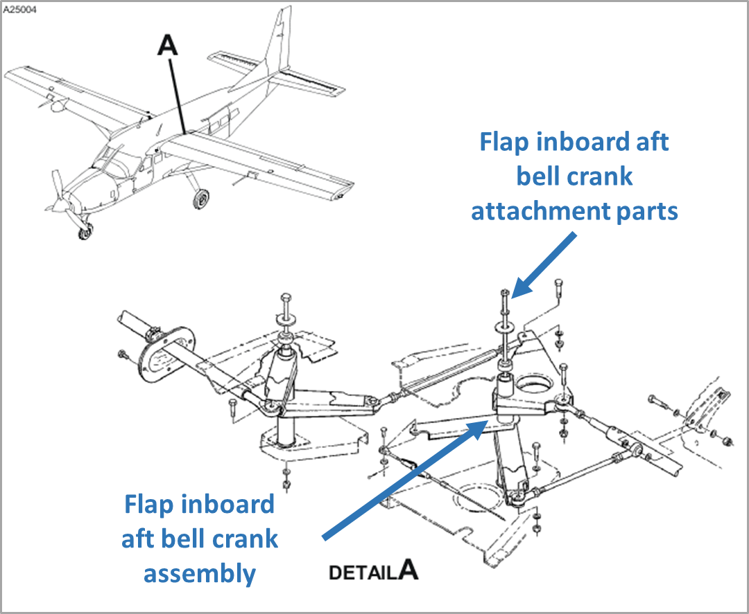
Source: Cessna 208 illustrated parts catalogue, modified by the ATSB

Manufacturer’s (Cessna) recommended maintenance schedule
Reference was made to the Cessna 208 maintenance manual (maintenance manual), chapter 27-50-01 ‘removal and installation procedures' for this component. However, the instructions did not include a recommended torque setting for any hardware in the flap system. Engineers were required to reference a torque setting in chapter 20 of the maintenance manual – the ‘standard practices’ section. The procedures also advised on the requirement for Loctite 242 to be applied to the component.
As a safety measure, the operator checked all other Cessna Caravan aircraft in the fleet. All were found to have the hardware in the flap system correctly torqued.

Independent audit
An independent audit of the operator’s maintenance system did not find any anomalies. All maintenance, relevant airworthiness directives (AD’s) and Cessna service bulletins (SB) had been correctly complied with. All upcoming inspections were also correctly scheduled.
The independent audit noted that there was no maintenance error. However, the audit concluded that there was a causal combination of both the design of the part, and the limitations of the maintenance schedule instructions.

The Civil Aviation Safety Authority’s (CASA) Service Difficulty Report (SDR) system
The ATSB contacted CASA and requested information regarding reports of any similar occurrences to Cessna 208B aircraft. CASA advised that there have been no similar flap hardware failures reported on these aircraft in the last five years (involving Australian aircraft).

Pilot experience and comments
The pilot has in excess of 4,000 hours flying Cessna 208 aircraft.
Once the left flap mechanism had failed, the aircraft was unresponsive to any control input, and it felt like being in a massive crosswind from the right. The right wing was generating a large amount of lift.
The pilot was not aware of the asymmetric flap situation until sometime after landing. The flap indicator had travelled to 30°, so there had been no reason to doubt it.
The pilot suspects that with the right flap extended to 30°, the dynamic pressure generated by the propeller wash must have pushed the broken left flap back up close to the zero flap position, resulting in the asymmetric flap situation.

Safety action
Whether or not the ATSB identifies safety issues in the course of an investigation, relevant organisations may proactively initiate safety action in order to reduce their safety risk. The ATSB has been advised of the following proactive safety action in response to this occurrence.

West wing Aviation
As a result of this occurrence, West Wing Aviation has advised the ATSB that they are taking the following safety actions:

Type of safety action
The reason for the pivot bolt working loose could not be established. However, as a preventative measure the operators approved Maintenance Program has been amended. This amendment included new maintenance actions and new replacement intervals for the affected bell crank, that are additional to the maintenance requirements in the Cessna maintenance schedule tasks.
This included life limits similar to those mandated by Cessna for the primary flap bell crank assembly and replacement at 10,000 landings for:
- bearings fitted to all four aft flap bell cranks
- bearings fitted to the left inboard forward flap bell crank
- all four aft flap bell crank attaching parts and bolts
- left inboard forward flap bell crank attaching parts and bolt.

General details

Occurrence details
Date and time: | 10 November 2015, 1300 EST
Occurrence category: | Serious incident
Primary occurrence type: | Technical systems – flight controls - flaps
Location: | Townsville Airport, Queensland
 | Latitude: 19° 15.15’ S | Longitude: 146° 45.92’ E

Aircraft details
Manufacturer and model: | Cessna Aircraft Company 208B
Registration: | VH-WZJ
Operator: | West Wing Aviation
Serial number: | 208B1108
Type of operation: | Air Transport Low Capacity - Passenger
Persons on board: | Crew – 1 | Passengers - 8
Injuries: | Crew – 0 | Passengers - 0
Damage to aircraft: | Nil

Near collision involving Cessna 210L, VH-TCI, and Cessna 208,
VH-PGA

What happened
On 15 July 2015, a Cessna 210L aircraft, registered VH-TCI (TCI), was inbound to Broome Airport from Cockatoo Island, Western Australia. The pilot was the only person on board. At about 1037 Western Standard Time (WST), when the aircraft was about 40 NM from Broome, the pilot made an inbound call on the Broome air traffic control (ATC) Tower frequency. The Tower controller was unable to hear what the pilot said, and responded by broadcasting that the calling aircraft was transmitting a carrier wave only, with no voice modulation. Even though there appeared to be a problem with radio transmissions, the pilot could hear the Tower controller and the pilots of other aircraft communicating on the frequency.
The pilot checked the aircraft radio equipment, but was unable to identify any faults. They tried using another radio and calling the pilots of other aircraft, but were still unable to establish two-way communications. The pilot set the transponder code to indicate a loss of two-way communications, and established the aircraft in a holding pattern to the north of Broome, just outside Broome Class D airspace. The pilot stated the holding pattern was between 25 and 27 NM (remaining outside 25 NM, then turning inbound in the pattern at 27 NM) from Broome and at an altitude of about 5,000 ft. The pilot continued to try to establish contact with the Tower controller and other aircraft in the area without success.
Without having been able to establish two-way communications via radio, the pilot used a mobile telephone to contact the operator, who provided a telephone number for Broome Tower. The pilot subsequently discovered that the number was incorrect, so asked the operator to search for the correct number.
At about 1046 (about 9 minutes after the pilot of TCI reported making an inbound call that was only transmitting a carrier wave) the pilot of a Cessna 208, VH-PGA (PGA) made an inbound call on the Broome Tower frequency. At that time, the aircraft was about 43 NM from Broome, on the 021° bearing (from the Broome non-directional beacon). PGA was inbound to Broome at about 6,500 ft after conducting a scenic flight, having departed Talbot Bay for Broome via Cape Leveque and Willies Creek (Figure 1). On board were the pilot and 12 passengers. The Tower controller acknowledged the call and cleared PGA to enter controlled airspace (Class D airspace), tracking to Broome via Willies Creek, and descending to 1,500 ft.
Figure 1: Map showing the location of Cockatoo Island where TCI departed for Broome and the location of Talbot Bay where PGA departed for Broome via Cape Leveque and Willies Creek (blue track). Map also shows the approximate location of PGA from the aircraft’s real-time satellite tracking system as provided by the operator.
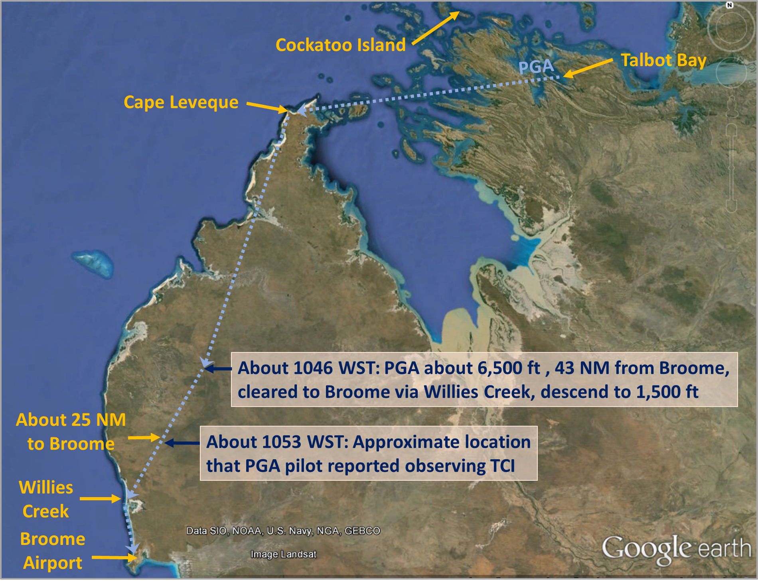
Source: Google earth, modified by the ATSB.
At about 1053, the pilot of PGA heard the aircraft’s traffic information system alert ‘traffic 12 o’clock same level’ (or similar words), indicating that an aircraft (subsequently identified as TCI) was directly ahead of PGA, at the same altitude, and within 0.25 NM. The pilot of PGA sighted the aircraft (subsequently identified as TCI) and observed it flying in the opposite direction on the right side, in close proximity. At about the same time, the pilot of TCI recalled that an aircraft (later identified as PGA) was seen to fly overhead.
After the aircraft had passed each other, the pilot of PGA advised the Tower controller that an aircraft had ‘passed at 26 miles through 5,000 same level looked like a 210.’ The Tower controller was subsequently able to establish limited one-way communication with the pilot of TCI (who was still unable to transmit voice communication), asking for confirmation of intentions, and using two short clicks/transmissions to acknowledge receipt of the Tower controller’s transmissions. The Tower controller then broadcast a telephone number for the pilot, and asked the pilot to make contact on that number if possible.
Note: The pilot of TCI recalled holding over land, near James Price Point, outside of Class D airspace. Communications between ATC and the pilot of PGA immediately following the point at which the aircraft passed, suggested that the incident occurred further to the east, at about 26 NM from Broome. A later communication between ATC and the pilot of PGA suggested that the incident occurred about 23 NM from Broome. Information provided to the ATSB by the pilot for the incident flight from the tracking data from PGA’s real-time satellite tracking system also suggested that the incident occurred near the latter location (Figure 2).
Figure 2: Broome Visual Terminal Chart depicting the area where the pilot of each aircraft believed they were located at the time of the occurrence.
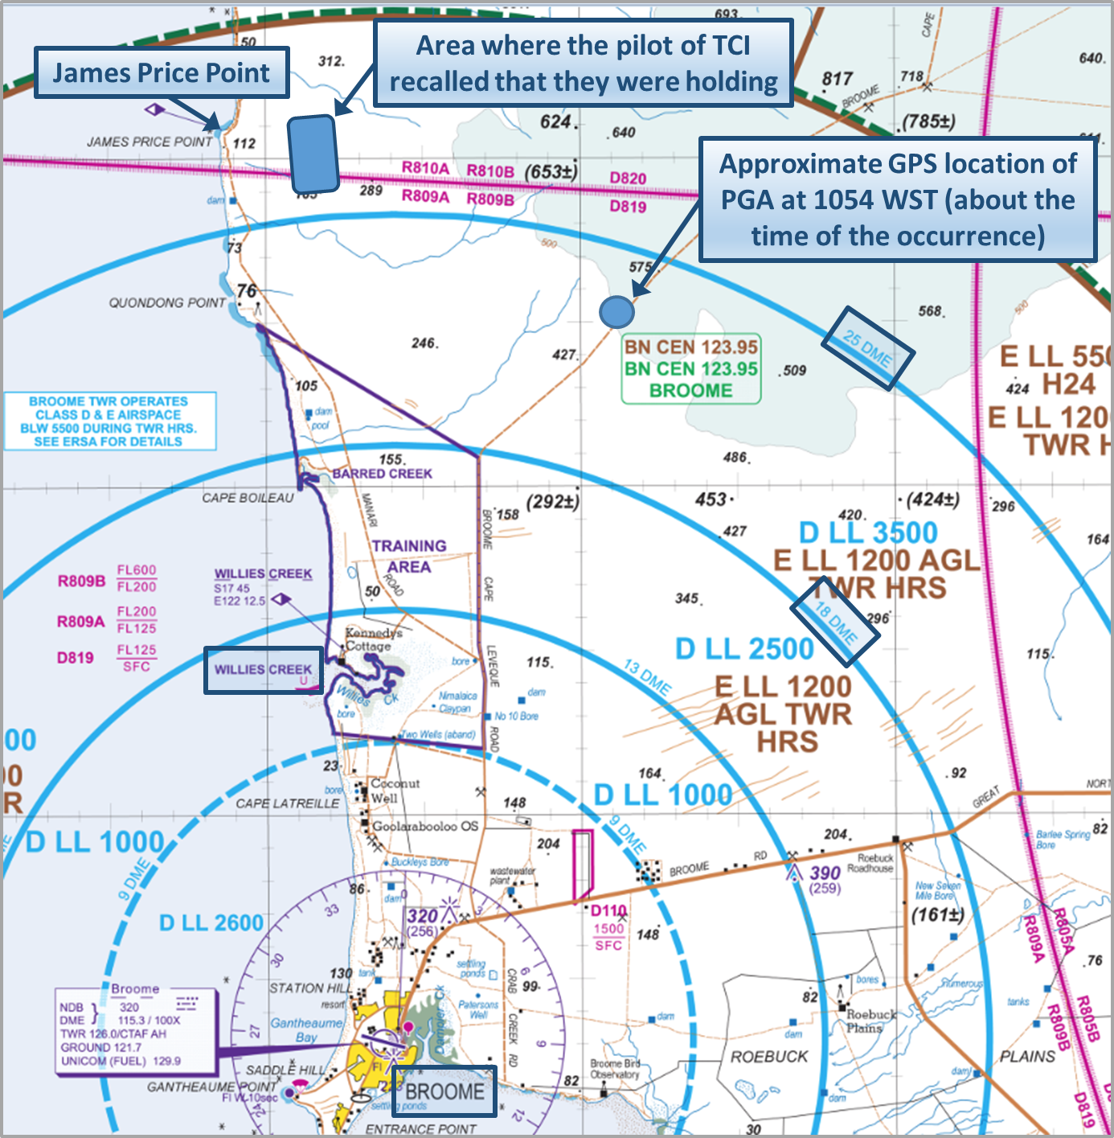
Source: Airservices Australia, modified by the ATSB
The pilot of TCI contacted the Tower controller by telephone on the number provided, and was cleared to follow PGA to Broome, via Willies Creek. They also agreed to make a long transmission when TCI was 10 NM from Broome, and to ‘transmit blind’ beyond that point. The controller then advised the pilot of PGA of the aircraft TCI, a Cessna 210, and advised that TCI would track inbound to Broome behind PGA. The pilot of PGA acknowledged this information.
At about 1103, the Tower controller cleared TCI for a visual approach as number two to land, and asked the pilot to make ‘one click on left base’. The pilot of TCI acknowledged the controller with two short clicks/transmissions. PGA landed ahead of TCI at about 1104. About 3 minutes later, the pilot of TCI made a short click/transmission on the Tower frequency to indicate that they were on left base. The Tower controller responded by acknowledging that TCI was ‘transmitting blind’, and cleared TCI to land. TCI landed without further incident.

Radio failure
After the event, the operator investigated the reason for the radio failure in TCI. They found that an electrical cable for the microphone plug had come loose, resulting in the failure of that part of the communication system.

Pilot of TCI comment
The pilot of TCI reported that when they detected the radio failure, they were on descent from 8,000 ft. The pilot elected to hold at 5,000 ft outside Class D airspace, to remain clear of aircraft operating at 4,500 ft and 5,500 ft, and to enable mobile telephone reception (to contact the operator and air traffic control).
The pilot of TCI reported hearing the pilot of PGA make an inbound call, and was monitoring the position of PGA using an application on an iPad. The pilot commented that although the iPad application did not provide real-time information, and that the accuracy of the information was limited, it nonetheless provided general information about aircraft in the vicinity. Based upon their understanding of the circumstances, the pilot believed that there was some distance between the area in which they were holding and the planned track of PGA.
Having identified that there was a communication problem, the pilot consulted the En Route Supplement Australia (ERSA), but considered the guidance available in that document to be of limited relevance under the circumstances.
When the two aircraft crossed, the pilot of TCI believed that PGA was about 500 ft above and about 1 NM (1.9 km) horizontally separated, at the closest point.

Pilot of PGA comment
The pilot of PGA reported that they had been maintaining a listening watch on the Broome Tower frequency from about 65 NM out, to gain situational awareness of the traffic operating in the area. The pilot heard the Broome Tower controller broadcast that an aircraft was only transmitting carrier wave, with no voice modulation.
The pilot estimated at the closest point when passing, TCI was about 50 m (0.03 NM) horizontally separated from PGA, and slightly below. After landing, the pilot indicated that several of the passengers made comments regarding the other aircraft (TCI).
The pilot obtained the tracking data from PGA’s real-time satellite tracking system for the flight that showed the location of PGA at the time of the occurrence. That location is consistent with the approximate location, as shown in Figure 2, that the pilot of PGA observed TCI.
Based upon their experience flying in the Broome area, the pilot strongly believed radar facilities should be available to assist with management of the large volume of diverse air traffic that operates at Broome.

Safety message
This occurrence highlights the fundamental importance of communication – where the quality of communication is compromised for any reason, an effective pilot lookout becomes increasingly important. Awareness of the limitations of the see-and-avoid principle may assist pilots in developing effective lookout techniques. The ATSB publication Limitations of the See-and-Avoid Principle provides information on the limitations of seeing and avoiding another aircraft and measures that can be taken to increase the chance of sighting other traffic. The Civil Aviation Safety Authority (CASA) publication CAAP 166-2(1) Pilots’ responsibility for collision avoidance in the vicinity of non-controlled aerodromes using ‘see-and-avoid’ also contains information on measures that can be taken to increase the chance of sighting other traffic.
Communication difficulties can generate a high workload and stressful environment for all concerned, and have the potential to escalate into a more serious situation if not handled effectively. Pilots are encouraged to familiarise themselves with the actions outlined in the ERSA, that may be appropriate when dealing with communication difficulties. Although in this case, the pilot considered the guidance to be of limited relevance, the information may be important in guiding pilot decision making under other circumstances. A common understanding between air traffic control and pilots experiencing radio difficulties, with regard to the intended actions of the pilot, may be critical to a safe outcome.

General details

Occurrence details
Date and time: | 15 July 2015 – 1053 WST
Occurrence category: | Serious incident
Primary occurrence type: | Near collision
Location: | 46 km NNE of Broome Airport, Western Australia
 | Latitude: 17° 33.93' S | Longitude: 122° 21.67' E

Aircraft details – VH-TCI
Manufacturer and model: | Cessna Aircraft Company 210L
Registration: | VH-TCI
Serial number: | 21060548
Type of operation: | Charter - Test & Ferry
Persons on board: | Crew – 1 | Passengers – 0
Injuries: | Crew – 0 | Passengers – 0
Damage: | Nil

Aircraft details – VH-PGA
Manufacturer and model: | Cessna Aircraft Company 208
Registration: | VH-PGA
Serial number: | 20800312
Type of operation: | Charter - Passenger
Persons on board: | Crew – 1 | Passengers – 12
Injuries: | Crew – 0 | Passengers – 0
Damage: | Nil

Piston Aircraft

Landing accident involving Cessna 180C, VH-FDH

What happened
Cessna 180C, VH-FDH
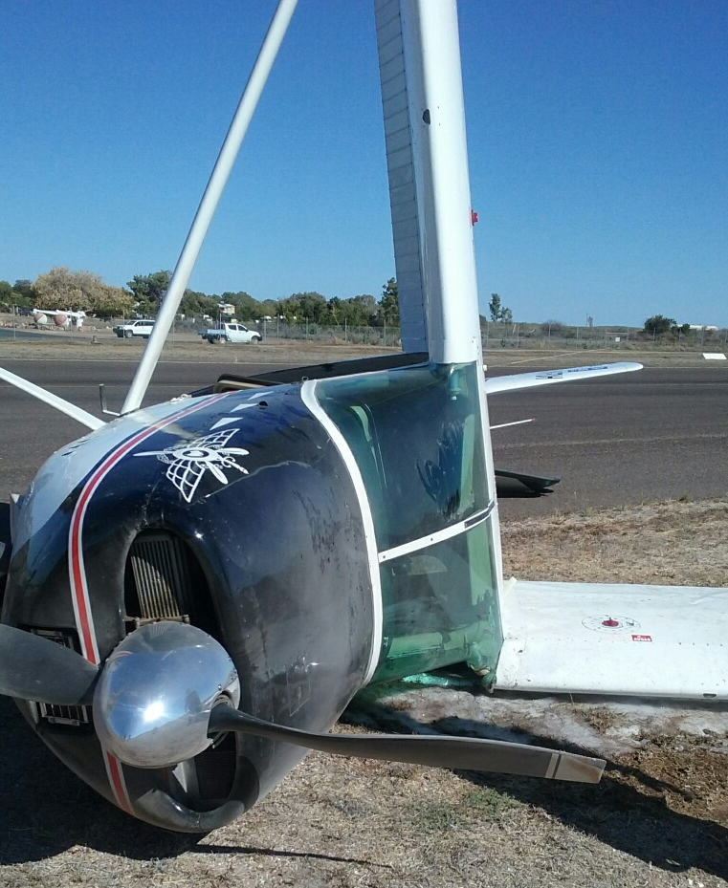
Source: Carpentaria Shire Council
On 1 September 2015, a Cessna 180C aircraft, registered VH-FDH (FDH), departed Normanton for Karumba Airport, Queensland at about 1435 Eastern Standard Time (EST). The pilot and two passengers were on board for the private flight. The aircraft had a tail wheel landing gear and the landing technique planned to be used was a wheel landing (see Landing techniques below).
At Normanton, the aircraft was refuelled and departed at almost maximum take-off weight. The aircraft climbed to about 1,000 feet for the short distance to Karumba (about 20 NM). On approaching Karumba, the pilot used the aircraft radio to contact another pilot who had just landed at Karumba to ascertain the weather conditions and to determine the most suitable runway for a landing. The pilot of the aircraft that just landed indicated to the pilot that the wind was directly across the runway from the north-west and either runway direction would be suitable for a landing. They decided to land on runway 21 (Figure 1) and joined the circuit on the downwind leg. On downwind, the windsock was observed and confirmed that the wind direction was directly across the runway from the north-west and the pilot estimated the wind speed to be about 10 knots.
Figure 1: Map of Karumba Airport
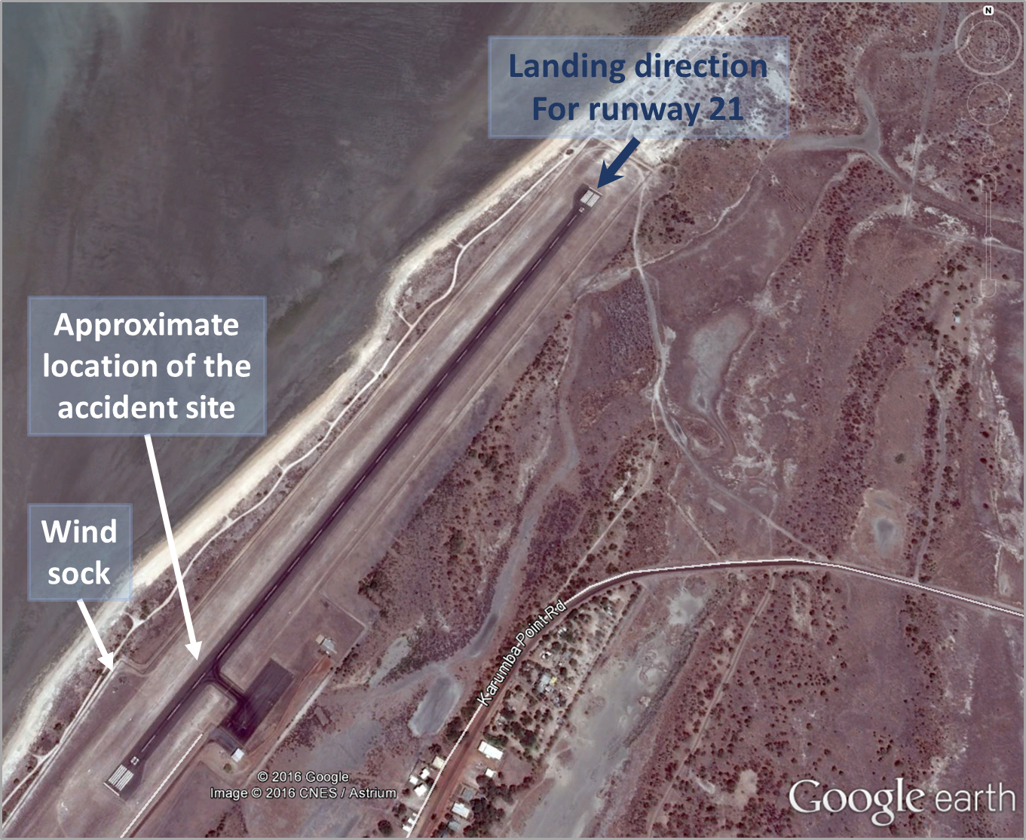
Source: Google earth, modified by the ATSB
The aircraft was established in a stable final approach and the pilot determined that there was no crosswind correction required. The main wheels touched down firmly on the runway and the aircraft bounced about 3 to 4 feet. The pilot moved the control column forward slightly to stop the tail from touching the runway. The main wheels touched again at about the same time as the pilot noted that the nose started to move to the right (turning into wind). The pilot moved the aircraft controls to straighten the aircraft in line with the runway, but the aircraft did not respond to the correction. The tail continued to move quickly around (ground loop) before the pilot could take any other action. The pilot was pushed up against the cockpit door. A very loud bang was heard as the left main landing gear failed, the left wing folded up and the fuselage tilted onto its side where the aircraft skidded a short distance to a stop. The aircraft stopped, almost pointing back in the opposite direction to the landing, partly on the grass beside the runway (Figure 2). The pilot turned off the engine magnetos, aircraft fuel, and electrical master switch. The two passengers exited the cockpit right door with the help of bystanders and then the pilot exited the same way. The pilot received minor injuries and the two passengers were uninjured. The aircraft was substantially damaged.
Figure 2: Cessna C180 FDH accident site
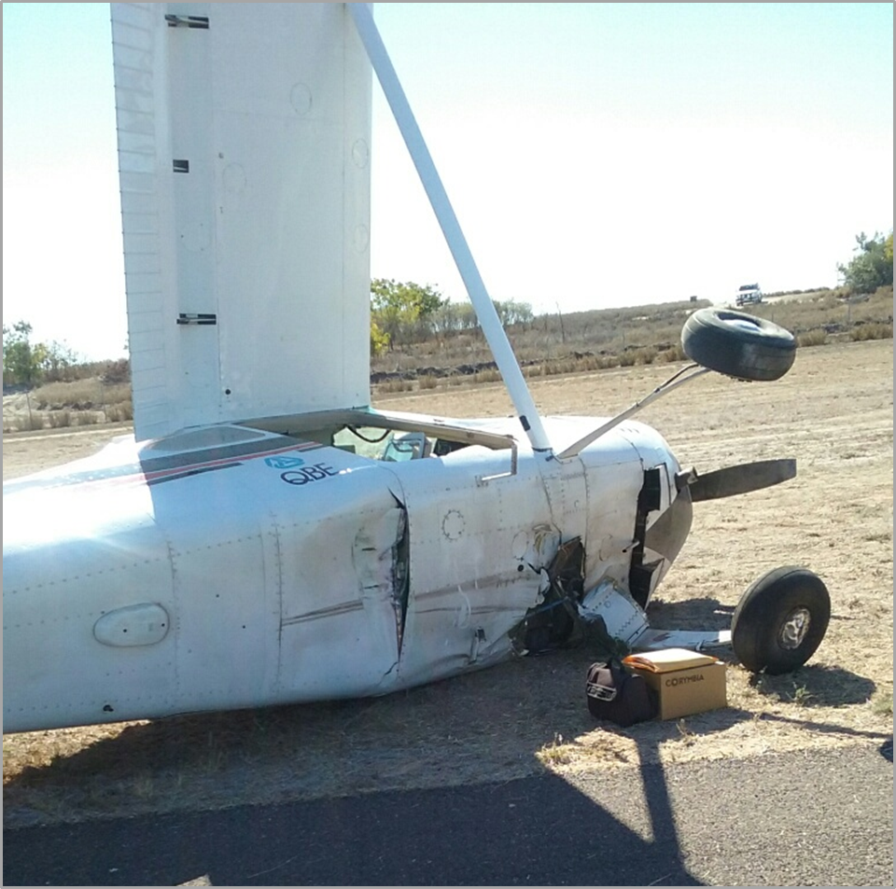
Source: Carpentaria Shire Council

Landing techniques
There are two landing techniques that can be used in tail wheel aircraft. A wheel landing is where the tail of the aircraft is held off the runway and the main wheels touch down first and then the tail wheel. The other landing technique used in a tail wheel aircraft is the three-point landing where the two main wheels and tail wheel touch the runway together.

Pilot training and tail wheel experience
The pilot had about 1,200 total flight hours with about 84 hours in tail wheel aircraft. The majority of landings in those tail wheel aircraft were three-point landings. The pilot commenced training in 2006 for a tail wheel endorsement, initially training in an Avions Mudry CAP 10, where only three-point landings were practiced. The pilot gained further training in an American Champion Super Decathlon, focussing on the wheel landing technique. During an aerobatics and formation endorsement in the Super Decathlon, the pilot revised both wheel and three-point landings. The pilot was also checked-out to fly an Aviat Aircraft Husky and a de Havilland Chipmunk, although reported only having a few hours in each. The pilot conducted a biannual flight review in March 2015 in a Cessna 172 (tricycle landing gear aircraft). The pilot had flown one other Cessna 180 and in that aircraft, had conducted three-point landings.
Of the pilots 84 hours in tail wheel aircraft, 30 were in a Cessna 180, and in the preceding 30 days, about 23 hours were in FDH.

Pilot comment
The flight was part of an air race and prior to the accident they had conducted about 20 hours of flying, departing Jandakot, and landing at Esperance, Forrest, Ayers Rock, Alice Springs, Davenport Downs, Winton, and Normanton. Of those landings, the pilot reported not being happy with any of the landings. The pilot indicated that this was the first landing in the aircraft that was conducted at almost the maximum landing weight and with a significant crosswind. All the other landings were with little to no crosswind component.
The pilot reported that the owner of FDH, who was also a pilot (medical not current), was extremely proficient at conducting wheel landings and wanted the pilot to conduct wheel landings in FDH. The pilot had conducted circuits with the owner about 2.5 weeks prior to the air race and recalled mentioning to the owner that they felt more comfortable conducting three-point landings.
The pilot reported that during the landing, they were very focused on keeping the aircraft straight with the runway and recovering from the bounce. On another landing in FDH where the aircraft had bounced about 3 to 4 feet, the pilot reported resolving the landing without going around.

Safety message
The US Federal Aviation Administration (FAA) discusses in their publication Airplane Flying Handbook Chapter 13 Transition to Tailwheel Airplanes the importance to land with the aircraft in the longitudinal axis exactly parallel to the direction the aircraft is moving along the runway. If the aircraft lands while in a crab or while drifting, it imposes severe side loads on the landing gear and imparts ground looping (swerving) tendencies. The handbook is available from the FAA website.

General details

Occurrence details
Date and time: | 1 September 2015 – 1435 EST
Occurrence category: | Accident
Primary occurrence type: | Loss of control
Location: | Karumba Airport, Queensland
 | Latitude: 17° 27.33' S | Longitude: 140° 49.90' E

Aircraft details – VH-FDH
Manufacturer and model: | Cessna 180C
Registration: | VH-FDH
Serial number: | 50680
Type of operation: | Private – Pleasure / Travel
Persons on board: | Crew – 1 | Passengers – 2
Injuries: | Crew – 1 Minor | Passengers – 0
Damage: | Substantial

Wheels up landing, involving a Nanchang CJ-6, VH-ALO

What happened
On 6 February 2016, at about 1250 Eastern Daylight Time (EDT), the pilot of a Nanchang CJ-6 aircraft, registered VH-ALO (ALO), was completing the first in a series of formation ‘combat’ joy flights booked for that day. The ‘combat’ flight, which consisted of a pilot and passenger on board each of two Nanchang aircraft (ALO and Number 2), had departed Barwon Heads airport, Victoria, about twenty-five minutes earlier. The pilot of ALO acted as the leader aircraft (or ‘Number 1’) for the formation flight.
At the chosen ‘break-point’ on upwind, Number 2 positioned ahead of ALO in the circuit. The two Nanchang aircraft remained in this single-file sequence behind a Pipistrel aircraft, which had joined the circuit on the downwind leg for runway 36. The Pipistrel aircraft landed, then rolled through to the end of the runway in order to exit; Number 2 followed suit. As ALO touched down, third in a close landing sequence, the pilot realised that they had not completed the pre-landing checks, and the landing gear had not been extended. The aircraft slid along the sealed runway, coming to a stop just off the centreline (Figure 1). The pilot and passenger were not injured, and were able to safely egress. The aircraft sustained damage to the propeller, engine and the underside of the fuselage.
Figure 1: Nanchang VH-ALO, on runway 36 after a wheels up landing
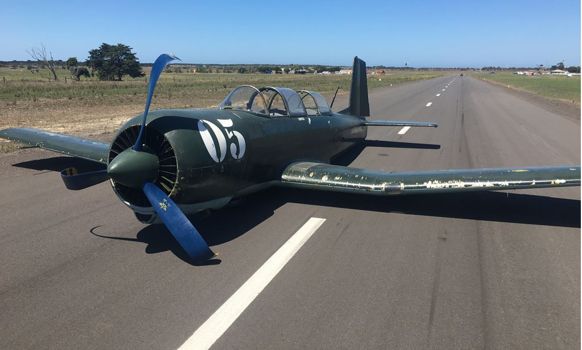
Source: Pilot

Events leading to the wheels up landing
As the formation joined upwind, the pilot from a parachute aircraft operating at the airport, broadcast that tandem parachutists (student and instructor) had been dropped, and that this parachute aircraft was now conducting a second pass to drop the final student(s).
Figure 2: Barwon Heads airport showing relative positions of the formation, Pipistrel and the drop zone
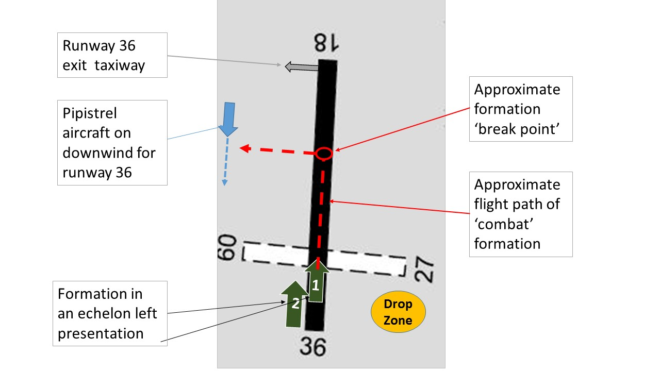
Source: En Route Supplement Australia entry for Barwon Heads; annotated by the ATSB
To avoid any issues for the novice parachute jumpers, and to prevent Number 2 from flying too close to the drop zone in the preferred echelon right, ‘dead side’ of the circuit join, the pilot in ALO made the decision that the formation would remain in the echelon left configuration and join over the top of runway 36. At the break point, Number 2 would move ahead, and both aircraft would conduct an early turn onto crosswind. This would keep both Nanchang aircraft well clear of the remaining parachute jumpers approaching the drop zone (Figure 2).
However, while the formation was still on upwind, the pilot of a smaller Pipistrel aircraft broadcast their intention to join the downwind leg for runway 36 (Figure 2), further delaying the Nanchang’s turn onto crosswind. To maintain a reasonable separation from the Pipistrel, the two Nanchang pilots conducted a much wider crosswind leg, and resultant circuit, than normal.
The pilot in ALO continued to check for the remaining parachute jumpers, while broadcasting and responding to pertinent radio reports on behalf of the formation; and also managing the ‘slowing down’ of the formation. Once the Pipistrel has passed abeam the formation’s position, and because the runway at Barwon Heads is too narrow to allow a formation landing, the pilot in ALO instructed the pilot in Number 2 to ‘break’. The landing order became the Pipistrel, followed by Number 2 and then ALO.
The Pipistrel touched down, and took some time to roll through to the only available exit taxiway at the end of runway 36. The pilot in Number 2 requested the pilot in the Pipistrel to expedite the exit, as they wanted to land, but could not land until the Pipistrel was clear of the runway. The pilot in ALO reported keeping a close eye on proceedings in front of their aircraft. This included sideslipping the aircraft to maintain a clear view of the runway movements as the Nanchang has limited vision over the nose at slow airspeeds.
Once Number 2 had landed and cleared the runway, the pilot in ALO reported flaring the aircraft in preparation for landing. It was not until the pilot heard the noise of the aircraft scraping the runway that they realised that the landing gear had not been extended.

Pilot experience and comment
The pilot had around 2,950 flying hours, with about 1,800 of these on Nanchang aircraft.
- The pilot reported that although feeling relatively fresh on the day, due to other demands, the previous week had been personally ‘full on’ and somewhat draining. This may have had played a small part in the oversight of the downwind and pre-landing checklists.
- With the combination of the parachute activities, the slower aircraft in the circuit, and the less than optimal echelon left formation configuration, the pilot in ALO reported their attention moved from their own aircraft into the Number 2 aircraft. Still maintaining the duties of Number 1 of the formation, but in the unusual ‘behind’ position, they had checked that Number 2’s landing gear had been extended, and kept a close watch on the spacing of the three aircraft.
- The pilot reported the Nanchang is always a challenge to slow down until the landing gear is extended. The landing gear can be extended once the airspeed had reduced to 108 knots (usually during the downwind checks). The extension provides sufficient aerodynamic drag to reduce the airspeed closer to the desired approach speed.
- The pilot reported that it was more common for these combat flights to operate from Moorabbin Airport, where the wider runways allowed a formation landing.
- These events and conditions, combined with no landing gear warning system being fitted to these early military training aircraft, allowed the pilot’s attention to remain distracted and the landing gear was not selected down.

Safety message
The combination of factors distracting the pilot’s attention during the approach and landing led to the downwind and pre-landing checklists being overlooked. The lack of any landing gear warning system fitted to the aircraft, which would have alerted the pilot to the incorrect configuration, left no protection between the distraction and the final action.
According to an Interruptions / distractions briefing note by the Flight Safety Foundation, interruptions and distractions usually result from the following factors:
- flight crew-ATC, flight deck or flight crew-cabin crew communication
- head down work, and
- response to an abnormal condition or unexpected situation.
Further information is available at:
Flight Safety Foundation Approach-and-landing accident reduction Briefing note 2-4, Interruptions / distractions.
Research conducted by the ATSB identified 325 occurrences between 1997 and 2004, which involved distractions. Of these, 54 occurred during the landing phase of flight.
ATSB (2006). Dangerous Distraction: An examination of accidents and incidents involving pilot distraction in Australia between 1997 and 2004. (Research and Analysis report B2004/0324).

General details

Occurrence details
Date and time: | 6 February 2016 – 1250 EDT
Occurrence category: | Accident
Primary occurrence type: | Wheels up landing
Location: | Barwon Heads Airport, Victoria
 | Latitude 38° 15.48' S | Longitude: 144° 25.65' E

Aircraft details
Manufacturer and model: | Nanchang Aircraft Manufacturing CJ-6
Registration: | VH-ALO
Serial number: | 532002
Type of operation: | Private – other (Warbird – Limited)
Persons on board: | Crew - 1 | Passengers - 1
Injuries: | Crew - 0 | Passengers - 0
Damage to aircraft: | Substantial

Incorrect configuration resulting in a collision with terrain involving Cessna R182, VH-PFZ

What happened
On 14 February 2016, at about 0945 Eastern Standard Time (EST), the pilot of a Cessna R182 aeroplane, registered VH-PFZ, was returning to a private airstrip near Ingham aircraft landing area (ALA), Queensland. The pilot, who was the only person on board, had just completed a routine one-hour property inspection and decided to complete the flight with some practice touch and go circuits.
The pilot reported that the weather was fine, with minimal wind and a temperature of about 30 °C.
The pilot approached the circuit with the aircraft in the same configuration used for the inspection flight. This was with 20 inches of manifold pressure, the propeller set at 2,000 revolutions per minute (RPM), and the landing gear retracted.
The pilot joined downwind for runway 22 as per their normal procedure, and conducted their downwind checks. However, they inadvertently omitted one of the checks. Although they extended the landing gear, they did not return the pitch control to the HIGH RPM (full fine) position. The pilot continued with the approach, and selected full flap, but again omitted the pre-landing checks on final approach. This oversight left the pitch control lever at about 2,000 RPM.
The pilot described the approach and initial touchdown as a little faster and higher than normal, with the touchdown point about 300 m into the 1,100 m airstrip (Figure 1).The aircraft ballooned slightly. At about 10-15 ft above ground level, the pilot commenced a go-around and applied full throttle, with the propeller remaining at 2,000 RPM. With an airspeed of 64 kt, the pilot assessed there was sufficient airspeed to climb out, so retracted all of the flap and then the landing gear.
Figure 1: Initial touchdown point on runway 22, and VH-PFZ (far end)
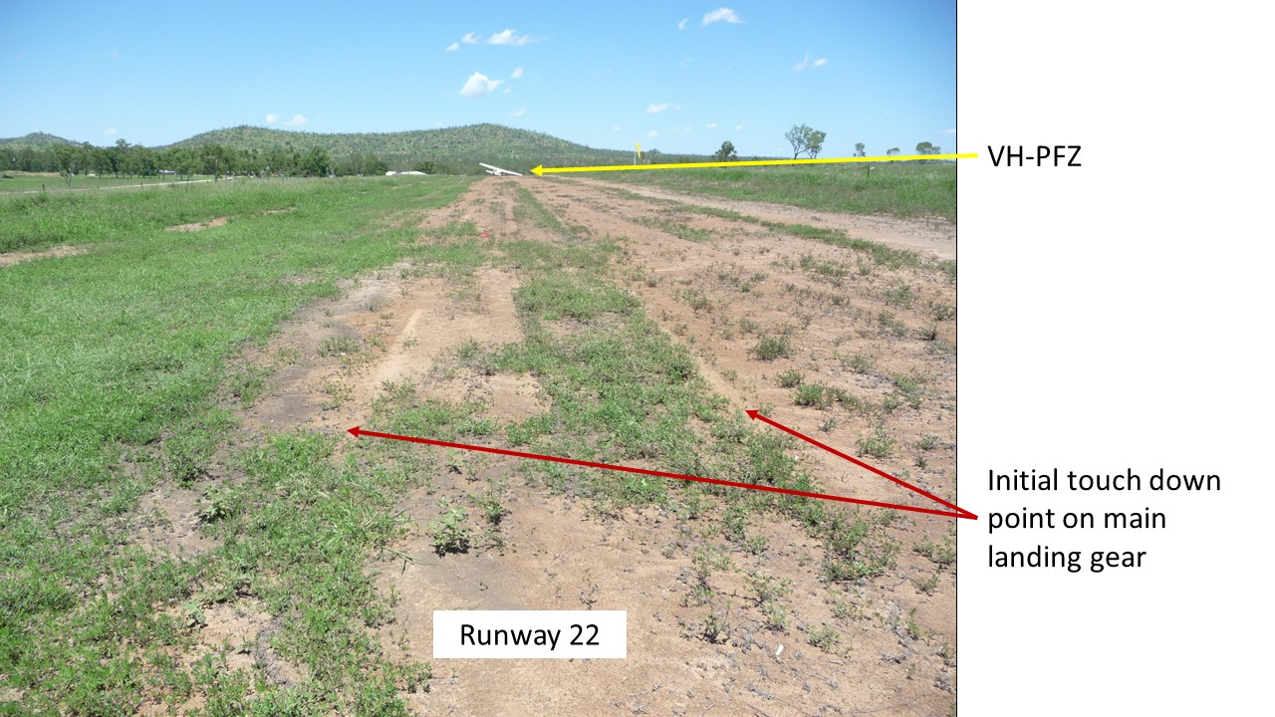
Source: Pilot
However, the aircraft began to sink, and the nose dropped. Moments later, the main landing gear struck the ground. This second ‘touchdown’ was about 265 m beyond the first, (about 565 m along the airstrip). The pilot attempted to keep the nose of the aircraft raised. However, the propeller struck the ground and the pilot realised that the nose wheel had retracted, so closed the throttle. The aircraft continued to skid along the runway. The propeller stopped rotating when the aircraft had travelled about another 77 m. The aircraft then continued to slide sideways, and the right main landing gear retracted (Figure 2). The pilot was not injured, but the aircraft sustained substantial damage.
Figure 2: VH-PFZ showing retracted nose wheel and right landing gear, and damaged propeller
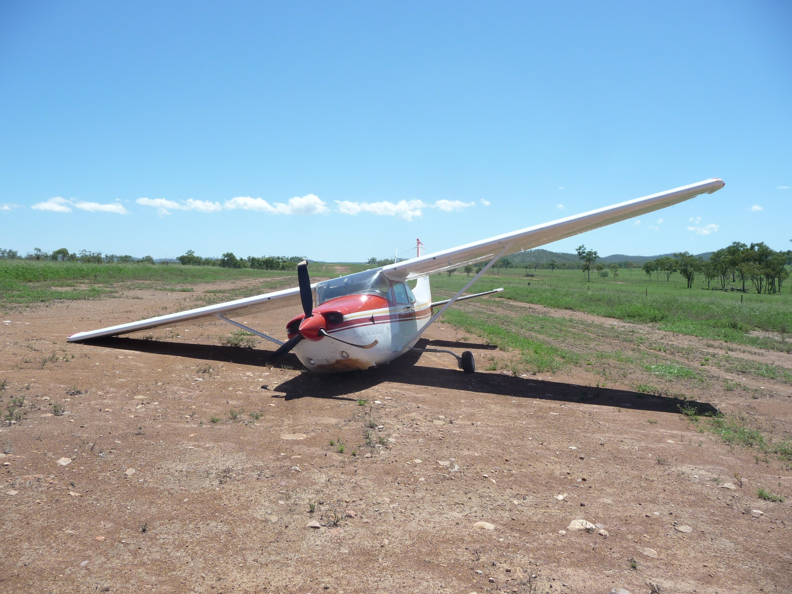
Source: Pilot

Pilot experience and comments
The pilot had attained almost 4,000 hours of flight experience, 2,800 of which were in VH-PFZ.
The pilot reported that there had been no particular issues affecting the flight on the day, the weather was good, and the inspection flight had been enjoyable. However, the temperature was 30 °C, which increased the density altitude. The pilot could not attribute any particular reason for the checklist oversight.
The pilot reported that during their early flying training, when they had been training for a go-round, they had been instructed to retract all the flap with their right hand, then immediately move their right hand onto the landing gear selector, and retract the landing gear. The pilot commented that ‘the flap travelling up reduced the lift being produced, and the landing gear retracting reduced the drag. These two actions balance out each other.’ The pilot qualified this statement by stating that this technique should only be attempted once a positive rate of climb has been achieved. On this occasion this had not occurred.
The pilot consulted the aircraft’s performance charts post-accident. With the correct propeller (2,400 RPM) and manifold pressure settings, the aircraft delivers the maximum brake horsepower (BHP). For any of the take-off configurations (see POH data below), it is a requirement to have the propeller in the full fine position of 2,400 RPM. The charts do not cater for propeller settings of 2,000 RPM. The pilot reasoned that landing further along the runway than normal may have contributed to a slight rushing of the go-round sequence. It is possible, that this mindset also contributed to retracting the flap and landing gear prior to achieving a positive rate of climb.
The pilot also reported that possibly being too comfortable in the aircraft, and the reliance on its performance, had created an expectation that all would be well.
The pilot summarised that engine RPM was insufficient to produce enough thrust to maintain altitude and climb at the critical point of change in aircraft configuration, while retracting the flap and landing gear.

Cessna R182 Pilot operating handbook (POH)
Information from a generic 1981 Cessna R182 pilot operating handbook stated that the propeller control should be moved to HIGH RPM (full fine) prior to landing.
The Normal Take-off checklist included:
- Propeller HIGH RPM (2,400 RPM)
- Climb speed 70 kt indicated airspeed (KIAS) (Flaps 20°)
- Climb speed 80 KIAS (Flaps UP).
- Brakes – APPLY momentarily when airborne
- Landing gear – RETRACT in climb out
- Wing Flaps – RETRACT

The Short Field Take-off technique included:
- Propeller HIGH RPM (2,400 RPM)
- Climb speed – 59 KIAS until all obstacles are cleared.
- Landing gear – RETRACT after obstacles are cleared
- Wing Flaps – RETRACT slowly after reaching 70 KIAS.

ATSB comment
The pilot could not recall any particular reason as to why the pre-landing check (propeller control to HIGH RPM (full fine)) was overlooked on two occasions in the circuit.
Although the aircraft could have landed safely in this configuration, attempting to climb with the propeller still at 2,000 RPM created a chain of events from which the pilot did not recover.
The pilot’s decision to retract the flaps all at once, followed immediately by the landing gear, prior to obtaining a positive rate of climb at a low altitude also decreased the aircraft’s performance. The elevation of the airport was 1,100 ft above mean sea level. This, coupled with a warm day of around 30 °C, translated to a higher density altitude,2 resulting in reduced performance.

Safety Message
Although the pilot did not recall any distraction which could have led to the omission of the checklist item on both the downwind and final approach checklists, this omission fits a familiar pattern.
Any change of routine or even cognitive thoughts can distract a pilot from an essential checklist item. Research conducted by the ATSB found that distractions, or a change in routine, were an everyday part of flying, and that pilots generally responded quickly and efficiently. The report, Dangerous Distraction: An examination of accidents and incidents involving pilot distraction in Australia between 1997 and 2004 speaks to these issues.
This research commented that pilot distractions in the study did not always occur in response to non-normal tasks. In fact, the research indicated that distraction can occur when pilots are conducting normal routine tasks.

General details

Occurrence details
Date and time: | 14 February, 2016 at 1215 EST
Occurrence category: | Accident
Primary occurrence type: | Incorrect configuration
Location: | 58 km SW Ingham ALA, Queensland
 | Latitude: 18° 55.40 S | Longitude: 145° 40.28 E

Aircraft details
Manufacturer and model: | Cessna R182
Registration: | VH-PFZ
Serial number: | R18201731
Type of operation: | Private
Persons on board: | Crew - 1 | Passengers - 0
Injuries: | Crew - 0 | Passengers - 0
Damage to aircraft: | Substantial

Helicopters

Foreign object damage involving an Eurocopter AS365 N3 Dauphin,
VH-WPX

What happened
On 3 November 2015, at about 1400 Western Standard Time (WST), a pilot of a Eurocopter AS365 N3 (Dauphin), registered VH-WPX, conducted a maintenance test flight at Jandakot Airport, Western Australia.
The test flight was the third that day, to conduct track and balancing of the main rotor, following reports of vibration.
During the post-flight inspection following this test flight, one of two Licenced Aircraft Maintenance Engineers (LAMEs) involved in the test flight, noticed two large gouges to the leading edge of one of the main rotor blades (Figure 1).
A spanner that had been used during the third track and balance related adjustments could not be located. It was later located on an adjacent taxiway about 43 m from the hangar. Due to the scuff marks and scratches found on the spanner, it was determined that it had been left in the rotor head area and was likely ejected during the aircraft start up.
Figure 1: Damage to leading edge of a main rotor blade on VH-WPX
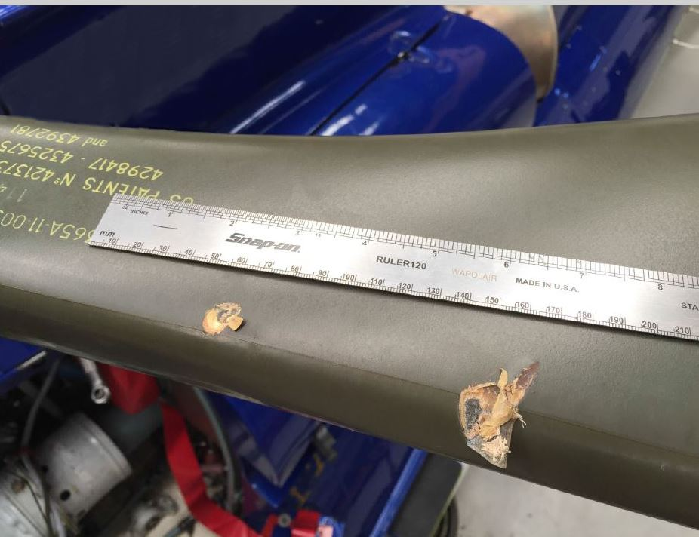Source: Aircraft operator

Events leading up to the foreign object damage
Prior to the event, the main rotor head bolts (bolts) had approached their scheduled life limit. So on 26 October the maintenance organisation replaced the bolts, in accordance with the Airbus Helicopters AS365 Maintenance Manual. The maintenance manual required that a main rotor blade track and balance be performed following this replacement.
Helicopter vibration was automatically monitored using the Honeywell Chadwick Helmuth Vibration Expert (VXP), which was installed in the helicopter. The VXP data generated was automatically sent to an external diagnostics organisation for trend monitoring. Additionally, LAMEs could access this data for rotor track and balancing requirements.
The operator advised that when the bolts were replaced, a work pack was generated for the task. Prior to the required track and balancing flights, one of the two LAMEs tasked with the job (LAME 2), transferred the main rotor blade track and balancing procedure to the aircraft technical log and ground run/test flight sheet.
However, due to non-availability of flight crew, the test flights were not conducted until 28 October. The ground run/test flight record indicated that the results of the track and balance procedure were satisfactory, and the aircraft was returned to service the same day.
The aircraft continued in service, and flew about 14 hours between 28 October and 3 November. During this period, the maintenance organisation reported that a 4P vibration (within manufacturer tolerance) was being monitored and a pilot advised of a vibration. However, this information was not formally recorded on technical documentation.
On 2 November, the external diagnostics company that monitored the aircraft VXP data, advised the operator of a rising vibration trend. This rising vibration trend was still within tolerance, and supported the pilot reported vibration that was being monitored by the maintenance engineers. At this time, the Chief Engineer advised the other LAME (LAME 1) to conduct further main rotor track and balancing during the following few days, subject to pilot availability.
Further track and balancing, and smoothing, was conducted on 3 November. The two LAMEs’ recollections and observations of the task are detailed below.

LAME 1
- Reported that a work pack had not been created for the subsequent track and balancing job, however, they (LAME 1) endorsed the ground run/test flight sheet and annotated the corresponding number on the technical log prior to the test flights.
- Reported that the Chief Engineer had discussed the required maintenance with them.
- Reported that although not formally assigned the role, thought they were most likely the Job Coordinator.
- LAME 1 had tagged out a socket and a screwdriver. Prior to each test flight, LAME 1 placed the tools being used into a metal tray, and then placed the tray on top of the toolbox. As the job was ongoing, there had been no documented requirement to place the tools back into their assigned location. LAME 1 had visually checked the tools in the metal tray prior to the third test flight, but did not use the tag procedure (refer Tool Control Procedure).
- LAME 1 had performed adjustments to the main rotor pitch links and blade weights, and had asked LAME 2 to perform an independent inspection of the work after the second test flight. LAME 1 reported that the request had been for LAME 2 to both perform the independent inspection, and to check that no tools had been left on the helicopter.
- LAME 1 was not aware that the spanner that they had been using had been left on top of the main rotor blades.

LAME 2
- Also reported that a work pack had not been created for the job.
- Stated that prior to the third test flight, they (LAME 2) had completed an independent inspection of the maintenance tasks, performed by LAME 1.
- LAME 2 did not notice that the spanner had been left on top of a main rotor blade. They noted that the blade was very flat, and that it would not be possible to see it on top of the rotor blade from the ground.
- LAME 2 had tagged the spanner and several other tools out earlier in the day. The tools had not been returned to the toolbox during the day, as it was expected that further adjustments would be required.

Pre-flight inspection
The daily inspection had been certified in the aircraft technical log by an engineer prior to the first flight. Additionally, the pilot reported conducting a ‘walk-around inspection’ in accordance with the flight manual procedures. The pilot was aware that flight control maintenance had been conducted by the engineering group. The pilot signed the aircraft technical log and ‘accepted’ the aircraft prior to each of the three test flights.
The pilot reported that the aircraft handled normally throughout the three test flights.

Tool control procedure
While there was a practice of tool control in place prior to the incident, formal procedures had not been documented and incorporated in the maintenance organisation manual (MOM).
The tool control practice in place, prior to this incident, required that that each tool removed from the toolbox be tagged out by the person removing the tool. Each engineer was assigned a series of numbered tags of a certain colour, and the tag was placed into the ‘empty’ location (cut out) of the tool being used (Figure 2). A review of both the toolbox and the engineer’s assigned tags would quickly identify if any tools were still in use.
Figure 2: Tool control procedure showing coloured number replacing tool in use by the engineer assigned the blue coloured tags
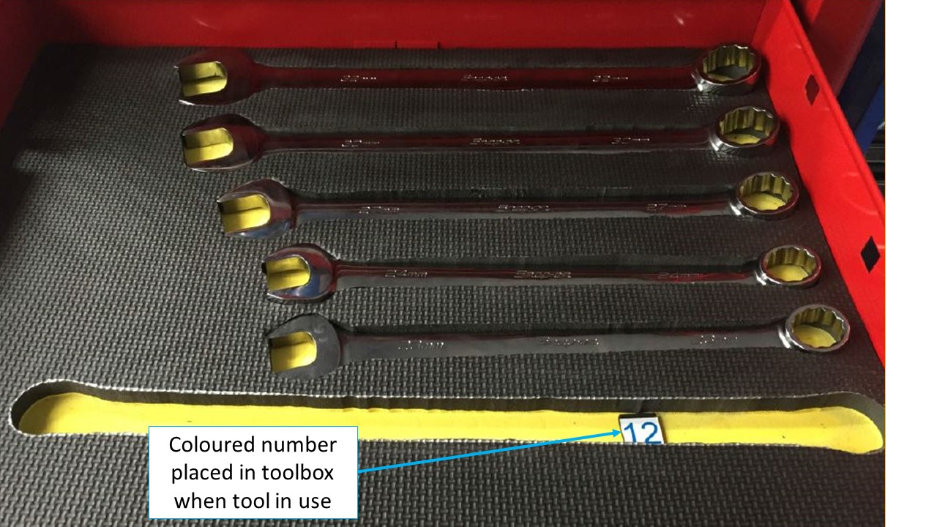
Source: Operator

Operator procedures
The MOM stated that induction training of all staff shall be carried out on all new maintenance staff. This training was to provide staff with sufficient information to enable them to integrate into the company and to ensure compliance with the policies and procedures of the organisation. However, there was no written record of any such induction training having taken place.

ATSB comment
The organisation involved conducted a thorough internal investigation after this occurrence. There were a range of other issues identified in regard to training and documentation procedures, and the company have initiated remedial action in all these areas. These other issues do not fall within the scope of this investigation.

Safety actions
Whether or not the ATSB identifies safety issues in the course of an investigation, relevant organisations may proactively initiate safety action in order to reduce their safety risk. The ATSB has been advised of the following proactive safety action in response to this occurrence.

The operator
As a result of this occurrence, the aircraft operator has advised the ATSB that they are taking the following safety actions:

Tool control procedure
A tool control procedure was in place at the time of the incident, however, the procedure had not been documented in the MOM. Additionally, there was no documented procedure requiring the tools to be returned to the toolbox prior to the aircraft being started.
The operator will incorporate the tool control procedure into the MOM. This procedure requires that all tools used during any aircraft maintenance are returned to the tool storage location prior to any of the company aircraft being started.
A tool control procedure will be implemented for any maintenance that occurs away from the main base. Additionally, a tool control procedure will be implemented to ensure external maintenance providers (for example avionics specialists) adopt the company tool control procedure.

Training for maintenance personnel
All maintenance personnel be provided with sufficient training and information to enable them to understand the workings of the organisation, its policies, manuals, procedures and their individual responsibilities.

General details

Occurrence details
Date and time: | 3 November 2015 – 1400 WST
Occurrence category: | Accident
Primary occurrence type: | Foreign object damage
Location: | Jandakot Airport, Western Australia
 | Latitude: 32° 05.85’ S | Longitude: 115° 52.87’ E

Aircraft details
Manufacturer and model: | Eurocopter AS365 N3
Registration: | VH-WPX
Serial number: | 6936
Type of operation: | Private – Test & ferry
Persons on board: | Crew – 3 | Passengers - 0
Injuries: | Crew - 0 | Passengers - 0
Damage to aircraft: | Substantial

Collision with terrain involving a Robinson R22, VH-HWJ

What happened
On 12 November 2015, a pilot was mustering cattle in a Robinson R22 helicopter, registered VH-HWJ, at a property about 90 km south of McArthur River Mine, Northern Territory.
At about 1400 Central Standard Time (CST), as the helicopter approached the cattle yards, it descended rapidly and collided with a tree and terrain. The helicopter landed on its side and sustained substantial damage (Figure 1). The accident occurred about 200 m prior to the cattle yards. The pilot sustained serious injuries and was unable to recall the sequence of events.
Figure 1: Accident site showing damage to VH-HWJ
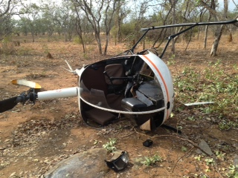
Source: Helicopter operator

Analysis of fractured yoke
The yoke connecting the clutch shaft to the rearward flex plate was found to have fractured at the connection to the shaft (Figure 2). The ATSB conducted analysis to determine whether the yoke failure may have contributed to the accident, or occurred as a result. The analysis found no evidence of fatigue damage in the yoke, and no other signs of pre-existing damage. The helical fracture was consistent with torsional overstress inducing failure in the yoke.
Figure 2: Fracture surfaces
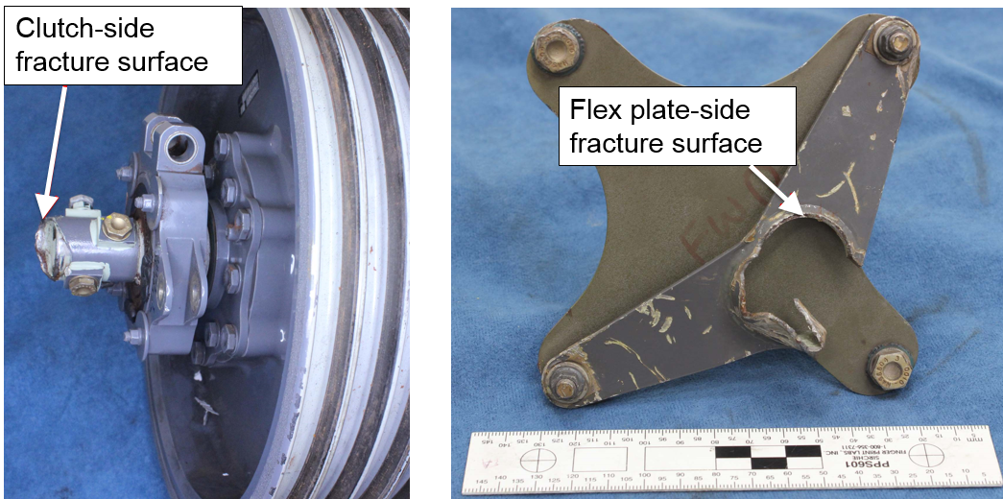
Source: ATSB

Weather
The weather at McArthur River mine was recorded at 1200 and 1530. At 1200, the wind was from 340° at 5 kt and the temperature was 36 °C. At 1530, the wind was from 160° at 4 kt and the temperature was 38 °C. The direction of the helicopter relative to the wind at the time of the accident could not be determined. The ambient temperature at the time of the accident was about 37 °C. Although the influence of the temperature on the accident is unknown, high ambient temperatures adversely affect helicopter performance.

Operator comments
Subsequent to a previous accident, the operator mandated the wearing of helmets for all pilots. The operator commented that although the pilot sustained head injuries, the outcome might have been worse if the pilot had not been wearing a helmet.

ATSB comment
The ATSB was unable to determine the cause of the accident.

Safety message
US military research analysed helicopter accidents that were at least partially survivable. It found that occupants not wearing a protective helmet were significantly more likely to sustain severe and fatal head injuries. The US National Transportation Safety Board (NTSB) also acknowledged that the use of head protection can reduce the risk of injury and death. The NTSB issued Safety Recommendation A-88-009, recommending that crewmembers of emergency medical services helicopters wear protective equipment including helmets.
The ATSB investigation report (AO-2014-058) into an accident involving a Robinson R22 helicopter where the pilot sustained a serious head injury, reminded pilots and operators to consider the benefit of occupants wearing helmets to reduce the risk of head injury in the event of an emergency landing.

General details

Occurrence details
Date and time: | 12 November 2015 – 1400 CST
Occurrence category: | Accident
Primary occurrence type: | Collision with terrain
Location: | 90 km S of McArthur River Mine, Northern Territory
 | Latitude: 17° 14.48' S | Longitude: 136° 10.72' E

Helicopter details
Manufacturer and model: | Robinson Helicopter Company R22
Registration: | VH-HWJ
Serial number: | 2930
Type of operation: | Aerial Work - Aerial Mustering
Persons on board: | Crew – 1 | Passengers – 0
Injuries: | Crew – 1 Serious | Passengers – 0
Damage: | Substantial

Wirestrike and collision with terrain involving Robinson R22, VH-LYW

What happened
On the morning of 20 February 2016, the pilot of a Robinson R22 helicopter, registered VH-LYW, was conducting aerial cattle mustering operations on a property about 88 km northeast of Roma, Queensland.
The pilot had mustered in that paddock several times previously, and was aware of a set of high voltage transmission wires that had been erected across the property in the previous 12 months.
Prior to commencing mustering, the pilot overflew the paddock, sighted the powerlines and formed a plan to muster the cattle from north to south, giving due consideration to the wires running east-west. The pilot then mustered the mob from north to south, and the helicopter remained above the wires during that time.
The pilot then saw two bullocks hidden in scrub, near a dam that was situated near to and just south of the powerlines, and returned to muster them up. The helicopter then descended below the level of the wires. The cattle would not turn back, so the pilot radioed a musterer on horseback to assist. The pilot turned the helicopter to leave the area as the horse and rider arrived. The pilot then saw another vegetated area near the dam, where cattle may be hidden from view, and flew the helicopter towards it.
While the pilot’s focus was on searching for cattle in the scrub below, the helicopter neared the powerlines. The pilot’s attention suddenly returned to the wires, and sighting them close in front at the same level, immediately commenced a near-vertical climb to try to avoid them. As the helicopter climbed, the pilot assessed that it was not going to clear the earth wire, and lowered the nose of the helicopter in an attempt to pass below the earth wire and above the other wires. The tail rotor blade struck the earth wire.
The helicopter was vibrating and the pilot turned it away from the wires. The tail rotor then failed and the helicopter yawed around. The helicopter descended rapidly and continued to rotate. The pilot entered an autorotation, and closed the throttle, overriding the governor. As the helicopter neared the ground, the low rotor revolutions per minute warning horn sounded, and the pilot raised collective to try to cushion the landing.. The helicopter collided with the ground nearly upright, and sustained substantial damage (Figure 1). The pilot was seriously injured.

Marking of overhead cables
The Australian Standard (AS) 3891.2-2008 Air navigation – Cables and their supporting structures – Marking and safety requirements, specified requirements for permanent and temporary marking of overhead cables and their supporting structure for visual warnings to pilots of aircraft involved in intentional and legal low-flying operations. The AS included examples such as powerlines in areas where aerial agricultural activities took place. An Appendix to the AS stated that markers should be installed where regular low-level flying operations take place, and that the responsibility for requesting their installation rests with the person requesting the planned low-level flying operations.
Additionally, other than for low-level flying, Part 1 of the AS 3891.1 Permanent marking of overhead cables and their supporting structures for other than planned low level flying, stipulated that any section of cable that had a height in excess of 90 m above a road, railway or navigable waterway should be marked. Cables above 90 m located in other places should be marked if they had a continuous span greater than 50 m.

Pilot comment
The pilot reported feeling substantial operational pressure to ensure no cattle were missed. They commented that this may have increased focus and attention on looking for cattle, and therefore momentarily lost awareness of the powerlines.
Figure 1: Accident site showing damage to VH-LYW
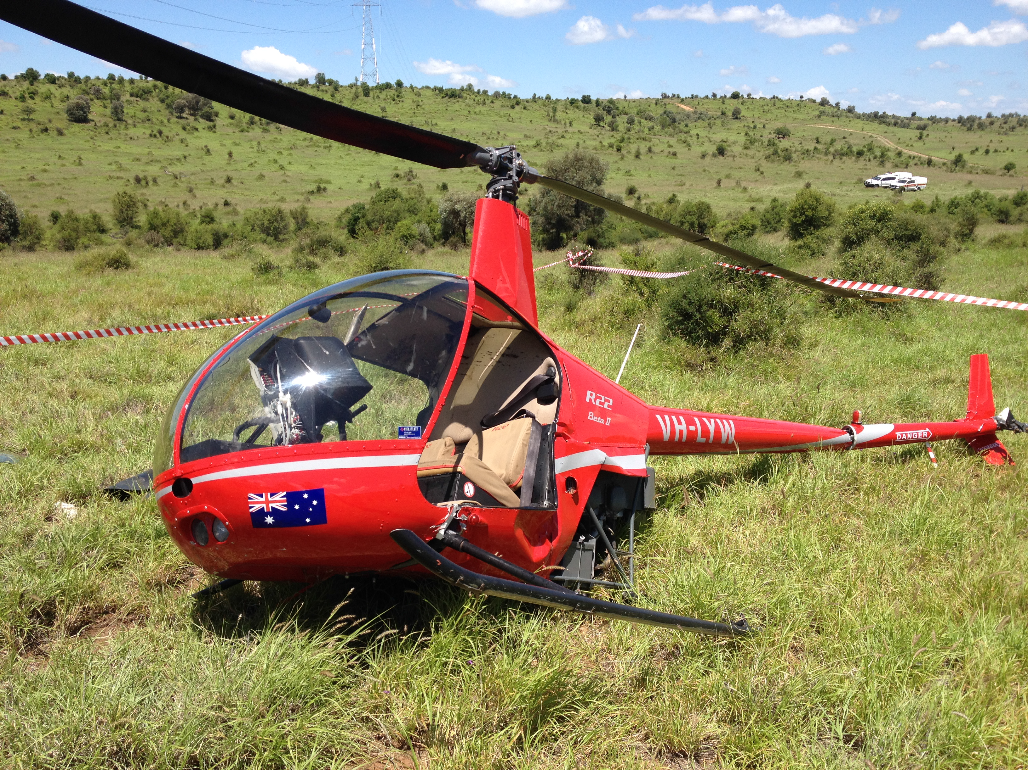
Source: Queensland Police

Safety message
Pilots and operators are reminded that they can ask the property owner and power company to have a wire marked if it presents a hazard to low-level operations, even if it is not required to be marked according to the Australian Standard due to its height and span.
ATSB research indicates that in 63 per cent of reported wirestrike incidents, pilots were aware of the position of the wire before they struck it. In this instance, the pilot was aware of the powerline, however, the pilot’s attention was diverted to looking for cattle, and they did not maintain awareness of the wires.
The Aerial Agricultural Association of Australia suggests a way to keep focus is to ask yourself:
- Where is the wire now?
- What do I do about it?
- Where am I in the paddock?
For further risk management strategies for agricultural operations, refer to the Aerial Application Pilots Manual.
The ATSB publication Avoidable Accidents No. 2 – Wirestrikes involving known wires: A manageable aerial agricultural hazard, explains strategies to help minimise the risk of striking wires while flying. Pilots are reminded to avoid unnecessary distractions and to refocus when distracted. Distraction, combined with difficulty in seeing wires makes them extremely hard to avoid at the last minute.

General details

Occurrence details
Date and time: | 20 February 2016 – 0808 EST
Occurrence category: | Accident
Primary occurrence type: | Wirestrike
Location: | 88 km NE Roma Aerodrome, Queensland
 | Latitude: 26° 04.98' S | Longitude: 149° 29.50' E

Helicopter details
Manufacturer and model: | Robinson Helicopter Company R22 Beta
Registration: | VH-LYW
Serial number: | 4482
Type of operation: | Aerial work – Aerial mustering
Persons on board: | Crew - 1 | Passengers - 0
Injuries | Crew - 1 | Passengers - 0
Aircraft Damage | Substantial

Hot Air Balloons

Wirestrike involving Kavanagh G 450 balloon, VH-RUW

What happened
On 7 February 2016, the pilot of a Kavanagh G-450 balloon, registered VH-RUW, conducted a 30-minute scenic flight from Mareeba, Queensland with 18 passengers on board.
Shortly before 0627 Eastern Standard Time (EST), the balloon approached the target landing area. The pilot referred to his iPad, which showed the location of the balloon and a set of powerlines strung across the paddock. The balloon was then about 30 ft above ground level, travelling at a ground speed of 7 kt, with a descent rate of 50 ft per minute. The pilot confirmed that all the passengers were in the correct landing position.
The pilot sighted two power poles either side of the landing area, but was unable to see the wires. The pilot estimated where the wires would be based on the crossbars on the poles, and assessed that the balloon had sufficient height to pass over the powerlines. The pilot then sighted the powerlines, about half a metre ahead of and below the basket. The pilot applied all four burners to try to climb and avoid the powerlines, but the left side of the basket contacted one wire, breaking it. The pilot heard a loud fizzing noise and immediately realised they had struck a powerline.
The pilot checked that the passengers were all ok and still in the landing position, and checked that there was no evidence of fire. Due to the amount of heat in the balloon, the balloon was climbing. The pilot then conducted a normal controlled descent and landing into a paddock about 500 m beyond the original planned landing site. The balloon landed without further incident and no one was injured. The wicker basket sustained scorching (Figure 1) and a stainless steel cable fixed to the underside of the basket sustained arc damage.
Figure 1: Scorch marks on wicker basket
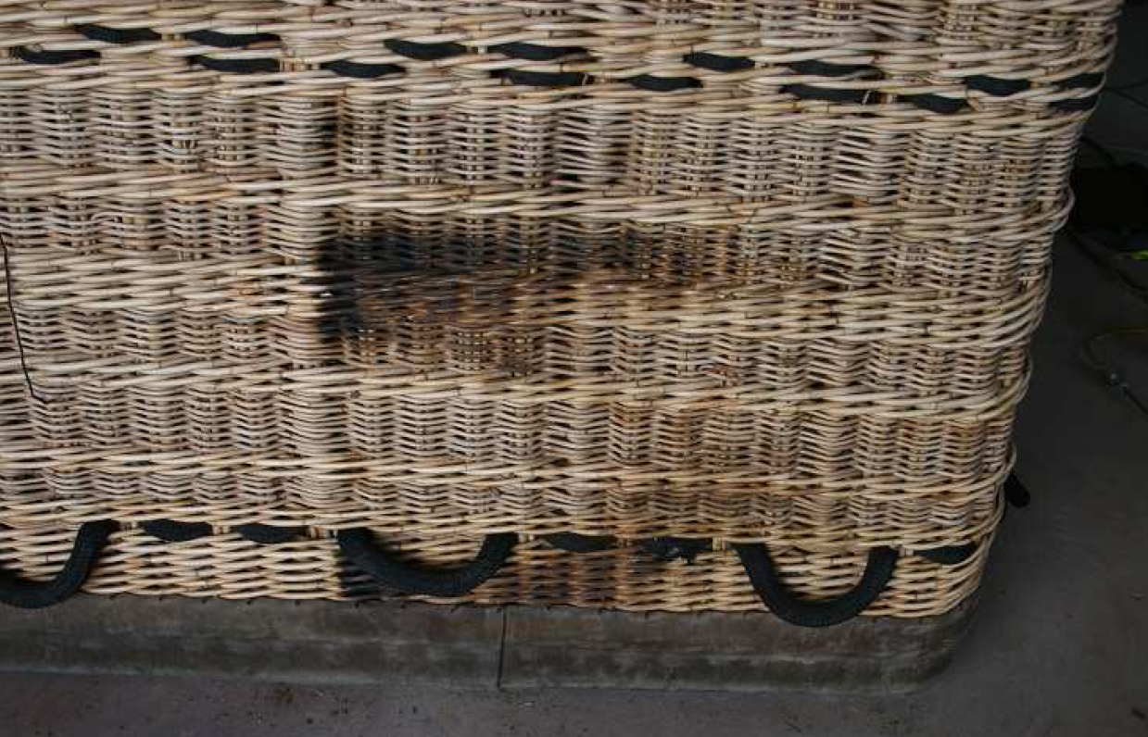
Source: Balloon operator

Landing site
The balloon operator and the pilot had used the paddock on many occasions for both launching and landing.
The balloon’s track crossed the powerlines at an angle (Figure 2). As the balloon approached the wires, the pilot lost sight of the pole to the left and used the pole on the right to gauge their height. However, the left pole was situated on a hill and higher than the right pole, and the wires sloped upwards from the right pole to the left. The pilot’s assessment of sufficient height was based on the lower pole; consequently, the left side of the basket struck the wires to the high side.
The powerlines were difficult to see as the area was heavily vegetated. The sun was to the right of the balloon and did not affect the pilot’s vision of the wires.
Figure 2: Balloon track and location of powerlines
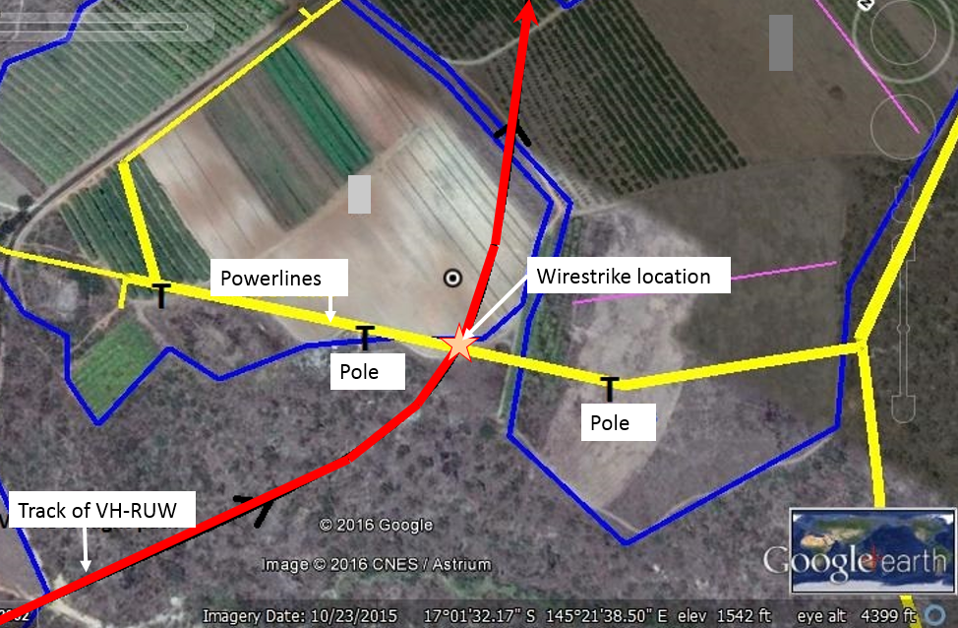
Source: Balloon operator

Powerlines and markings
The balloon operator used the following strategies to improve powerline awareness:
- The operator had developed an iPad application which pilots used in-flight as an early powerline warning system, which showed all of the powerlines on a google earth map, and the balloon’s current location. The energy company provided updates to the location of the powerlines at six monthly intervals.
- The operator maintained a map of powerlines identified by the company pilots to be of low visibility. These were highlighted on the application to draw pilots’ attention.
- Company pilots were required to visit the site of identified low-visibility powerlines to familiarise themselves with the location of the lines.
- In addition, ground personnel were expected to identify from the ground any powerlines in the balloon’s flight path, which may pose a risk to the balloon on approach to land, and to confirm that the pilot was aware of the lines and their location.
- The balloon operator had designated the powerlines at the site to be low-visibility, and had paid the energy provider to fit white marker flags with a reflective green centre to the wires to increase the pilot’s ability to see the lines (or flags). Despite being clearly visible from the ground, the pilot was unable to see the flags. This may have been due to the effect of the wind deflecting the flags at an angle, and possibly their colour.

Pilot comments
Two other balloons had already landed in the paddock. The pilot elected to fly on rather than conduct an emergency descent after the wirestrike, because a high rate of descent from that height carried a risk of injury to the pilot and passengers, and to avoid a collision with the balloons that had landed ahead.

Safety action

Balloon operator
As a result of this occurrence, the balloon operator has advised the ATSB that they are taking the following safety actions:

Review of powerline markings
The operator is investigating the installation of more visible three dimensional powerline markings such as balls.

Communication to company pilots
The operator will circulate a copy of their investigation report and findings to all company pilots. Pilots are reminded to consider the possibility of sloping powerlines and apply an appropriate clearance margin when overflying them.

Safety message
The ATSB research report, Wirestrikes involving known wires: A manageable aerial agriculture hazard, explains a number of strategies to assist pilots manage the risk of wirestrikes. These include:
- ensure you are fit to fly
- prioritise safety
- conduct thorough pre-flight planning
- avoid unnecessary distractions
- don’t rely on your ability to react in time to avoid a wire
- have a systematic approach to safely managing wires.
The Australian Ballooning Federation produced safety advisory notice pilot circular number 18 in 2012, detailing strategies to avoid wirestrikes.

General details

Occurrence details
Date and time: | 7 February 2016 – 0640 EST
Occurrence category: | Serious incident
Primary occurrence type: | Wirestrike
Location: | Mareeba, Queensland
 | Latitude: 17° 01.40' S | Longitude: 145° 21.40' E

Balloon details
Manufacturer and model: | Kavanagh Balloons G-450
Registration: | VH-RUW
Serial number: | G450-401
Type of operation: | Ballooning
Persons on board: | Crew – 1 | Passengers – 18
Injuries: | Crew – 0 | Passengers – 0
Damage: | Minor

Australian Transport Safety Bureau
The Australian Transport Safety Bureau (ATSB) is an independent Commonwealth Government statutory agency. The Bureau is governed by a Commission and is entirely separate from transport regulators, policy makers and service providers. The ATSB’s function is to improve safety and public confidence in the aviation, marine and rail modes of transport through excellence in: independent investigation of transport accidents and other safety occurrences; safety data recording, analysis and research; fostering safety awareness, knowledge and action.
The ATSB is responsible for investigating accidents and other transport safety matters involving civil aviation, marine and rail operations in Australia that fall within Commonwealth jurisdiction, as well as participating in overseas investigations involving Australian registered aircraft and ships. A primary concern is the safety of commercial transport, with particular regard to fare-paying passenger operations.
The ATSB performs its functions in accordance with the provisions of the Transport Safety Investigation Act 2003 and Regulations and, where applicable, relevant international agreements.

Purpose of safety investigations
The object of a safety investigation is to identify and reduce safety-related risk. ATSB investigations determine and communicate the safety factors related to the transport safety matter being investigated. The terms the ATSB uses to refer to key safety and risk concepts are set out in the next section: Terminology Used in this Report.
It is not a function of the ATSB to apportion blame or determine liability. At the same time, an investigation report must include factual material of sufficient weight to support the analysis and findings. At all times the ATSB endeavours to balance the use of material that could imply adverse comment with the need to properly explain what happened, and why, in a fair and unbiased manner.

About this Bulletin
The ATSB receives around 15,000 notifications of Aviation occurrences each year, 8,000 of which are accidents, serious incidents and incidents. It also receives a lesser number of similar occurrences in the Rail and Marine transport sectors. It is from the information provided in these notifications that the ATSB makes a decision on whether or not to investigate. While some further information is sought in some cases to assist in making those decisions, resource constraints dictate that a significant amount of professional judgement is needed to be exercised.
There are times when more detailed information about the circumstances of the occurrence allows the ATSB to make a more informed decision both about whether to investigate at all and, if so, what necessary resources are required (investigation level). In addition, further publically available information on accidents and serious incidents increases safety awareness in the industry and enables improved research activities and analysis of safety trends, leading to more targeted safety education.
The Short Investigation Team gathers additional factual information on aviation accidents and serious incidents (with the exception of 'high risk operations), and similar Rail and Marine occurrences, where the initial decision has been not to commence a 'full' (level 1 to 4) investigation.
The primary objective of the team is to undertake limited-scope, fact gathering investigations, which result in a short summary report. The summary report is a compilation of the information the ATSB has gathered, sourced from individuals or organisations involved in the occurrences, on the circumstances surrounding the occurrence and what safety action may have been taken or identified as a result of the occurrence.
These reports are released publically. In the aviation transport context, the reports are released periodically in a Bulletin format.
Conducting these Short investigations has a number of benefits:
- Publication of the circumstances surrounding a larger number of occurrences enables greater industry awareness of potential safety issues and possible safety action.
- The additional information gathered results in a richer source of information for research and statistical analysis purposes that can be used both by ATSB research staff as well as other stakeholders, including the portfolio agencies and research institutions.
- Reviewing the additional information serves as a screening process to allow decisions to be made about whether a full investigation is warranted. This addresses the issue of 'not knowing what we don't know' and ensures that the ATSB does not miss opportunities to identify safety issues and facilitate safety action.
- In cases where the initial decision was to conduct a full investigation, but which, after the preliminary evidence collection and review phase, later suggested that further resources are not warranted, the investigation may be finalised with a short factual report.
- It assists Australia to more fully comply with its obligations under ICAO Annex 13 to investigate all aviation accidents and serious incidents.
- Publicises Safety Messages aimed at improving awareness of issues and good safety practices to both the transport industries and the travelling public.

MAYDAY is an internationally recognised call for urgent assistance.
CTAF means Common Traffic Advisory Frequency. It is the frequency on which pilots operating at a non-towered aerodrome should make positional radio broadcasts.
The pilot intended to highlight that fire services may be required after landing, but it is not clear whether the intended message was fully understood by the Airport Safety Officer. Fire services were not ordered, but the Airport Safety Officer was standing-by to render assistance as required.
With respect to the incident that precipitated this ATSB investigation, CASA commented that there was no information in the aircraft records that documented when the oil transfer elbow was last removed. Additionally, there was no evidence available from log book records of other maintenance events that may have had an effect on the integrity of the oil transfer elbow.
Instrument meteorological conditions (IMC) describes weather conditions that require pilots to fly primarily by reference to instruments, and therefore under Instrument Flight Rules (IFR), rather than by outside visual references. Typically, this means flying in cloud or limited visibility.
Final approach fix (FAF) is a specified point on a non-precision instrument approach, which identifies the commencement of the final segment.
The pilot was able to maintain visibility along the intended flight path within the published circling area.
With a lowered wing and no balancing rudder input the aircraft will begin to slip in the direction of the lowered wing, which leads to a yawing motion in the same direction.
Only the transmitted radio wave is heard, without the voice. In effect, this means that the Tower controller was aware that someone was attempting to transmit on the frequency, but the controller was unable to hear what was being said.
In accordance with the requirements outlined in AIP Australia, the pilot of an aircraft losing two-way communication is required to set the transponder to code 7600.
The area in which VH-TCI was holding was Class E airspace. Aircraft operating under the Visual Flight Rules are required to maintain two-way continuous communication in Class E airspace, but do not require an air traffic control clearance to operate in Class E airspace. Aeronautical Information Package (AIP) ENR 1.1 19.12 Avoiding Controlled Airspace indicates that ‘…where there is a risk of an airspace infringement, the pilot in command should consider…altering track to remain well clear.’
PGA had two global positioning systems (GPS) – a Garmin 650 and a Garmin 750 installed in the aircraft. Both units had a traffic information system, which provided an aural voice alert when another aircraft was within 0.25 NM.
The clock code is used to denote the direction of an aircraft or surface feature relative to the current heading of the observer’s aircraft, expressed in terms of position on an analogue clock face. 12 o’clock indicates that the traffic is directly ahead.
A ‘blind’ transmission from one station to another in circumstances where two-way communication cannot be established, but it is believed that the called station is able to receive the transmission.
Aircraft operating under the Visual Flight Rules must flight plan to cruise at altitudes like 4,500 ft at 5,500 ft, Aircraft operating under the Instrument Flight Rules must flight plan to cruise at altitudes like 5,000 ft (see AIP ENR 1.7 Tables of Cruising Levels).
A ground loop is an uncontrolled turn during ground operation.
In an echelon formation, number 1 (ALO in this instance) is the lead aircraft, and makes the decisions for the formation and also makes and responds to all radio communication for the formation; each individual pilot is still responsible for their own aircraft’s safety.
The position in the circuit, where the pilot in the lead aircraft (ALO) in the formation determines that the formation will manoeuvre into single file, usually with Number 1 in the lead.
An echelon formation is where the aircraft (usually military) are arranged diagonally. In a left echelon, each station (in this case Number 2) was stationed behind and to the left of the lead aircraft) ALO (adapted from Wikipedia definition).
The non-active side of the circuit.
High RPM (full fine) was 2,400 RPM for that aircraft.
An increased density altitude would have increased the power required and decreased the power available.
BHP is the power developed by the engine
The Eurocopter Group was renamed Airbus Helicopters in January 2014.
The operator’s maintenance organisation manual required that a work pack for maintenance tasks be created by the Maintenance Controller
Refer to comments under LAME 1 and 2 who advise a work pack was not generated for this maintenance
The technical log provides a method of efficiently recording information, on one page, relating to the operation and maintenance status of the helicopter. It is accessible to flight crew and maintenance personnel.
The ground run/test flight sheet is used to record requirements for ground runs and check flights. The sequential number of the record is annotated in the appropriate section of the aircraft technical log.
6 The AS365 has a rotor system consisting of four main rotor blades. A 4P vibration is one that has a frequency of 4 per each revolution of the main rotor.
Civil Aviation Regulation CAR 42G required an independent inspection be conducted if any part of the flight control system has been disturbed
Crowley, J.S. (1991) Should Helicopter Frequent Flyers Wear Head Protection? A Study of Helmet Effectiveness. Journal of Occupational and Environmental Medicine, 33(7), 766-769.
A primary helicopter flight control that simultaneously affects the pitch of all blades of a lifting rotor. Collective input is the main control for vertical velocity.

